EXTERNAL

Whistleblower

Policy

  - Senior Support Services Unit

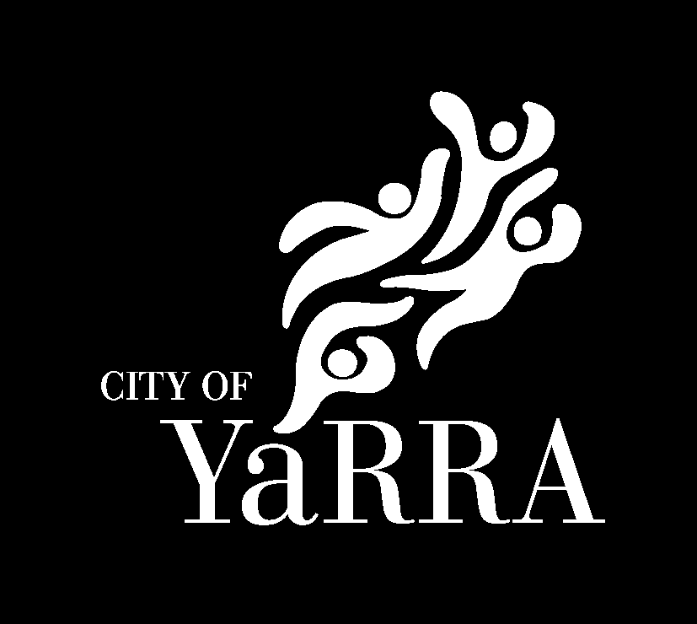

Yarra City Council acknowledges the Wurundjeri Woi Wurrung people as the Traditional Owners and true sovereigns of the land now known as Yarra. We also acknowledge the significant contributions made by other Aboriginal and Torres Strait Islander people to life in Yarra. We pay our respects to Elders from all nations and to their Elders past, present and future.

Document Details
Title: | Whistleblower Policy
Type: | Policy
Description: | Outlines Council’s commitments and obligations for managing and protecting whistleblowers under the Aged Care Act 2024.
Senior Support Services Policy Category: | 3: Open Disclosure
Senior Support Services Policy Number: | 3.1
Audience: | External
Approval Authority: | Manager Ageing Equity and Community Development
Responsible Branch: | Senior Support Services Unit
Document Owner: | Coordinator Senior Support Services
Approval Date: | 31/07/2026
Review Date: | 31/07/2027
Version: | Version 1
Content Manager Ref: | D26/370301
Senior Support Services File Link

1. Purpose
This policy establishes Council’s framework for receiving, assessing, and responding to whistleblower disclosures related to aged care services, ensuring compliance with the whistleblower protection requirements under the Aged Care Act 2024.
The policy ensures that individuals who disclose suspected wrongdoing in good faith are protected from detriment and that Council responds to disclosures lawfully, confidentially, and transparently. Council acknowledges that such disclosures contribute to continuous improvement of our delivery of funded aged care services; and will proactively encourage and support aged care workers and others to raise concerns.

2. Scope
This policy is intended for:
- All Council employees, contractors, volunteers, and consultants.
- Aged care workers, representatives, and subcontractors engaged by Council.
- Any person disclosing wrongdoing connected to Council’s aged care service delivery.
- Disclosures relating to conduct that breaches the Aged Care Act 2024, including but not limited to the Code of Conduct, care quality and safety standards, financial mismanagement, misuse of public resources, and other reportable wrongdoing.
The policy operates alongside Council’s obligations under the Public Interest Disclosures Act 2012 (Vic), and other relevant regulatory frameworks.

3. Definitions
Term / Abbreviation | Definition
Aged Care Act 2024 | The Commonwealth legislation establishing obligations for aged care providers, including whistleblower protections and mandatory responses to disclosures.
Anonymity | One’s identity is unknown. In the case of an anonymous whistleblower, their identity is not known by anyone, including those who receive and investigate the Qualifying Disclosure.
Confidentiality | One’s identity is protected to prevent harm. In the case of a whistleblower, their identity may be known to those receiving and investigating the Qualifying Disclosure, but it is protected from the broader organisation and the public.
Detriment | Any disadvantage, harm, or retaliation experienced by a whistleblower because of making a disclosure. Includes dismissal, demotion, discrimination, harassment, or reputational harm.
Disclosure | Information provided about suspected or alleged wrongdoing within Council’s aged care services.
Responsible Person | Member of the Council in a role designated as a responsible person by the organisation under the definition outlined in the Aged Care Act 2024.
Whistleblower | A person who discloses this policy or under the Aged Care Act 2024 regarding suspected wrongdoing.
Wrongdoing | Conduct that breaches the Aged Care Act 2024, including unsafe care, financial impropriety, breach of the Code of Conduct, or failure to meet care quality and safety standards.

4. Legislative and Policy Context
This policy operates alongside:
- Aged Care Act 2024
- Local Government Act 2020 (Vic)
- Public Interest Disclosures Act 2012 (Vic)
- Privacy and Data Protection Act 2014 (Vic)
- Council’s internal Codes of Conduct and complaint-handling procedures
Where obligations overlap, Council will apply the framework that provides the greatest level of protection for the whistleblower.

5. Policy Statement
Council is committed to delivering senior support services in accordance with the Aged Care Act 2024 and the Aged Care Rules 2025 (including associated regulatory requirements).
In developing this policy, consideration has been given to the obligations, principles, and expectations set out in the aged care legislative framework. Council will operate senior support services in a manner that:
- Supports compliance with applicable legislation, standards, and funding agreements;
- Upholds the rights, dignity, and safety of older people;
- Promotes safe, quality, and person-centred service delivery;
- Maintains appropriate governance, risk management, and accountability processes; and,
- Supports continuous improvement through monitoring, feedback, and review.
Council recognises that compliance with the Aged Care Act is an ongoing organisational responsibility and will maintain systems and practices that support adherence to legislative requirements.

5.1 Commitment to Whistleblower Protection
Council is committed to creating a culture that supports the reporting of wrongdoing and protects individuals who raise concerns in good faith. Council will ensure compliance with the whistleblower protection requirements of the Aged Care Act 2024, including confidentiality, protection from detriment, and prompt and fair assessment of disclosures.

5.2 What Can Be Reported
Whistleblowers may report any conduct related to breaches of the Aged Care Act 2024 or the Aged Care Code of Conduct. This may include:
- Breaches of the Aged Care Act 2024 or Aged Care Code of Conduct.
- Unsafe, substandard, or inappropriate care.
- Neglect, abuse, or exploitation of care recipients.
- Misuse of aged care funding or resources.
- Fraud, corruption, or financial irregularities related to Aged Care only.
- Reprisal or detriment arising from a disclosure.

5.3 How to Make a Disclosure
Disclosures may be made to:
- Yarra City Officers and/or Responsible Persons, including but not limited to:
  - Manager Governance
  - Manager Ageing, Equity and Community Development
  - General Manager Community Strengthening
  - Coordinator Senior Support Services
  - Chief Executive Officer
  - Yarra Senior Support Services Workers
- The Aged Care Quality and Safety Commission
- The Whistleblower Protection Authority (once operational)
- Other authorised statutory bodies as permitted by law (e.g. police)
Disclosures may be made verbally (in person or via telephone) or in writing. Anonymous disclosures are permitted; however, this may limit Council’s ability to investigate.

5.4 Confidentiality
Council will take all reasonable steps to protect the confidentiality of whistleblowers and the information they provide. Identifying information will only be disclosed:
- With the whistleblower’s consent; or
- Where required or authorised by law; or
- Where necessary to prevent a serious risk to life, health or safety.
Where possible, information will be disclosed in a way that does not identify the whistleblower. Access to information will be limited to authorised personnel on a need-to-know basis and managed in accordance with Council’s privacy and records management requirements.
Council will take reasonable steps to protect whistleblowers from victimisation or detrimental action because of making a disclosure.

5.5 Protection from Detriment
Council will not tolerate any form of detriment, retaliation, or harassment against whistleblowers. Council will:
- Take immediate steps to prevent or address any risk of reprisal.
- Implement protective measures such as changes to work arrangements, wellbeing support, or temporary relocation.
- Take disciplinary action against any individual found to have engaged in detrimental conduct.

5.6 Assessment and Management of Disclosures
Aged Care whistleblower disclosures and complaints will be directed to Governance for appropriate assessment, handling and escalation, separate from operational service delivery pathways.
Council will:
- Acknowledge receipt of disclosures where possible.
- Assess disclosures promptly to determine whether investigation is required.
- Refer matters to external regulators where appropriate.
- Conduct investigations impartially, confidentially, and in accordance with legal obligations.
- Provide feedback to whistleblowers where appropriate and lawful.
Council will ensure the management procedures above are reviewed as required, at least annually, to ensure they continue to meet the policy requirements.

5.7 Investigation Procedures

5.7.1 Investigation Planning
In consultation with the relevant manager/s, an investigation plan will be prepared by Governance officer/s which will include:
- The key issues to be investigated;
- The scale of the investigation, in proportion to the alleged wrongdoing; and
- Allocation of resources.

5.7.2 Principles of conducting investigations
Investigations will be undertaken applying fair and ethical principles, and as such:
- Any person accused of wrongdoing will have the presumption of innocence;
- All investigations will be conducted without bias;
- Persons accused of wrongdoing will be supported throughout the process and referred to external support services if necessary;
- Investigations will follow the procedures of natural justice;
- In circumstances where the whistleblower is unable to remain anonymous, they must remain free from any retaliatory action;
- During and after the investigation, relevant officers should monitor for any detriment or threats towards the whistleblower from any member of the organisation; and
- All disciplinary action will be proportionate to the seriousness of the breach.

6. Implementation

6.1 Training & Awareness
Council will ensure all staff and responsible persons involved in aged care services receive training on:
- Their responsibilities under the Aged Care Act 2024.
- How the whistleblower system works (i.e. how to handle disclosures, protect confidentiality, manage disclosures, etc.)
- Protections available to whistleblowers.
- Council’s internal procedures for managing disclosures.
Council will prepare and keep up-to-date documents detailing their whistleblower system and the roles/responsibilities of their aged care workers and responsible persons under that system and ensure aged care workers/responsible persons are aware of and understand their roles and responsibilities under the system.

6.2 Record Keeping
Council will securely record all disclosures, assessments, investigations, and outcomes in accordance with legislative requirements and Council’s records management policies.

7. Related Documents
- Aged Care Act 2024
- Aged Care Quality and Safety Standards
- Yarra Public Interest Disclosures Procedure
- Council Code of Conduct
- Council Complaints and Feedback Policy
- Senior Support Services Complaints and Service User Feedback Policy (D13/26877)
- Serious Incident Management Policy (D12/8489)

8. Approval (Electronic)
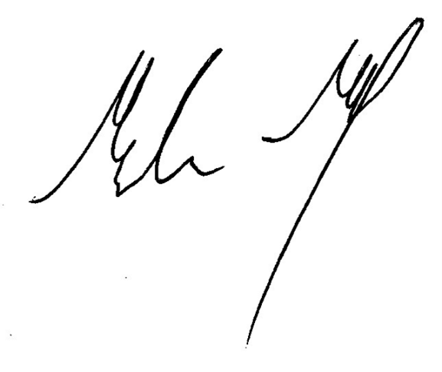
Malcolm McCall
Manager AECD
31/07/2026

