EXTERNAL

Client Fees

Policy

  - Senior Support Services Unit



Yarra City Council acknowledges the Wurundjeri Woi Wurrung people as the Traditional Owners and true sovereigns of the land now known as Yarra. We also acknowledge the significant contributions made by other Aboriginal and Torres Strait Islander people to life in Yarra. We pay our respects to Elders from all nations and to their Elders past, present and future.

Document Details
Title: | Client Fees Policy
Type: | Policy
Description: | Defines Council’s approach to fees (client contributions) which meets legislative and funding requirements while supporting Council’s commitment to social justice and human rights.
Senior Support Services Policy Category | 5: Fees & Charges
Senior Support Services Policy Number | 5.1
Audience: | External
Approval Authority: | Manager Ageing Equity and Community Development
Responsible Branch: | Senior Support Services Unit
Document Owner: | Coordinator Senior Support Services
Approval Date: | 10/08/2026
Review Date: | 10/08/2027
Version: | Version 1
Content Manager Ref: | D11/86138
Senior Support Services File Link

1. Purpose
The purpose of this Policy is to:
- Establish a fair, transparent and consistent framework for client fees for senior support services delivered or facilitated by Council;
- Support equitable access to services regardless of a person’s financial circumstances;
- Ensure Council complies with the Aged Care Act 2024, Aged Care Rules 2025, Commonwealth Home Support Programme (CHSP) obligations and other applicable legislation and funding agreements;
- Outline Council’s approach to fee setting, hardship, fee review, debt management, refunds and complaints; and
- Support a rights-based, person-centred approach to service delivery.

2. Scope
This Policy applies to:
- All Council officers, contractors and volunteers involved in the assessment, administration, coordination, review or collection of client fees for senior support services;
- All clients receiving senior support services funded or administered by Council, including CHSP services and successor programs;
- Services delivered directly by Council or on Council’s behalf; and
- Situations involving fee reduction, waiver, review, refund, debt recovery or complaints regarding client fees.

3. Definitions
Term / Abbreviation | Definition
Aged Care Act | The Aged Care Act 2024 (Cth).
Aged Care Rules | The Aged Care Rules 2025 (Cth)
CHSP | Commonwealth Home Support Program
Fees | A fee charged to a client to contribute toward the cost-of-service delivery
Financial Hardship | A situation where a client, or a person responsible for paying fees on their behalf, is experiencing genuine difficulty in meeting the cost-of-service fees without compromising their ability to meet reasonable and necessary living expenses. Financial hardship may be temporary, intermittent or ongoing.
Statement of Rights | Rights framework established under the Aged Care Act 2024.
Full Cost Recovery | The full cost to Council of providing a service.

4. Legislative and Policy Context
This Policy is informed by and intended to align with:
- Aged Care Act 2024 (Cth);
- Aged Care Rules 2025 (Cth);
- Commonwealth Home Support Program (CHSP) Program Manual;
- Aged Care Quality Standards;
- Privacy Act 1988 (Cth);
- Health Records Act 2001 (Vic);
- Local Government Act 2020 (Vic);
- Charter of Human Rights and Responsibilities Act 2006 (Vic); and,
- Relevant Council policies and procedures.

5. Policy Statement
Council is committed to delivering senior support services in accordance with the Aged Care Act 2024 and the Aged Care Rules 2025 (including associated regulatory requirements).
In developing this policy, consideration has been given to the obligations, principles, and expectations set out in the aged care legislative framework. Council will operate senior support services in a manner that:
- Supports compliance with applicable legislation, standards, and funding agreements;
- Upholds the rights, dignity, and safety of older people;
- Promotes safe, quality, and person-centred service delivery;
- Maintains appropriate governance, risk management, and accountability processes; and
- Supports continuous improvement through monitoring, feedback, and review.
Council recognises that compliance with the Aged Care Act is an ongoing organisational responsibility and will maintain systems and practices that support adherence to legislative requirements.

5.1 Overarching Principles – Council and Senior Support Services
The Yarra City Council Plan 2025 – 2029 states Council will:
- “Deliver programs and make better use of existing places to foster connection, and support people of all ages and backgrounds to live a healthy and fulfilling life” (Strategic Objective 2.1 – Living in the City).
The 2025 Community Vision Reflection and Update confirms Council’s commitment to affordable services:
- “Affordability is an emerging issue, which must include access to affordable housing, services, transport, food, energy and community spaces. Yarra should be a place where everyone can afford to live”.
In March 2022, Council adopted six Guiding Principles to steer decisions on aged services in Yarra. Principle 1 states that Council will be a robust advocate and steward for the provision of quality and accessible aged care services for our community.

5.2 Fee Setting Principles
Council will apply the following principles when setting and administering fees:
- Fees will be transparent, documented and publicly available;
- No eligible client will be refused services solely because of inability to pay;
- Clients experiencing hardship (see Section 5.5) may access reduced fees, waivers or payment plans;
- Fee discussions will occur respectfully and confidentially;
- Clients may involve advocates, carers or support persons; and,
- Clients may request review of fee decisions at any time.

5.3 Fee Calculation Strategy
Council is committed to providing accessible, equitable and financially sustainable senior support services. Fees are determined through a transparent process that considers legislative and funding requirements, the cost-of-service delivery, and clients' capacity to contribute.
When setting or reviewing fees, Council considers:
- Funding arrangements and requirements under the Commonwealth Home Support Program (CHSP), Home Care Package (HCP) Program, Support at Home Program (where applicable), and other relevant funding agreements.
- The actual cost of delivering services, including labour, administration, equipment, transport, overheads, and other operational expenses.
- Council's commitment to subsidising services to support access for older people and vulnerable community members.
- Commonwealth policy and guidance regarding client contributions and co-contribution principles.
- Fees charged by comparable local government and community service providers.
- The affordability of services for clients and the potential impact of fees on service access and participation.
- The long-term financial sustainability of services.
For Commonwealth-funded services, client fees (contributions) are generally based on the principle that government funding covers most service costs, while clients with the capacity to contribute based on their income are expected to make a reasonable contribution towards the cost of the services they receive. Client contributions are not intended to recover the full cost of service delivery.
The criteria for calculating income levels are listed below.
- Where a person is living alone, that person’s income is assessed.
- Where couples are both consumers, their combined income is assessed.
- Where one member of a couple is the consumer, the decision regarding whose income is assessed depends on the nature of that income. For example, joint pensioners are assessed at the level of their joint pension income.
- Where an older person is living with a family or carer (who are not themselves clients), only the older person’s income is assessed.
- Where there is a household of three or more unrelated people living together, the income of the person requiring services is assessed. Services should be provided only to support that person (for example, housework is restricted to personal space and property, not communal living areas).
- Allocation to low, medium, or high category is made after any special expenditure considerations are taken into account.
Outlined below (Table 1) are the three income-level tiers that determine fee contributions based on income range (high/medium/low).
Table 1: Income Ranges
 | Low Range | Medium Range | High Range
Individual | < $39,089 | > $39,089 & < $86,208 | > $86,208
Couple | < $59,802 | > $59,802 & < $115,245 | > $115,245
Council may apply different fee structures across service types to reflect variations in service costs, funding arrangements, and program requirements.
Fees may be charged as a fixed amount, unit rate, hourly rate, percentage contribution, full cost recovery (e.g. SAH program formally HCP clients), or other approved charging methodology.

5.4 Individual Service Fees
The fees for the following Senior Support Services are set out in the Council 2026-2027 Budget:
- Home Maintenance (including Home Adjustments)
- Delivered/Centred Meals
- Willowview
- Community Transport
- Home Care Package Clients
A summary of these fees is attached (Attachment A).
Fees are charged per hour, trip, meal or session. Where a couple or family receives an hour of service, they are not separately charged (that is, charged for two hours of service, when the couple receives only one hour between them).
Council will review fees periodically, and at least annually, to ensure they remain consistent with legislative requirements, funding conditions, service delivery costs, Council objectives, and community expectations.

5.5 Financial Hardship
Council recognises that some clients may experience temporary or ongoing financial hardship (see Definition - Section 3). As per principles of equity, access, social justice and supported decision-making that underpin the Aged Care Act 2024 and senior support service delivery, no eligible client will be denied access to essential services solely because of an inability to pay a fee or contribution due to demonstrated financial hardship.
Clients may request a fee reduction, waiver or payment plan at any time. Requests may be made verbally, in writing, through an advocate, carer or representative. Council staff will assist clients to make an application where required.
In assessing financial hardship, Council may consider the client's income, assets, liabilities, unavoidable expenses, dependants, and any other relevant circumstances. The existence of assets alone does not necessarily exclude a person from experiencing financial hardship.
Examples of financial hardship may include, but are not limited to:
- Loss or reduction of income due to retirement, illness, injury, caring responsibilities, redundancy or other unforeseen circumstances.
- Significant medical, disability-related or other essential expenses that impact financial capacity.
- Exceptional personal circumstances such as bereavement, family violence, separation, homelessness, or natural disaster.
- Financial commitments or debt that affect the person's ability to meet essential living costs.
- Circumstances where payment of the fee would compromise the person's ability to meet reasonable living expenses, such as housing, food, utilities, transport or healthcare.
These examples are intended as guidance only and do not limit Council's discretion to consider other circumstances that may demonstrate financial hardship.
A finding of financial hardship may result in the reduction, waiver, deferment or alternative arrangement of fees or contributions. The result will be determined on a case-by-case basis in consultation with the client.
Clients may be asked to provide information relevant to their financial circumstances that can be viewed by the assessing officer. Evidence may include:
- Centrelink Income Statement or pension statement;
- Evidence of significant living expenses such as rent, mortgage, utilities or medical costs;
- Evidence of debts or other financial commitments; and/or
- Any other information relevant to the application.
Council will only request information reasonably necessary to assess financial hardship.
Each application will be assessed individually by authorised Council officers, considering the client’s circumstances, supporting evidence and the extent of hardship. Relevant considerations may include:
- Income and available financial resources;
- Essential living expenses;
- Medical or disability-related costs;
- Dependants and caring responsibilities;
- Assets, liabilities and debts;
- Any exceptional or unforeseen circumstances.
Receipt of a pension or concession card alone does not automatically qualify a client for a fee reduction or waiver.
On review and consideration of the application, Council may maintain, reduce, waive, offer payment plan/arrangement or defer payment. The approval for a reduction or suspension of fees is temporary. A review will be undertaken if circumstances change, and/or reviewed periodically as part of a client’s annual review.

5.6 Debt Recovery
Please refer to Council’s Debtor Management Policy.

5.7 Delegation
ACTIVITY | ACTION | RESPONSIBILITY
Setting annual fees | Annual budget process | - Council
Assessment and determination of client fee and income range | Complete assessment with client and negotiate agreed fees (including at reviews) | - Senior Support Services Team Leads  - Business Support Officers
Reduced Fees | Request for a determination of a reduced fee | - Coordinator Senior Support Services
Fee Waiver | Consider request to apply nil fee | - Coordinator Senior Support Services
Non-payment of fees | Cessation of services where payments are not being made unrelated to financial hardship | - Manager Ageing, Equity and Community Development
Complaints Procedure | Consider and respond to requests to review fee decisions and/or assessment process | - Manager Ageing, Equity and Community Development

5.8 Complaints & Feedback
All clients are to be provided with a Client Information Booklet which includes information and contact details for making a complaint and/or service user feedback.
All clients have the right to complain about or question the fee charged if they believe it is unfair or unaffordable. They may do this at any time they are receiving services. Clients may require or elect to use an advocate in the complaints process.
In resolving fee complaints, checks will include:
- Clarification of whether the process established the correct income level.
- Whether significant additional costs affect the client’s ability to pay for services, and whether these costs have been considered when applying a fee reduction or waiver.
- The client has understood the fee process and their entitlements.
- The client’s circumstances have changed, and the fee needs to be reassessed.
- There is a carer or guardian who should be involved in the fee process.

6. Implementation
Implementation of this Policy includes:
- Maintaining a current Schedule of Fees and Charges;
- Ensuring staff understand fee assessment and hardship processes;
- Providing accessible fee information to clients;
- Documenting fee assessments and decisions appropriately;
- Maintaining appropriate governance and delegation arrangements; and
- Reviewing the Policy annually or following legislative reform.

7. Related Documents
- Aged Care Act 2024
- Council’s Complaints and Feedback Policy
- Senior Support Services Complaints and Service User Feedback Policy
- Annual Budget 2026-2027 Fees & Charges
- Debtor Management Policy (AR Drive/D16/77438, D16/72280, D16/69231???)
- Financial Hardship Policy (D22/144269)

8. Approval (Electronic)
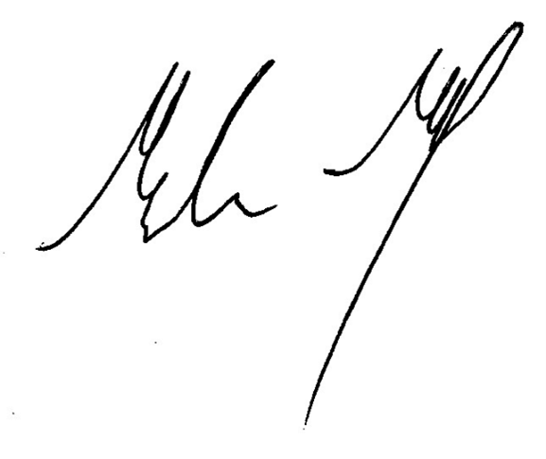
Malcolm McCall
Manager AECD
10/08/2026

Attachment A: Council 2026-2027 Budget Fees
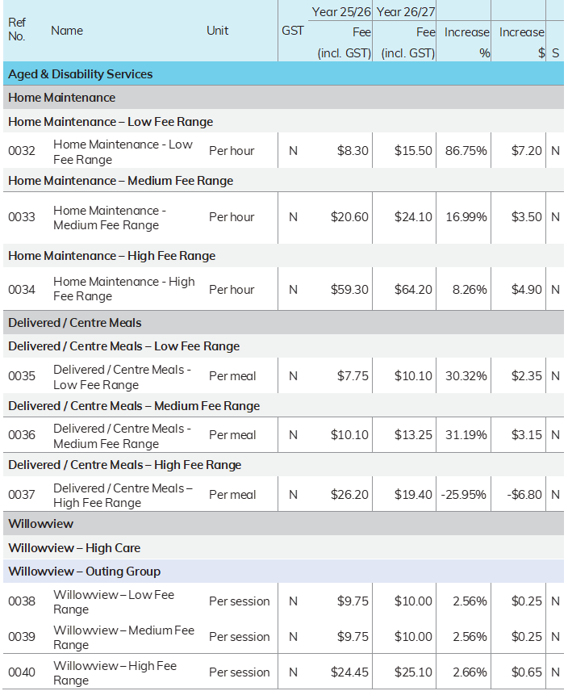



These income thresholds are set by the Department of Families, Fairness and Housing to determine out-of-pocket costs for state-funded community health, dental, and allied health services. The thresholds set by the State have historically been used by Council when setting fees for the Home and Community Care program and remain an appropriate scale.

