
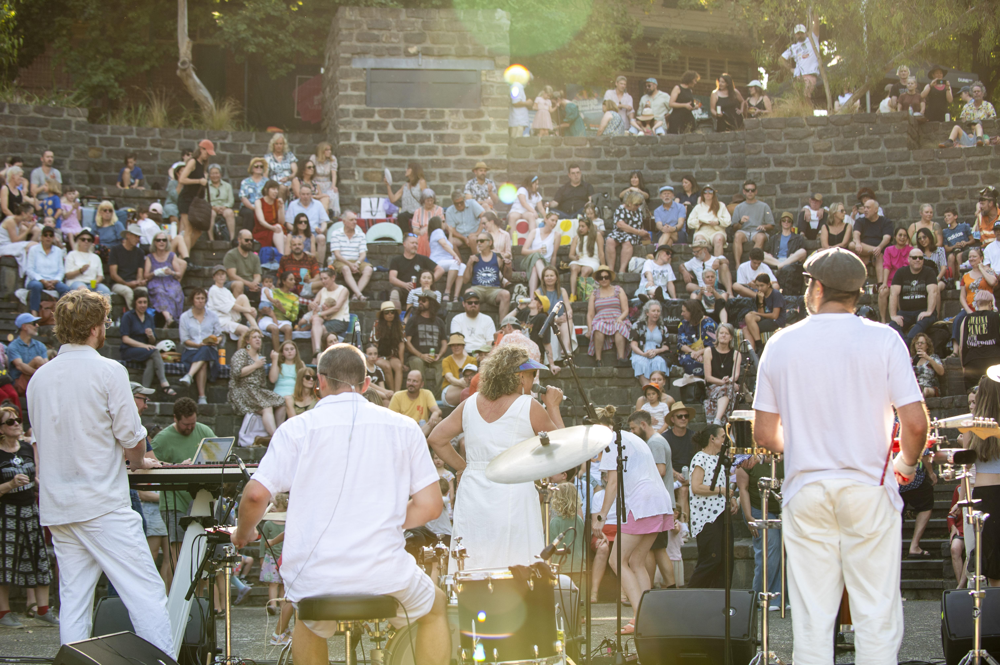
FAIRFIELD IN FEB 2027

Expression of Interest guidelines.

Yarra City Council acknowledges the Wurundjeri Woi Wurrung people as the Traditional Owners and true sovereigns of the land now known as Yarra. We also acknowledge the significant contributions made by other Aboriginal and Torres Strait Islander people to life in Yarra. We pay our respects to Elders from all nations and to their Elders past, present and future.

CONTENTS

Key Information 2
Introduction 3
Opportunity 3
Eligibility 3
Expression of Interest – project brief 4
Purpose 4
Event details 4
Location 4
Scope 4
Objectives 5
Budget 5
Council support 5
Timeline 6
How to apply 6
Assessment criteria 7
Seeking partnership and/or further funds 7
Questions? 7

Key Information
Application Form | https://cityofyarra.smartygrants.com.au/FIF2027EOI
Applications Open | Thursday 15 October 2026 at 5pm (AEST).
Applications Close | Wednesday 11 November 2026 at 11:59pm (AEST).
Funding on offer | $30,000.00 plus GST.
Event Dates and Times | Funding is provided for the delivery of two events at Fairfield Amphitheatre in February 2027.  Sunday 7th and Sunday 21st of February 2027.  Each event will run for approximately 2.5 to 3 hours, scheduled within the 3pm to 8.30pm event window.
Any questions and to arrange a site visit | Christel Starkey | Festivals and Events Lead  Email: Christel.starkey@yarracity.vic.gov.au  Call: 03 9426 1561

Introduction
The City of Yarra has a long and proud history as a centre of creativity, artistic endeavour and cultural production. Fairfield in Feb reflects Council's vision for Yarra as a creative place where diverse and vibrant arts activities thrive, and where arts and culture are experienced as part of everyday community life.
Since 2000, Fairfield in Feb has been a well-loved community event, showcasing live music in a unique outdoor setting along the River Birrarung. The event supports emerging and established local artists, celebrates diverse talent and brings the community together through free, accessible and family-friendly cultural experiences.
With financial support from Council, Fairfield in Feb provides opportunities for local producers, organisations and musicians to develop and showcase live music to audiences from Yarra and across Melbourne including young people, families and adults.
Over its history, the event has been delivered by a range of respected organisations, including Multicultural Arts Victoria, Cultural Infusion and The Boite. In recent years, producers including Quiet Riot Creative, Foreign Brothers, Mz Rizk, Afrohub and Vollyspot, in collaboration with Music in Exile, have curated and presented Fairfield in Feb.

Opportunity
Council is seeking an experienced producer, arts organisation or event management company to curate and deliver a distinctive, inclusive and community-focused event series at the Fairfield Amphitheatre for Fairfield in Feb 2027.
The funding available to develop, produce and deliver two music-focused events in February is $30,000 plus GST.

Eligibility
- Applications are sought from interested event management companies, arts organisations and/or cultural producers with experience in event management and music programming.
- Applications will demonstrate the capacity to develop, promote and deliver a coherent program and a commitment to best practice in risk management and technical production requirements.
- If successful, applicants must:
  - Hold an active ABN (Australian Business Number),
  - Provide proof of Public Liability Insurance with a minimum cover of $20million,
  - Ensure all staff and sub-contractors have current Working with Children Checks and WorkCover coverage, and comply with Fair Work legislation and the Victorian Child Safe Standards as legally required.
  - Ensure any food and beverage sub-contractors hold all required licenses and permits, are registered with FoodTrader, and have appropriately qualified staff and equipment to deliver services.

Expression of Interest | Project Brief

Purpose
For decades, Fairfield in Feb has celebrated and supported culturally diverse communities and creatives in the City of Yarra through programming of local African, Latinx, Middle Eastern, Asian and First Nations artists across a broad range of musical and contemporary art forms.
Through funding of $30,000 plus GST, Council aims to support a high-quality cultural experience that creates opportunities for local creatives and businesses, expands public access to arts and culture, and strengthens Yarra’s creative community.

Event details
Fairfield in Feb 2027 will consist of two afternoon performances on Sunday 7th and Sunday 21st February 2027.
Each event day will run programming for approximately 2.5 to 3 hours, scheduled within the 3pm to 8.30pm event window.
Events are expected to be free, family-friendly and suitable for a broad community audience.

Location
Fairfield Amphitheatre, Fairfield Park, Heidelberg Road, Fairfield.
Link here to venue information and maps.
The Fairfield Amphitheatre has a seated capacity of 350 people and features a 20m x 10m performance area. The venue includes an accessible wheelchair viewing platform located at the top of the amphitheatre, as well as power and public toilet facilities. A kiosk is also available for use as a ticket box and/or for food and beverage sales. Existing lighting on site is for safe egress only and is not designed nor suitable for events at night (additional lighting production is required).
To arrange a site visit, please contact the Festivals and Events Lead (see contact details provided at the end of this document).

Scope
The successful applicant will Develop:
  - A distinctive and engaging music program curated for two free community events at the Fairfield Amphitheatre.
  - A programming concept that reflects the value and objectives of Fairfield in Feb and prioritises artists from diverse and underrepresented communities, including First Nations, culturally diverse, women, gender-diverse, LGBTQIA+, artists with disability, young people and seniors.
  - And identify opportunities to support local artists, creative practitioners and businesses.

The successful applicant will Produce:
  - The planning and production requirements for the delivery of two events.
  - Artist, contractor, supplier and food and beverage provider engagement and management.
  - Technical production, including sound, lighting, staging and event infrastructure procurement and coordination.
  - A marketing and communications plan to support attendance and audience engagement.
  - Marketing and promotional design that comply with Council branding requirements and acknowledge Yarra City Council as the presenter.
  - All marketing and promotional assets, including print, digital and social media content, for Council review and approval.
  - Required event documentation including event and site plans, risk and safety plans, noise management, security and red line plans (if required). Council will supply guidelines and templates for event, risk and safety plans.

The successful applicant will Deliver:
  - Two safe, inclusive and accessible community events.
  - Effective management of all event operations, staffing, contractors and suppliers.
  - Implementation of approved event, risk and safety management plans.
  - Compliance with all relevant permits, licences and legislative requirements.
  - A post-event report outlining attendance, outcomes and key learnings.

Objectives
The successful proposal should:
- Build on the legacy and reputation of Fairfield in Feb as a well-established community event.
- Present high-quality, accessible live music experiences that celebrate cultural diversity and support artists from underrepresented artists and communities.
- Showcase and support local artists, creative practitioners and organisations, particularly those with connections to Yarra.
- Encourage community participation and connection through an inclusive and welcoming event experience.
- Reflect the values and strategic priorities of the Yarra City Council Plan, specifically Working and Playing in the City
- Attract and engage both existing and new audiences, increasing access to arts and cultural experiences.
- Council encourages applicants to consider accessibility in programming, communications and audience experience.

Council support
Council will provide:
- $30,000.00 plus GST funding.
- Event permit processing and waiver of permit fees.
- Existing site infrastructure including power, access to amenities and waste bins. (Note existing lighting on site is not designed for night events).
- Additional promotion through Council communication channels and community real estate boards.
- Event plan and risk and safety plan templates.
- Council branding guidelines and logo files.
- Review and approval of event plans and marketing materials.
- Directional and site safety signage such as; toilet access, emergency exits, water and first aid.
- Liaison with Council departments (as required).

Council will not provide:
- Artist fees
- Design of marketing assets and promotion campaign (social, broadcast or print)
- Technical production infrastructure or staffing
- Security services
- First Aid staffing
- Event staffing
- Food and beverage services
- Temporary limited liquor license (this is to be applied for through Liquor Control Victoria).

Budget
A fixed fee of $30,000 plus GST is available to develop, produce and deliver two events as part of Fairfield in Feb 2027.
The budget must cover all costs associated with producing, programming, production, marketing, staffing, contractors and event delivery as outlined in the scope.

How to apply
Applications are to be submitted online via Yarra City Council’s SmartyGrants portal:
Click here to start your application.
(https://cityofyarra.smartygrants.com.au/FIF2027EOI)

Applications must be received by 11:59pm (AEST) Wednesday 11 November 2026. Late applications will not be accepted. All applicants will be notified in writing once a decision is made.

Applicants will be required to submit:
- A proposed event concept and programming approach.
- Relevant experience and examples of previous work.
- A proposed budget.
- A marketing and audience development approach.
- Any supporting material relevant to the proposal such as support letters from collaborators.

Seeking partnership and/or further funds

Applicants are encouraged to explore partnerships with other producers or arts organisations to curate, share resources and expand the programming offering for the event series. For example, in 2025 Vollyspot partnered with Music in Exile and Nongkrong to deliver an event for Fairfield in Feb.

Applicants may seek appropriate sponsorship from other sources to expand the series in consultation with the Council, taking the following into consideration;
- Ensure that the Council is recognised as presenting the series and that all advertising material recognises Council as such. No subsequent sponsor shall have naming rights or supersede Council's logo or sponsorship placement.
- Sponsorship from companies associated with alcohol, tobacco, or gambling activities are not permitted. Please note, the event can operate a licensed bar at the Fairfield Amphitheatre for the series to offset costs associated with delivering the event.
- If your project involves a partnership with another organisation, you are encouraged to include evidence of that collaboration, such as a letter of support or confirmation of involvement.

Assessment criteria
Applications will be assessed by a panel against the following criteria based on a 100% scale.

Assessment Criteria | Weighting | What we are looking for
Program concept and quality | 30% | A distinctive and engaging music program that aligns with the objectives of Fairfield in Feb. Consideration will be given to artistic quality, audience appeal, feasibility and suitability for the Fairfield Amphitheatre.
Diversity, inclusion and community impact | 20% | A demonstrated commitment to cultural diversity, accessibility and inclusion. Proposals should encourage community participation and create opportunities for underrepresented artists and communities.
Experience and capability | 20% | Relevant experience delivering events of a similar scale and nature. Demonstrated capacity to manage artists, contractors, production, marketing and event operations.
Event delivery and marketing approach | 15% | A clear and practical approach to event planning and production requirements. Consideration will be given to the quality of the proposed marketing and audience development approach.
Budget and value for money | 15% | A realistic and achievable budget that demonstrates appropriate allocation of resources and effective use of Council funding.
TOTAL | 100%

Timeline
THUR 15 OCT 2026 | EOI Opens at 5pm (AEST)
FRI 16 OCT – 10 NOV 2026 | Officers are available to discuss ideas and to arrange site visits.
WED 11 NOV 2026 | EOI closes at 11:59pm (AEST).
THUR 12 – MON 23 NOV 2026 | Assessment of submissions.
TUES 24 NOV | All applicants notified of outcome.
MON 21 DEC 2026 | Draft program, event documentation, marketing and promotional material submitted to Council contact for review by 9am.
MON 11 JAN 2027 | Final event, risk and safety plans submitted to Council contact for approval by 9am.

Questions?
Further details or to arrange a site visit please contact:
Christel Starkey | Festivals and Events Lead
Email: Christel.starkey@yarracity.vic.gov.au
Phone: (03) 9426 1561

