Yarra City Council
2025/26 Quarterly Community Report Quarter 4

Contents
CEO Message 5
Strategic objective 1: Living in the City 7
Homelessness Strategy (including Yarra Zero) and Social and Affordable Housing Strategy 7
Strategic objective 2: Building the City 8
Car Share 8
Capital Works 9
Planning Scheme Amendments 18
Statutory Planning Activity 19
Statutory Planning – expired permits 21
Statutory Planning - Social & Affordable Housing Approved 21
Statutory Planning – VCAT Activity 22
Statutory Strategic Planning Services Review Implementation 29
Road Fatality and Injury Data 29
Wellington Street - report on Council Meeting outcome 30
Strategic objective 3: Working and Playing in the City 31
Victoria Street Update 31
Strategic objective 4: Running the City 32
Acquittal of Council resolutions 32
Community Engagement Policy Adoption 33
Launch of "Yarra Decides" and cohealth outcome 34
Financial Report 36
Parking Revenue 50
Council Plan Action Plan performance 56
Annual Plan 2025/26 Progress Q4 58
Living in the City 58
Action Title: 1.1.2.1 Year 2 Climate Emergency Plan Implementation 58
Action Title: 1.1.3.1 Conduct a localised Community Safety Audit 58
Action Title: 1.2.1.1 Minor Richmond Library renewal works with business case for major redevelopment of the Library 59
Action Title: 1.2.3.1 Kindergarten Infrastructure and Services Plan for Yarra 59
Action Title: 1.2.4.1 Design and delivery of programs arising from the New Municipal Public Health and Wellbeing Plan 60
Building the City 60
Action Title: 2.1.1.1 Progress New Deal for Cycling corridor projects 60
Action Title: 2.1.2.1 Progress the preparation of a Kerbside and Parking Strategy 61
Action Title: 2.1.3.1 Update the Transport Action Plan and implement 61
Action Title: 2.2.1.1 Strategic Planning Agility: Implementing the State Government’s housing target and activity centre program 61
Action Title: 2.2.4.1 Reactivate the Collingwood Town Hall precinct housing proposal 62
Action Title: 2.3.3.1 Finalise the Community Infrastructure Plan 62
Action Title: 2.3.4.1 Strategic rollout of electric vehicle charging stations across Yarra 62
Action Title: 2.4.1.1 Continuation of the Brunswick Street Oval Project 63
Action Title: 2.4.1.1 New Open Space 63
Action Title: 2.4.1.2 Deliver Capital Works Projects 64
Working and Playing in the City 65
Action Title: 3.1.2.1 Activate our local economy by working with local trader group and associations 65
Action Title: 3.2.2.1 Implement planning service review outcomes 65
Action Title: 3.2.3.1 New Economic Development Strategy 66
Action Title: 3.2.3.2 Urban Renewal Strategy for Victoria Street 66
Running the City 67
Action Title: 4.1.1.1 Implement recommendations from the Financial Sustainability Strategy 67
Action Title: 4.1.2.1 Local Law Review 67
Action Title: 4.1.3.1 Develop the Benefits Management Framework 67
Action Title: 4.2.1.1 Development of a Waste and Recycling Strategy 67
Action Title: 4.3.1.1 Implement the Yana Ngargna Policy and increase and strengthen partnerships with Aboriginal Controlled organisations 68
Action Title: 4.5.1.1 Commence implementation of an Enterprise Resource Planning technology system 68
Action Title: 4.5.1.2 Improve Customer Experience 69

CEO Message

As we move through the last quarter of the financial year, I’m pleased to update the community on important work the Council has continued to deliver for our growing community.
The Brunswick Street Oval Precinct redevelopment moved into construction, with new tennis courts now underway and a modernised pavilion and two-storey sports facility for football and cricket to follow, making it one of the largest recreation upgrades Council has delivered in years.
In Victoria Street, more than 580 residents, traders and visitors shaped the draft Revitalisation Plan over four weeks of engagement this quarter – one of the largest community conversations Council has run this year – while quick wins on the ground, from new lighting to garden bed replanting, are improving the street. On 20 June, the unveiling of the Vietnamese 50th Anniversary Commemorative Marker in Butler Park brought together more than 150 people to mark a community connection to this precinct that goes back half a century.
And across the organisation, 22 of the 26 actions in this year's Council Plan Action Plan were delivered on track. This is a strong result against the ambitious program Council set itself in June 2025.
Council finished the year in a sound financial position, with full-year results favourable to budget by $15.5 million. This reflects disciplined financial management and gives us the capacity to continue investing in the services, places and infrastructure our community relies on every day.
During the year, Council delivered $36.2 million in capital works, supporting improvements to local roads, open spaces, community buildings and facilities across Yarra.
Revenue performance was also positive overall, including in parking-related income, while Council continues to monitor the broader impacts of the Richmond one-hour free parking trial.
It is important to note that the net surplus reported in Council’s Income Statement does not represent a cash profit. The result includes non-cash accounting items and should be considered alongside Council’s continued investment in capital works and asset renewal.
None of this happens without the work of Councillors, staff and the many community members who gave their time and views this year. I'm proud of what this quarter represents, and of the year it caps off.
Regards,
Sue Wilkinson,
Chief Executive Officer

Quarter 4 Report

Strategic objective 1: Living in the City

Homelessness Strategy (including Yarra Zero) and Social and Affordable Housing Strategy

The Yarra Homelessness Strategy guides Yarra Council's actions to address the impacts of homelessness. Over the past year, the Strategy has continued to focus on advancing Yarra Zero, a key initiative that works with crucial service partners such as Launch Housing.
It uses a 'By Name List' to understand the needs of each person experiencing homelessness. It brings together local partners from the housing, health, and legal sectors who collaborate on a focused service response to help each person find and sustain stable housing. From July 2023 to the end of June 2026, the Yarra Zero project identified 216 individuals experiencing homelessness in our city and supported 68 people in moving into stable housing. Table 1 shows trends among individuals active on the list, including those sleeping rough.
Table 1. Current Active and Sleeping Rough figures (July 2025 to June 2026)
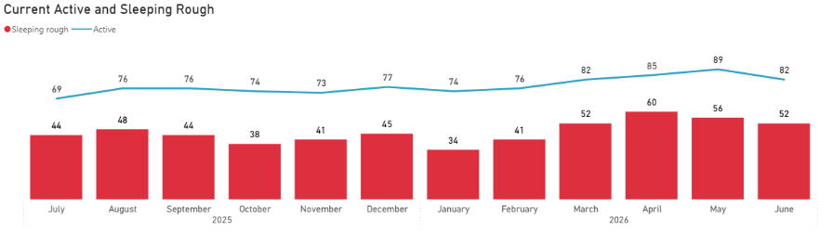
Yarra's Social and Affordable Housing Strategy outlines how Council seeks to increase the supply of social and affordable housing and address inequities in the local housing market. Council's current use of Section 173 agreements leverages opportunities to negotiate contributions of social and affordable housing stock in large-scale private developments.
The State government's demolition and redevelopment plans for the public housing towers in Yarra are underway. The high-rise at 139 Highett Street, Richmond, is the first in Yarra to be scheduled for demolition, along with the nearby low-rise housing at 111, 119 and 127 Elizabeth Street, 6 and 8 Anderson Court, 1–5, 7 and 9 Williams Court, Richmond. The last remaining renters are currently relocating.
Council continues to oppose the demolition through its advocacy to the Victorian Government.
A new Public and Community Housing Advisory Committee was established in late 2025 to provide a mechanism for community input into Council's strategic work on public, community and affordable housing. The Committee draws on members' lived experience, knowledge and networks to inform Council's understanding of local housing needs and broader housing policy issues. During 2025/26, the Committee considered a range of matters affecting public housing residents, including estate-level issues and resident concerns such as maintenance, parking, lighting, community safety, pet management, recycling services, tenancy support, rent settings, and the broader challenges associated with public housing redevelopment and its impacts on community.
The Collingwood Town Hall Affordable Housing project continues to progress. Community consultation about the lease or sale of the land was held in November and December 2025. In April 2026, Council resolved to proceed with an EOI process to select a development partner.

Strategic objective 2: Building the City

Car Share
Yarra currently has 183 car share bays across the municipality, unchanged from Quarter 3. This figure does not include car share bays located on private property.

Nine permits have recently expired and are progressing through the renewal process, while 128 permits are due for renewal in November 2026.

To better support car share services for the community, the application process has recently changed. Rather than being limited to two application rounds per year, car share providers can now submit applications at any time throughout the year for assessment. There is no formal permit renewal process, and providers may reapply at any time prior to their permit expiry.

The table below shows the top five popular locations within Yarra.

Top five locations
Richmond
Princes Hill
Clifton Hill
Collingwood
Abbotsford

Car share providers continue to promote and encourage the uptake of this alternative transport mode. However, the industry is experiencing increased challenges from car theft issues. It is likely that until this can be resolved, car share providers will withdraw permits following expiry at some locations being targeted.

Current status of applications in progress
There are currently two (2) applications in progress from car share providers. These are currently out for engagement with impacted nearby residents. An update on these applications will be provided for in the next Quarterly Community Report.

Capital Works

The redevelopment of the Brunswick Street Oval Precinct is moving forward at pace following an extensive State Government landowner approval process between January and early April 2026 and the official Ministerial ceremony in late May 2026.
The tennis court modernisation works commenced on site in June 2026, with the northern courts programmed for completion around December 2026, after which works will commence on the upgrade of the southern courts. The tennis court works will provide two brand-new courts, improve accessibility and lighting, and a full renovation of the six existing courts to bring them up to modern standards.
The tennis pavilion and clubhouse relocation contract has been awarded, with works scheduled to commence in Quarter 1 of the 2026/27 financial year and programmed for completion in February/March 2027. The work will support improved amenities for participants and better integration with the broader precinct upgrades.
The new two-storey sports pavilion project is progressing to tender, with release scheduled for July 2026. Contract award is anticipated in Quarter 2, with construction commencing on site following.
Construction activities and access arrangements will be managed to minimise community impacts and disruption. The staged approach allows key community facilities to remain operational where possible while enabling efficient delivery of upgraded sporting and recreation infrastructure across the precinct and adjoining public realm areas.

In 2025/26 Council invested $36.2m through its Capital Works Program. This included $2.75m of projects carried over from the previous financial year (2024/25).
Council continues to deliver capital projects that positively impact on our community, assets and infrastructure by:
- improving community safety and asset functionality
- increasing the life and reliability of assets
- increasing usability and efficiency
- addressing our community’s current and future needs.
A summary of the capital program delivery at the end of Quarter 4 (March to June 2026) is provided below.
Overall performance
The table below provides a summary of the projects completed to date. A total of $33.98m was spent by Quarter 4 successfully concluding the 2627 program.
Project Status | Year-To-Date totals  (Q1 to Q4)
Completed  (full scope) | 157
Carry forwards | 4
Cancelled/ deferred | 10

Infrastructure (including Open Space, Transport, and Stormwater)
This category includes planned renewals, and upgrades to open spaces, footpaths, roads, kerb and channel, drainage and cycling infrastructure across 140 projects.
At the end of Quarter 4, expenditure on the infrastructure category was $22.18m. A total of 76 projects were completed, some of which are listed below:
Completed Open Space projects
Projects completed in Q4
Charles Evans Reserve park upgrade - construction
Fairfield Park playground upgrade - construction
Merri Creek Parklands - Quarries Park playground design
Garryowen Reserve, Fitzroy
Burnley Depot security upgrade
Cremorne Street streetscape design
Linear Park Fitzroy North masterplan design
Synthetic Pitch to replace turf pitch at Bastow 2 at Kevin Bartlett Reserve Burnley - design
Annettes Place (River St Richmond) upgrade - design
Childcare centre playground works
Citizens Park, Richmond improvements
Design of Edwardes Place, Fitzroy North park renewal
Fletcher 1 pitch renewal at Kevin Barlett Reserve, Richmond design stage
Futsal Pitch at Atherton Gardens, Fitzroy design stage
George Knott, Clifton Hill sports lighting upgrade design
Golden Square Reserve, Burnley playground and garden bed and tree plantings - construction
Mayors Park Tennis and Netball Centre, Clifton Hill lighting upgrade design
Open space furniture renewal
Open space horticulture renewal
Open space irrigation renewal
Open space minor lighting renewal
Open space minor turf renewal
Open space playground renewal
Open space signage renewal
Open space walls and fences renewal
Quarries Park Clifton Hill dog park
Rewilding and planting of garden areas across the city
Roads to parks project feasibility and planning
Roads to Parks – Mater Street, Collingwood
Streetscape garden bed upgrades
Tree planting program
Electric vehicle chargers (design, investigation and delivery)
Smith Reserve electrical/ lighting works
Victoria Street Revitalisation
Memorial for staff member at Fitzroy Swimming Pool

Completed Roads projects
Projects completed in Q4
Church Street Abbotsford Intersection upgrade and Protected Bike Lanes – initial design
Cremorne Improvements - footpaths, fences, pram crossings etc.
Tree and road works in George Street, Fitzroy
Kerb and channel design works
Kerb build outs O'Grady and Canning Street at Carlton North Primary School (Carlton North)
Road, kerb and channel, footpath renewal Works - Green Street, Cremorne (Balmain to Adelaide)
Road, footpath, kerb and channel renewal works - Highett St, Richmond (Church St to Belgium)
Road and footpath renewal works - Highett St, Richmond (Davidson to Gardner Steet)
Road, footpath, kerb and channel renewal works - Highett St, Richmond (Egan Pl to Lennox Street)
Road renewal works - Highett St, Richmond (Gleadell Street to Coppin Street)
Urgent road renewal works (Road Services)
Elizabeth St Richmond Bike Lane modifications
Johnson Street / Victoria Street Richmond North intersection upgrade - Bicycle Safety Improvements
New Deal for Cycling - Building a better Elizabeth Street Richmond North
New Deal for Cycling - Building a better Coppin Street Richmond
Speed hump for Napier St, Fitzroy near Fitzroy Town Hall
Design and investigation work for future year delivery
Merri Creek Primary upgrade school crossing to wombat (Miller Street, Fitzroy North)
Mollison Street wombat crossings at Victoria Crescent (Abbotsford)
Victoria Street Abbotsford Improvements
Design Yarralea Street Alphington Pedestrian Crossing
New Deal for Cycling - Building a better Gipps St Richmond
Brockenshire St, Clifton Hill – Phase 1 Kerb and Channel
Kerb build outs O'Grady and Canning Street at Carlton North Primary School (Carlton North)
Road, kerb and channel, footpath renewal works - Green Street, Cremorne (Balmain to Adelaide)
Road, footpath, kerb and channel renewal works - Highett St, Richmond (Church St to Belgium)
Road and footpath renewal works - Highett St, Richmond (Davidson to Gardner Steet)
Road, footpath, kerb and channel renewal works - Highett St, Richmond (Egan Pl to Lennox Street)
Road renewal works - Highett St, Richmond (Gleadell Street to Coppin Street)
Urgent road renewal works

Completed Stormwater projects
Projects completed in Q4
Brick drain renewal - Little Abbots Street and Easey Street, Collingwood
Brick drain renewal - Nicholson Street, Abbotsford (Vere Street and Gipps Street)
Drainage improvement design - Cecil & Napier/ Westgarth Street
Drainage design - Richmond terrace, Richmond
Drainage upgrade project - St. Phillips Street (Gipps Street and Vere Street)
Drainage renewal project - Amess Street, Carlton North (Section 1)
Drainage renewal project - St David St, Fitzroy (Napier and George Street)
Drainage upgrade project - Tennyson Street, Richmond (Stewart Street and Tennyson Street)
Flood mitigation works - Michael Street, Fitzroy North
Minor works on brick drains and associated pits
Urgent drainage renewal works

Plant and Equipment
This category involves plant, machinery, and equipment renewals, along with the purchase of library books, computers, and telecommunications. There are 11 projects in this category.
At the end of Quarter 4, expenditure in this category was $1.42m. A total of seven projects were completed.
Completed Plant and Equipment projects
Projects completed in Q3
Desktop replacement to support delivery of services
Laptop replacement to support delivery of services
Network infrastructure replacement to support delivery of services
Parking technology upgrade project
Digital library collection renewal
Physical library collection renewal
Multimedia (AV/TV) to support delivery of services

Property (including Land and Buildings)
This category covering planned renewals, upgrades, and refurbishments across council-owned buildings and facilities, includes 46 projects with allocated funding in 2025/26. Year-to-date expenditure is $10.38m. Some of the projects that were completed during this quarter are listed below:
Completed Building projects
Projects completed in Q4
Yambla Pavilion Upgrade
Asbestos program
Bargoonga Nganjin Library security system renewal
Burnley Depot renewal
Closed Circuit Television (CCTV) renewal works
Children’s services minor buildings renewal works
Clifton Hill Depot renewal works
Collingwood Leisure Centre Improvements
Designs for future programs
Contaminated soil remediation
Electrification of small buildings
Fire indicator panels replacement
Fitzroy Town Hall risk mitigation and improvement works
Leisure plant/mechanical renewal works across all leisure centres
Plumbing renewals and inspections
Preliminary investigations for future works
Richmond Library renewals
Richmond Recreation Centre Improvements
Safe roof access
Air conditioning at Richmond Recreation Centre
Fitzroy Town Hall swipe cards for security
Yallabirrang Kindergarten
Leisure centre lockers and minor equipment
Bob Rose urgent remediation works
Open space for the garden next to Fitzroy Swimming Pool
Shade sail at Lord St, Richmond
Fitzroy Town Hall lighting for Council meetings

Major Q4 Adjustments
Budget adjustments are made throughout the financial year to respond to external and unexpected factors.

The following outlines key budget adjustments during Quarter 4.
- Leisure centre lockers and minor equipment renewal - $30K funded by program savings
- Bob Rose urgent remediation works - $150K urgent remedial works funded by program savings
- Open space for the garden next to Fitzroy Swimming Pool - $20K funded by program savings
- Edwardes Place Fitzroy North park renewal – $30K additional budget for the design and planning
- Mayors Park Tennis and Netball Centre, Clifton Hill lighting upgrade – $80K delivery of lighting improvements
- Shade Sail at Lord St, Richmond - $25K new budget from program savings
- Urgent drainage works - $100K additional to fund urgent drainage works
- Contaminated soil program – $100K additional budget for the program from Cubbys and Dill-de-bin
- Fitzroy Town Hall lighting improvements - $40K new budget to fund the lighting
- Memorial at Fitzroy Swimming Pool - $15K new budget funded by program savings
- Loughnan Oval Cricket Pitch – $10K grant funding to commence design and planning for construction the following financial year
- $181K new budget for the full reconstruction of asphalt footpath and bluestone kerb and channel on Brockenshire St, Clifton Hill.

Planning Scheme Amendments

City-Wide
Amendment C331 seeks to introduce live music precincts and individual music venues if not in a precinct into the Yarra planning scheme was adopted by Council on 16 December 2025. This amendment seeks to support local entertainment businesses and support a vital component of Yarra’s active night life.
Amendment C334 to reduce planning permit triggers for businesses and to simplify permit applications where permit triggers from State provisions exists was adopted by Council on 16 December 2025. The Amendment will also introduce exemptions for solar panels in heritage overlay areas to support sustainable outcomes, subject to conditions.
Amendment C335 to address administrative errors and undertake fix ups in the planning scheme was adopted by Council on the 16 December 2025.
Since Council’s adoption of the above three amendments, Council officers have submitted these to the Minister for Planning and have requested status updates.
A response for C334 has been received and officers are working through conditions to prepare exhibition. A response in relation to C331 and C335 is anticipated before September.
Officers continue to liaise with Melbourne Water and the Department of Transport and Planning regarding new flood provisions and how they will impact the community.
Council is waiting on access to the HCAP (Housing Capacity Assessment Platform) model informing Housing Targets but are progressing a Planning Scheme Review Report to be presented to Council in October 2026, as required by the Minister for Planning. Once Council has all the information from the State, any shortfall in dwelling capacity in the Yarra Planning Scheme will be assessed and a pathway for achieving Yarra’s housing target will be recommended.
Local-Area
The Standing Advisory Committee (SAC) hearing for Amendment C271 Fitzroy and Collingwood built form provisions took place on 8 April 2026 – 24 April 2026. A favorable SAC report has been received on 12 June and will be presented to the Council Meeting in July 2026.
A decision from the Minister for Planning on the translated Built Form Overlays for C291 Bridge Road / Victoria Street and C273 Heidelberg Road (presented to the Council Meeting on 12 May 2026) Is anticipated by August.
Amendment C318 Cremorne permanent built form provisions and the Urban Design Framework were publicly exhibited from 3 November to 8 December 2025. Officers have worked with the Transport arm of the Department of Transport and Planning to resolve concerns raised regarding the movement section of the urban design framework. A report to progress the amendment component of C318 is scheduled to be presented to Council in July 2026.
Officers are preparing an amendment to introduce individually significant places to the Heritage Overlay as an implementation action from the LGBTQIA+ Study, which is likely to be presented to Council in September 2026.

Statutory Planning Activity
During Quarter 4, Council received 328 applications and determined 299 applications (some of these were lodged in previous periods).

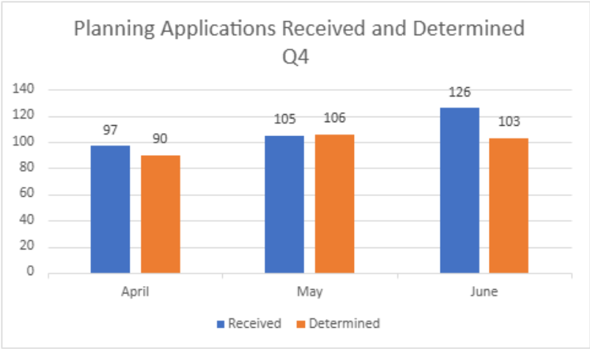

Timeframes
Council has two types of applications:
- Standard applications – 60 day statutory timeframe (inclusive of weekends and public holidays)
- VicSmart applications – 10 business day timeframe

During Quarter 4, Council determined 63% of its Standard applications within the 60-day timeframe and 100% of its VicSmart applications within the 10 business day timeframe. The table below shows monthly decision timeframes for the 2025/26 financial year:

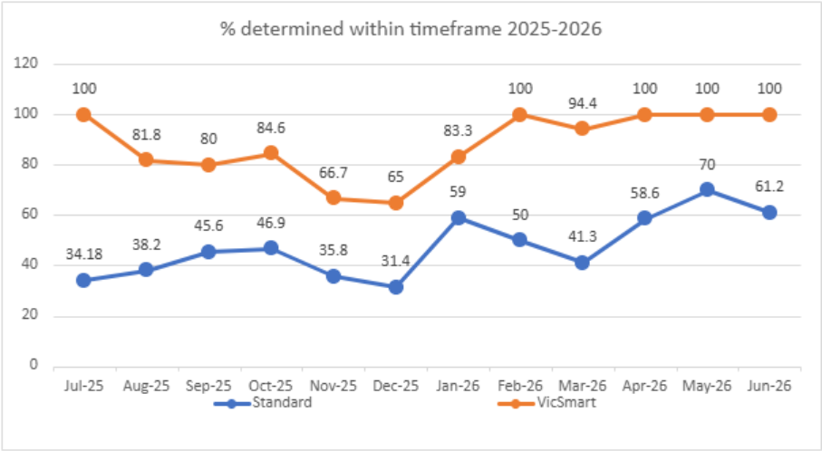

At the beginning of the 2025/26 financial year, Council commenced offering a dedicated service for business-related permits with the aim of improving timeframes for the issuing of planning permits for businesses. The table below shows the results for the 2025/26 financial year. On average, 84% of business-related permits were decided within the 60-day statutory timeframe.

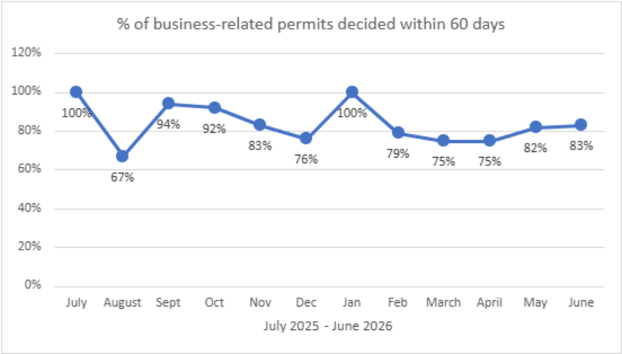

Statutory Planning – expired permits
Council has commenced reporting on the number of extensions granted to existing planning permits, as well as on the number of new dwellings that were approved under those planning permits.
The purpose of sharing this information is to draw attention to the many live planning permits that have not been acted upon to date, which could contribute to housing supply in the City of Yarra.
In Quarter 4, Council granted 39 extensions to planning permits (151 new dwellings were approved under the permits extended).

Statutory Planning - Social & Affordable Housing Approved
In Quarter 4, 188 new dwellings were approved by Council. None of these were social or affordable housing.
In Quarter 4, the Department of Transport and Planning approved a total of 243 new dwellings within the City of Yarra. The permits issued require a contribution of 10% affordable dwellings (unless an alternative contribution is proposed and accepted by the Minister for Planning). This equates to approximately 24 affordable dwellings.
Planning Application & Address | Total number of dwellings approved | Total number of social & affordable housing approved
PPE26/0074 - 165-167 Johnston St, Fitzroy | 243 | 10%

Statutory Planning – VCAT Activity
Appeals in Quarter 4 of 2025/2026
There were eleven applications that were referred to the Victorian Civil and Administrative Tribunal (VCAT) in Quarter 4 of 2025/26, five more than the same period of 2024/2025.
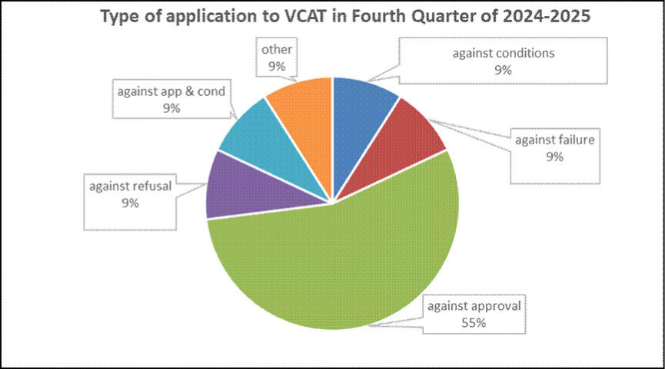
Total number of applications reviewed to VCAT: 11
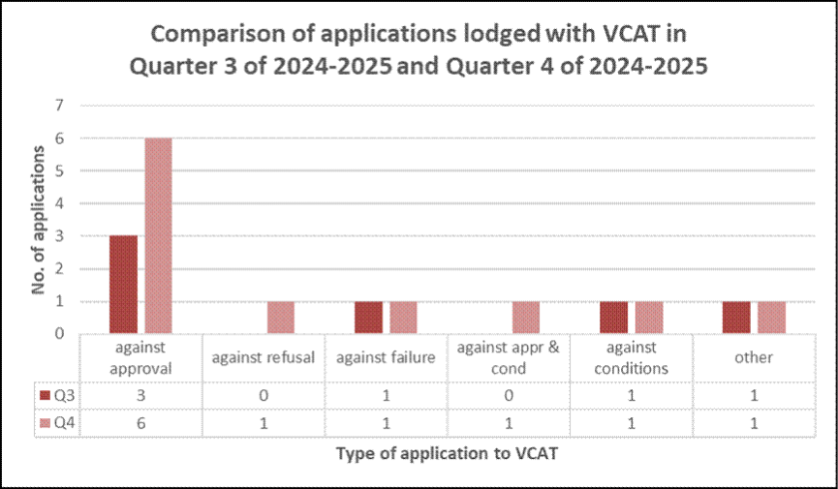
When comparing the type of applications reviewed with VCAT in Quarter 4 of 2025/2026 with the previous quarter, there were:
- 3 more applications ‘against approval’
- 1 more application ‘against refusal’
- the same number of applications ‘against failure’
- 1 more application ‘against conditions’
- the same number of applications ‘Other’.
The graph below shows the type of applications determined by VCAT in Quarter 4 of 2025/2026 and whether Council’s decision was affirmed, varied or overturned. A total of 12 decisions were made by the Tribunal.

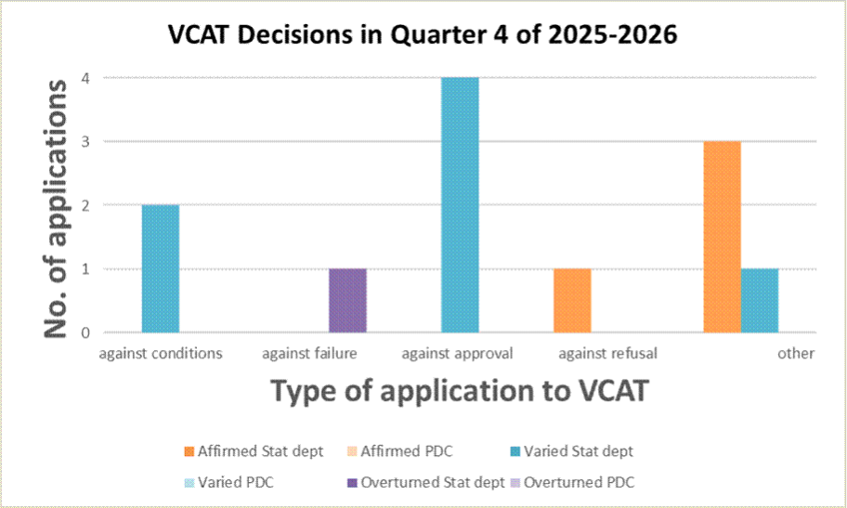
Of the 12 VCAT Decisions in Quarter 4 of 2025/2026:
- 4 x Statutory Department decisions affirmed
- 1 x PDC decisions affirmed
- 7 x Statutory Department decisions varied
- 1 x Statutory Department decisions overturned.
The graph below shows whether the VCAT decisions in Quarter 4 of 2025-2026 were via the consent of the parties.

VCAT Decisions in Q4 of 224/25 – consent / not via consent
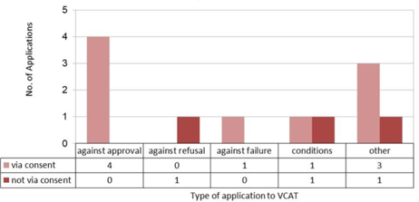

Of the 12 VCAT Decisions in Quarter 4 of 2025-2026, nine decisions (75%) were via the consent of the parties.

Appeals in Financial Year 2025-2026
There were 42 applications that were reviewed to VCAT in the financial year 2025/2026, 24 less applications than the previous financial year of 2024/2025.

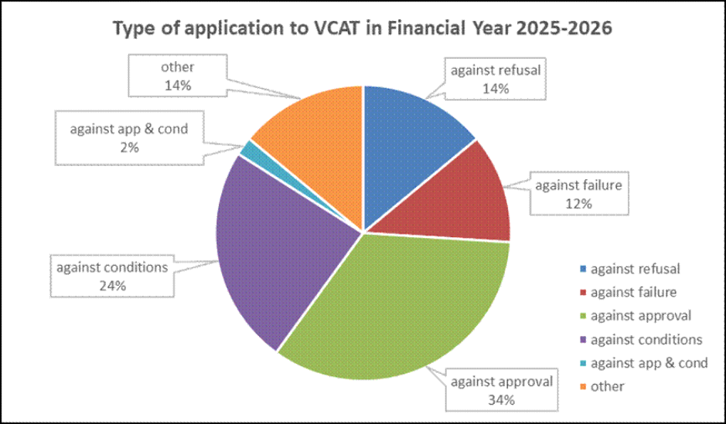 Total number of applications reviewed to VCAT: 42

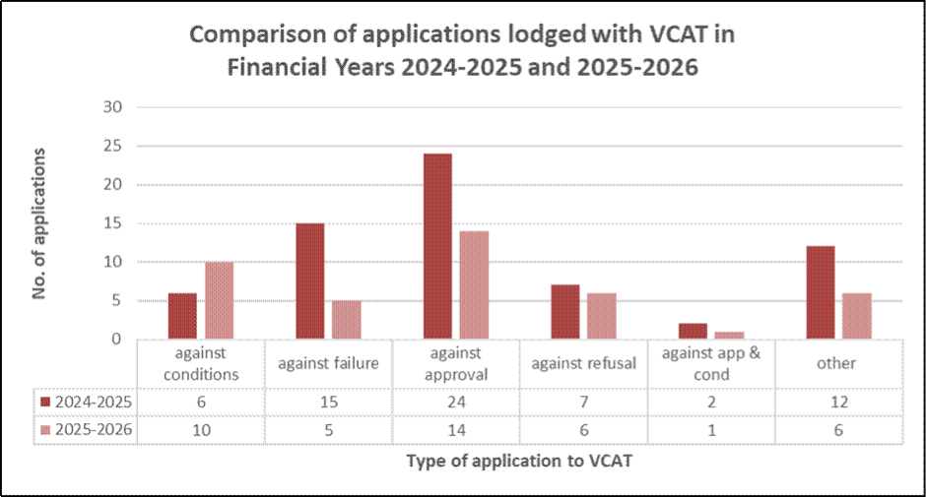
When comparing the type of applications reviewed with VCAT in the financial year of 2025-2026 with the previous financial year, there were:
- 4 more applications ‘against conditions’
- 10 less applications ‘against failure’
- 10 less applications ‘against refusal’
- 1 less application ‘against approval & conditions’
- 6 less applications ‘against Other’.
In the financial year 2025/2026, a total of 46 decisions were made by the Tribunal, plus four applications were withdrawn, and one application was remitted back to Council. 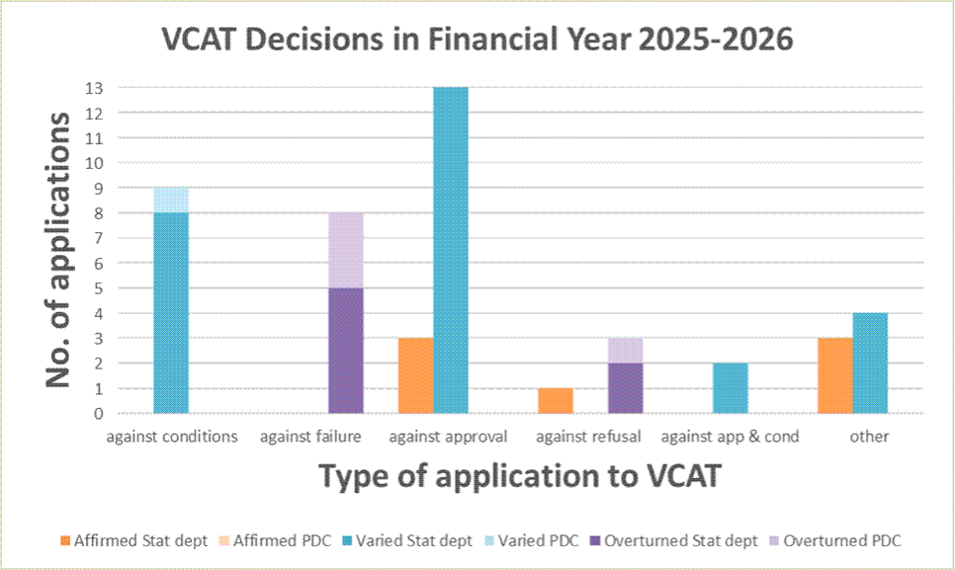
Of the 46 VCAT Decisions in the financial year of 2025/2026:
- 7x Statutory Department decisions affirmed
- 0x PDC decisions affirmed
- 27x Statutory Department decisions varied
- 1x PDC decision varied
- 7x Statutory Department decisions overturned
- 4x PDC decisions overturned.
The graph below shows whether the VCAT decisions in the financial year of 2025/2026 were via the consent of the parties. Of the 46 decisions in the financial year 2025/2026, 24 decisions (52%) were via the consent of the parties.

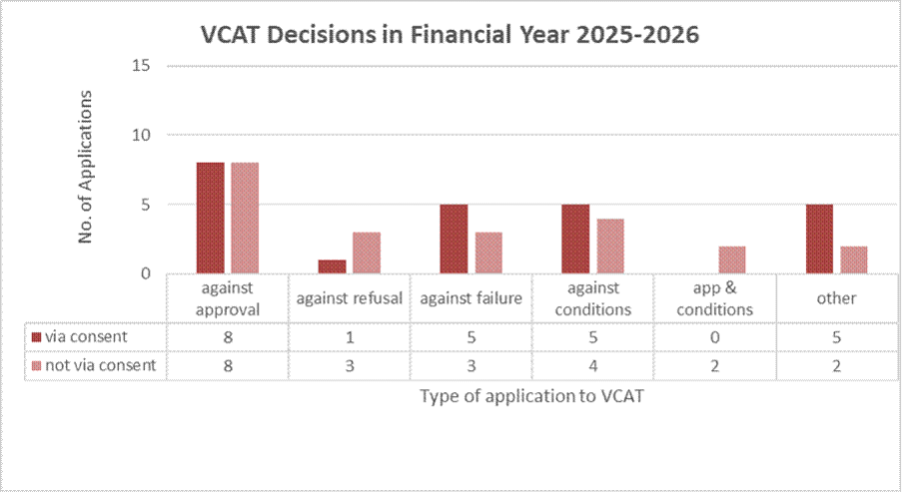
In summary, the financial year 2025/2026 has seen the total number of applications reviewed to VCAT (42) reduce by 24 applications compared to the previous financial year.
The number of applications for review against Council’s failure to determine the application within the prescribed time in the financial year 2024/2025 equates to 12% of all applications lodged (total five applications), which is 10 less applications compared to the previous financial year.

Statutory Strategic Planning Services Review Implementation
Statutory Planning
Review of processes has continued in Quarter 4 to find efficiencies to improve decision timeframes for simple matters. Report templates were reviewed and a revised allocation process introduced. Work also commenced reviewing report templates and procedures for matters that are reported to Council's Planning Decisions Committee. Work is also underway to continue to improve and promote the service provided to applicants for business-related planning permits, including new content for Council’s website.
Strategic Planning
The Strategic Planning website will continue to be updated; all heritage studies have now been uploaded. Officers ensured that information on recently adopted and progressed amendments is up to date (see Planning Scheme Amendments update for this quarter). A designated site relating to State Government planning reforms, including housing targets, has been published with the aim of providing the community with updates to the planning system implemented by the State, State Government projects | Yarra City Council.

Road Fatality and Injury Data
Council sources road fatality and injury data from the Road Crash Information System (RCIS), maintained by the Department of Transport and Planning. The Victorian Government applies a seven-month reporting lag to its public road crash and injury datasets, meaning RCIS is not updated in real time and may not capture all crashes that occurred during the reporting period. The Quarter 2 report included crashes up to 31 December 2025. Due to the seven-month reporting lag, no additional validated road crash and fatality data was available for inclusion in the Quarter 4 report. Crash data for the period 1 January 2026 to 28 February 2026 will be reported in the Quarter 1 2026/27 report once it becomes available.

Wellington Street - report on Council Meeting outcome

The Building A Better Wellington Street project is moving forward following the May 2026 Council resolution and the allocation of funding to progress further work in the 2026/27 Council Budget.
The Council resolution contained 17 potential tactical transport projects on Wellington Street to improve safety. These projects include lighting upgrades, measures to improve visibility for vehicles pulling out of side roads, upgrades to existing pedestrian crossings, the provision of new wombat crossings, bike head start lanterns at traffic lights, speed limit reductions, and the widening of bike lanes at intersections by narrowing traffic islands. There is also a commitment to undertake additional community consultation on potential turn bans at intersections subject to the outputs of further investigation and feasibility work.
Scoping of the above projects has now commenced and will inform concept design work, initial cost estimates and further advice to Council on feasibility/deliverability. Road Safety Audits, discussions with State Government approval agencies and additional data collection are other activities that will be undertaken as part of this process.
A detailed update will be provided to Council in Quarter 3 of the 26/27 financial year.

Strategic objective 3: Working and Playing in the City

Victoria Street Update

At the May 2026 Council meeting, Council approved a draft Victoria Street Revitalisation Plan for public exhibition and community feedback. The draft Plan was developed by engaging key stakeholders and the community, seeking expert advice, and incorporating ideas from a Community Reference Group made up of local residents and businesses.
Between 14 May and 7 June 2026, Council engaged more than 580 stakeholders through a mix of online surveys, face-to-face conversations, community events, and targeted outreach activities including a walking tour. We met with residents, businesses, community groups and visitors directly on Victoria Street and surrounding areas to gather a diverse range of perspectives, insights and feedback on the draft Plan.
A revised version of the Plan, incorporating this feedback, will be presented for consideration at a future Council meeting.
In parallel with this strategic work, we have delivered quick wins focused on improving safety and enhancing amenity within the precinct. Activities include replanting garden beds, graffiti removal, streetscape upgrades at Park and Charles Streets (including new seating, bike hoops and planting), installation of planter boxes for business operators, refreshed bins, roller doors and signage, as well as upgrades to lighting and footpaths.
On Saturday 20 June, the Vietnamese 50th Anniversary Commemorative Marker was unveiled in Butler Park, recognising the ongoing connection the Vietnamese community has to the Victoria Street precinct. Over 150 people gathered to celebrate the new artwork, Mythical Crane Boat by Van Phu Le. The artwork brings a new focus to the park, inviting people into the space to engage with the work and learn more about this significant anniversary and history of Yarra’s Vietnamese community. The new artwork will now be managed as part of Council’s Art and Heritage Collection.

Strategic objective 4: Running the City

Acquittal of Council resolutions

Council Meetings are the decision-making forum constituted under the Local Government Act 2020 where Councillors come together as a Council and are responsible for making decisions on behalf of the community.
Meetings are conducted in accordance with the Local Government Act 2020 and Yarra City Council Governance Rules.
Council decisions are made at meetings of the Council. These decisions are made by a resolution of the Council and actions are assigned accordingly.
The total number of resolutions refers to the tally of resolutions from Council meetings during the quarter.
This table shows a record of the Council resolutions for Quarter 4 of 2025/2026 financial year. Resolutions in progress refer to open resolutions where there are still actions that are currently in progress to be implemented.

Council Resolutions between 1 April 2026 – 30 June 2026
Total number of resolutions  allocated | Resolutions in progress -  April | Resolutions in progress -  May | Resolutions in progress -June | Total number of Resolutions in progress | % of Resolutions in progress
46 | 2 | 6 | 6 | 14 | 30%

Community Engagement Policy Adoption

Yarra’s new Community Engagement Policy was adopted at the Council Meeting on Tuesday 14 April 2026. The Policy was revised to align with the Yarra Council Plan 2025-2029, the Community Vision 2036, other legislative requirements and current best practice engagement. Community feedback helped to finalise the policy and shape the commitment statements guiding how Council will engage with traditionally harder to reach communities, as well as how Council will report back on engagement results. The Community Engagement Policy also contains an 'Engagement Matrix for Council activities' guide, which categorises the different types of projects undertaken by Council and outlines the engagement approach and typical engagement activities the community can expect for each category.
Council has updated the Your Say Yarra website look and feel as part of the implementation of the updated Community Engagement Policy, making the site simpler and easier to navigate.
Council has also commenced actioning on the Year 1 communities of focus by improving the demographic question on disability to ensure it is more inclusive and comparable to the questions in the Australian Bureau of Statistics Census.
In Quarter 4, Council also engaged or commenced engagement on the following projects:
- Safer Streets for schools - Princes Hill Primary School
- Roads to parks – Mater Street Stage 2
- Roads to parks – Budd Street Stage 2
- Draft Budget 2026/27
- Economic Development Stage 2
- Revitalising Victoria Street
- Rowena Parade – Road Safety Study
- Little Turner Street – Road Safety Study
- Waste and Recycling Strategy Stage 2
Participation from people living with a disability in the Roads to parks Mater Street and draft Budget consultations was higher than average. Council also created an Easy Read consultation page for the Universal Design and Disability Inclusion Policy consultation, using images and simple language, on the Your Say Yarra project page to encourage participation from people living with a disability.

Launch of "Yarra Decides" and cohealth outcome

Victorian Budget 2026-27
In its 2026/27 budget, the Victorian Government allocated $485,000 for the Richmond Youth Hub and Learning Bank on Victoria Street, and $100,000 to build a new cricket pitch at Kevin Bartlet Reserve. The Victorian Government also announced $1 million in upgrades to Spencley Street Primary School facilities, increased weekend services for Clifton Hill group train lines and week-night services for Burnley group train lines and the installation of tactile ground surface indicators at Clifton Hill train station. Council also secured a $150,000 grant to deliver a new school crossing outside Alphington Primary School on Yarralea Street, Alphington.
Yarra Decides Campaign
In May, Council launched the ‘Yarra Decides’ campaign, designed to raise community awareness of the challenges facing the City of Yarra, and the influence that community voices can have on local candidates in the lead up to the Victorian Election.
Council’s key asks of local candidates and an incoming government relate to much needed community infrastructure, open space, free community health services, affordable housing for key workers, and the importance of supporting the live music industry, just to name a few.
Campaign collateral is available to community members via Council venues and digitally through Council’s dedicated webpage - the Yarra Decides Hub.
Council will also host formal opportunities for the community to interact with candidates in the three months leading up to the election on 28 November 2026.
Saving community health services
Council has supported the community in its campaigning to prevent the closure of free community health services in Collingwood and Fitzroy since cohealth made its announcement in October 2025.
The community campaign has seen two major wins in recent months:
- In early May, the Federal Government announced it was providing $1.5 million in funding to keep cohealth services operational for up to 12 months while cohealth undertakes improvements to its operations with support from the North-Western Melbourne Primary Health Network.
- In early June, after months of pressure from Council and the community, the final report of the Independent Review of cohealth General Practice and related services was released.
However, this is once again only a temporary solution without guarantee of services continuing over the longer term. It also doesn’t address the future of the Collingwood site or the reintroduction of pharmacy and counselling services.
Council has been calling on both the Victorian and Federal Governments to respond formally to the Report’s recommendations. There is still no clarity on the specific actions required of cohealth, how these will be implemented, nor how cohealth will be held accountable for their implementation.
Council will continue to support community advocacy until the future of these vital free community health services is assured.

Financial Report
The Quarter 4 financial position reflects Council's continued commitment to responsible financial management and disciplined decision-making, consistent with the 2025/26 Annual Budget and the objectives of the Financial Sustainability Strategy (FSS).
Like all Victorian councils, Yarra continues to operate in a challenging financial environment characterised by rising costs, rate capping, cost shifting from other levels of government and increasing demand for services and infrastructure associated with population growth.
Councils across Victoria are also experiencing sustained cost pressures in areas such as infrastructure delivery, waste management, information technology, energy and employee costs. These pressures are driven by factors largely outside local government control, including supply chain constraints, labour market pressures, competition from major infrastructure projects and the increasing cost of service delivery.
Recent global economic uncertainty, including volatility in energy and fuel markets, has further contributed to financial risk and cost pressures across the sector.
Despite these challenges, Council has continued to strengthen its financial position while maintaining a focus on delivering services, infrastructure and strategic priorities. Council has previously highlighted the challenge of generating sufficient cash to fund future asset renewal without reliance on borrowing. This challenge has been amplified by reduced open space and developer contributions across the municipality at a time when infrastructure renewal and delivery costs continue to rise. Through the implementation of the Financial Sustainability Strategy, Council has continued to improve its financial resilience and capacity to respond to future challenges.
At 30 June 2026, Council's Risk Mitigation and Strategic Growth Reserves total $25.9 million. Of this amount, $17.9 million contributes directly towards Council's Financial Sustainability Strategy reserve targets, achieving approximately 90 per cent of Council's long-term target of $20 million, which is scheduled to be achieved within the next two years.

The remaining reserve balance has been set aside for known future commitments and emerging financial risks. This includes expenditure associated with the ERP program, which remains on track and within Council's approved budget envelope. As some project costs will occur later than originally anticipated, Council has transferred the associated 2025/26 timing variance to reserves to fund delivery in 2026/27.

The financial information and reports below demonstrate Council's continued progress in strengthening its financial position while maintaining prudent financial management. They present full-year actual results against the adopted 2025/26 budget and highlight the progress Council has made in improving its financial sustainability over recent years.
Quarter Four – Comprehensive Income Statement
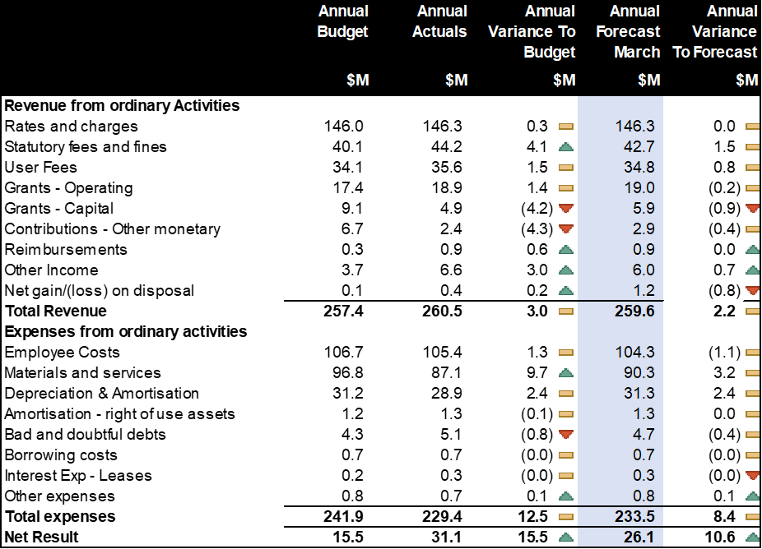
Summary Quarter Four Actuals to Forecast
Council has delivered a positive actual to forecast net result of $5.0 million, with the full year result increasing from the forecast of $26.1 million to an actual outcome of $31.1 million.
This stronger-than-anticipated outcome is attributable to a combination of increased revenue and lower expenditure across several areas.

Revenue
a) $1.5 million favourable in statutory fees and fines, primarily due to higher than anticipated infringement activity.
b) $0.8 million in additional user fees and charges.
c) Deferred capital grant revenue of $1.0 million, reflecting the revised timing of project completion and the associated recognition of grant funding in 2026/27.
d) Continued softening in development activity across the municipality, resulting in lower than anticipated open space and developer contributions.
Expenses
a) $3.2 million lower materials and services expenditure, primarily reflecting the timing of expenditure on the Enterprise Resource Planning (ERP) program and other strategic initiatives.
b) $0.8 million lower employee costs compared with forecast.
c) $2.4 million favourable depreciation expense, reflecting a revaluation of Council's assets and longer useful lives identified through condition assessments. This is a non-cash accounting adjustment and has no impact on Council's cash position.
d) The favourable variance from higher infringement activity was partially offset by increased Fines Victoria lodgement fees and higher provisions for doubtful debts associated with infringement debt recovery.

Summary Quarter Four Actuals to Budget
The full year net result of $31.1 million, an increase of $15.5 million to budget, is primarily attributable to the timing of expenditure on the Enterprise Resource Planning (ERP) program and the deferral of other information technology projects to align with the broader organisational transformation program. Additional contributing factors include lower depreciation expense following asset revaluations, which identified several assets as being in better condition than previously assessed, resulting in extended useful lives and reduced annual depreciation charges.
This result was achieved despite a challenging operating environment characterised by lower than anticipated development-related revenue, including open space and developer contributions, together with ongoing uncertainty associated with Multi-Enterprise Agreement negotiations across the local government sector.
While the ERP program remains a key strategic priority and is progressing on schedule and within the approved program budget envelope, some expenditure has occurred later than anticipated and will be carried forward into 2026/27 as delivery milestones are completed. In accordance with Council's Financial Sustainability Strategy, funds associated with this timing variance have been transferred to the Risk Mitigation Reserve and are expected to be drawn down in 2026/27 to support the continued delivery of the ERP program.
Revenue
- Rates and Charges
YTD performance is $0.314m favourable to budget, primarily driven by income from interest revenue expected from overdue payments $0.254m and supplementary valuations $0.255m.
- Statutory Fees
Performance is favourable to budget by $4.123 million. The favourable variances include $3.311 million from Parking Infringements, $0.720 million from Parking Meter Income and $0.337 million from Parking Permits. These favourable revenue outcomes were partially offset by increased lodgement costs payable to Fines Victoria and higher bad debt expenses associated with the collection and recovery of infringement notices, including provisions for amounts not expected to be recovered.
- User Fees
The favourable variance includes increased demand in Traffic and Civil Engineering of $1.604 million, stronger performance at Burnley Golf Course by $0.473 million, and an unplanned Fire Services Levy refund $0.550 million. Partially offset by lower utilisation of Children’s Services (-$0.458 million) and the Learn to Swim Program (-$0.404 million).
- Grants - Operating
The favourable variance in operating grant income is attributed to the timing of the VLGC grant ($1.045 million), School Crossing Supervisors unbudgeted grant income received for $0.444 million as well as other unbudgeted non-recurrent State grants $0.531 million (primarily relating to Combustible Cladding Services, Learning Bank and the 30km/h Trial).
- Grants – Capital
Unfavourable variances in capital grant income are driven by the rescheduled commencement of the Brunswick St Oval project (-$3.364 million) Yambla St Pavilion (-$1.360 million) and Destination Charging Across Victoria ($0.398 million). This was partly offset by grant income received for the Community Charge project $0.378 million.
Similarly, performance to Forecast is a result of rescheduled commencement of key capital works projects.
- Contribution – Other Monetary
Revenue from developer contributions is $4.265 million unfavourable reflecting slower-than-expected development activity across the municipality. This is mainly due to lower than anticipated Open Space Contributions of (-$4.260 million) but were partly offset by favourable Drainage Developer Contributions of $0.070 million.
- Reimbursement
The favourable variance of $0.636 million includes advance income received in Traffic Engineering from the previous financial year relating to Mollison Street $0.090 million, Engineering resource funding $0.113 million, Geater Western Water $0.326 million and Business Renewables Buying Group $0.109 million.
- Other Income
Favourable variance in other income is primarily attributable to higher interest income from term deposits of $2.617 million.
- Net gain on disposal of assets
The net gain on disposal of assets is favourable to budget, driven by proceeds from right-of-way (R.O.W) sales of $0.966 million and favourable outcomes were realised from fleet sales of $0.071 million following the cessation of private use agreements. This was offset by disposals related to upgrade works (-$0.619 million).
Expenses
- Employee Costs
Performance is $1.265 million favourable to budget, largely driven by $3.180m in salaried staff savings arising from a combination of higher than anticipated vacancy levels, timing of the EBA increment.
This was partially offset by the unbudgeted (grant funded) Childcare Workers Retention Payment ($1.002 million) and higher than planned Workcover premiums (-$0.371 million).
- Materials & Services
The favourable variance of $9.687 million is primarily driven by the rescheduling and rescoping of digital transformation projects of $3.748 million, the rescoping of software licensing requirements of $0.888 million, lower waste processing costs of $1.393 million resulting from reduced recycling and garbage tonnages, a $0.478 million favourable community-funding variance, principally reflecting provisions no longer required following revisions to the Nutrition and Social Inclusion Funding Agreements and the Yarra Community Grants Program, together with an unawarded Community Funding Agreement allocation and a modest small-grants underspend.
This was partially offset by higher-than-expected building maintenance works (-$0.948 million) and higher Fines Victoria lodgment costs (-0.842 million) resulting from stronger infringement income.

- Depreciation and amortisation
As per Yarra City Councils’ Non-Current Asset revaluation policy, all asset classes were required to be independently revalued. YTD variance of $2.377m is favourable to budget, primarily due to valuation adjustments in particular reassessment of Infrastructure asset values and useful lives from revaluation date onward ($1.932m).
- Bad and Doubtful Debts
Unfavourable variance of (-$0.799 million) is primarily driven by a higher level of parking infringement bad debts resulting from an increase in infringement notices issued (-$0.608 million).
Similarly, performance to Forecast is a result of asset values and estimated useful lives adjusted a s a result of annual revaluation of assets.
Quarter Four – Capital Works
Capital works performance
As at 30 June 2026, actual capital works expenditure totalled $33.98 million, representing 88 per cent of the adopted budget and 99 per cent of the final forecast, demonstrating a high level of delivery against the revised capital program. Planned carry-forward works total $3.27 million across four key projects, a moderate increase from $2.75 million in 2024/25.
Financial Results Summary | Annual  Budget | Annual  Actuals | Annual  Var to Budget | Annual  Budget | Annual Forecast | Annual  Var to Forecast
Financial Results Summary | $’000 | $’000 | $’000 | $’000 | $’000 | $’000
New asset expenditure | 9,069 | 5,551 | 3,518 | 9,069 | 6,020 | 3,049
Asset renewal expenditure | 14,877 | 15,748 | (871) | 14,877 | 15,193 | (316)
Asset upgrade expenditure | 14,567 | 12,679 | 1,889 | 14,567 | 12,983 | 1,584
Total capital works expenditure | 38,513 | 33,977 | 4,536 | 38,513 | 34,196 | 4,317

Quarter Four – Cash Position
At 30 June 2026, Council has total cash of $137.82m, of which $21.30m is funded by borrowings. Unrestricted and unallocated cash position is $44.58m, moving from $38.78m as at 30 June 2025.
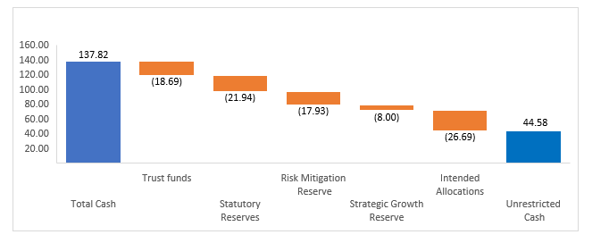

Quarter Four – Financial Sustainability Ratios
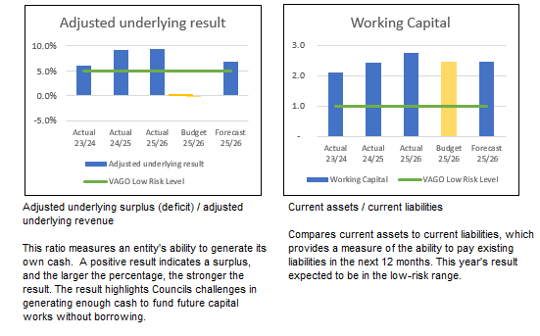
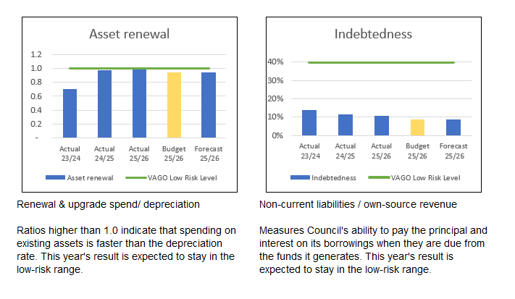

Treasury Corporation of Victoria (TCV) Loan financial covenants
TCV financing is conditional upon Council maintaining a sustainable financial position when measured by the interest cover and interest-bearing loans ratios. YTD results indicate that the Council meets the minimum requirements. TCV loan requirements are well within target given limited borrowing compared to own source revenue and liability obligations.

Quarter Four – Statement of Financial Position
* Draft financial results, subject to audit by the Victorian Auditor-General’s Office (VAGO) and require certification by Council and VAGO. The final certified result will be subject to any changes, recommended for agreed to by Council’s auditors

Quarter Four – Statement of Cash Flow
* Draft financial results, subject to audit by the Victorian Auditor-General’s Office (VAGO) and require certification by Council and VAGO. The final certified result will be subject to any changes, recommended for agreed to by Council’s auditors

Quarter Four – Statement of Capital Works
* Draft financial results, subject to audit by the Victorian Auditor-General’s Office (VAGO) and require certification by Council and VAGO. The final certified result will be subject to any changes, recommended for agreed to by Council’s auditors

Quarter Four – Operating Performance
Statutory Fees
Statutory fees and fines include infringement notices, parking permits and parking meter income. Current results are ahead of budget mainly attributed to improved management of operational environments.
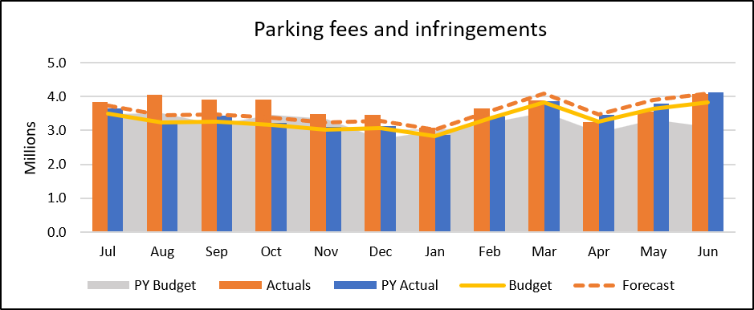

Recreation and Leisure Income
Recreation and leisure income for the year was behind last year's actuals however is on par with this years budget and slightly ahead of the full year forecast. This was driven by reduced Learn to Swim class uptake and reduced Pavillion and Facility Hire.
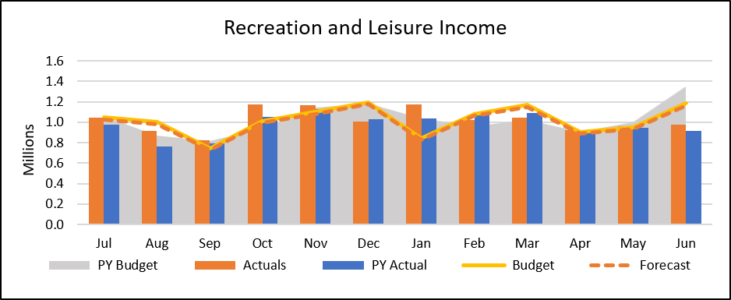

Rates Collection
The cash collections from rates are currently ahead of the average collections achieved in the last three years.
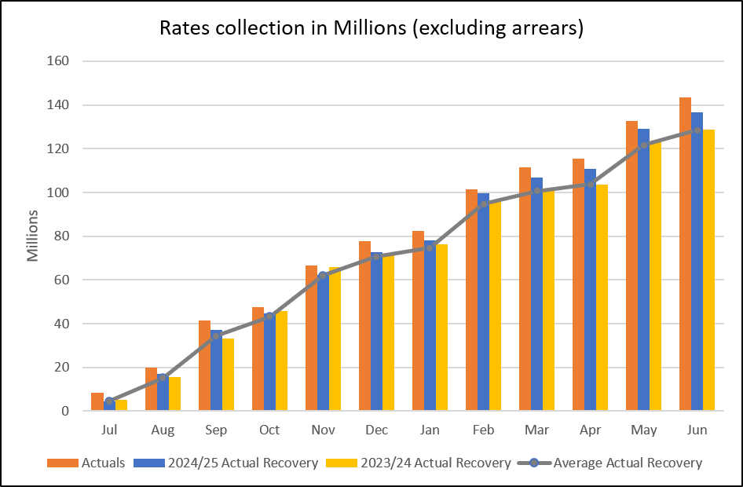

Parking Revenue

Parking revenue data for Quarter 4 of the financial year 2025/26 is provided below. It is intended to provide the community with an overview of parking revenue and identify trends or patterns.

Parking revenue is broken down into two categories:

- paid parking
- parking infringements.

Paid parking revenue includes income generated from both pay-by-phone (PayStay) and meter payments made by drivers.

Q4 Overall paid parking revenue

Total revenue for Quarter 4 decreased by 5.91% compared to Quarter 4 2024/25. The graph below shows however that the forecast for Quarter 4 was exceeded by 9.70%. Comparison of Quarter 4 figures for 24/25 and 25/26 are shown below detailing total paid parking revenue for this quarter decreased by $251,395.50:

- Quarter 4 2024/2025: $4,252,923.18
- Quarter 4 2025/2026: $4,001,527.68

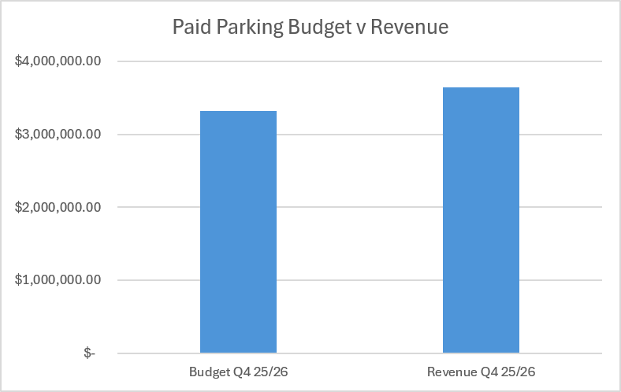
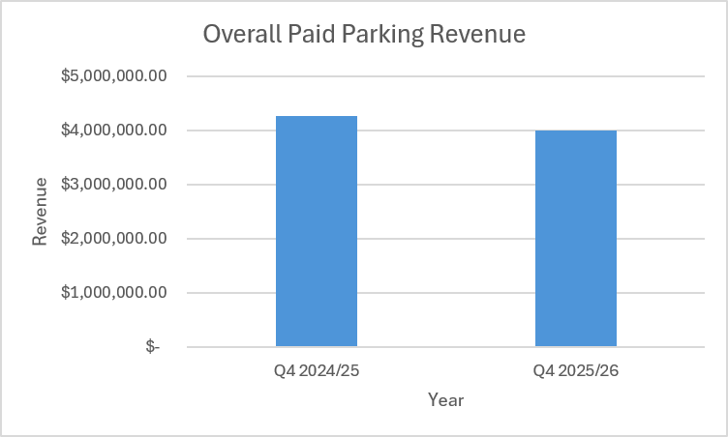

Quarter 4 Paid parking meters

The table below shows the parking meter data including revenue and time paid (or length of stay). A total of 290,601 transactions occurred during Quarter 4:

- Quarter 4 2024/25 Meter Revenue: $2,154,839.00
- Quarter 4 2025/26 Meter Revenue: $2,004,448.00
- Quarter 4 2024/25 Meter Transactions: 341,583
- Quarter 4 2025/26 Meter Transactions: 290,601

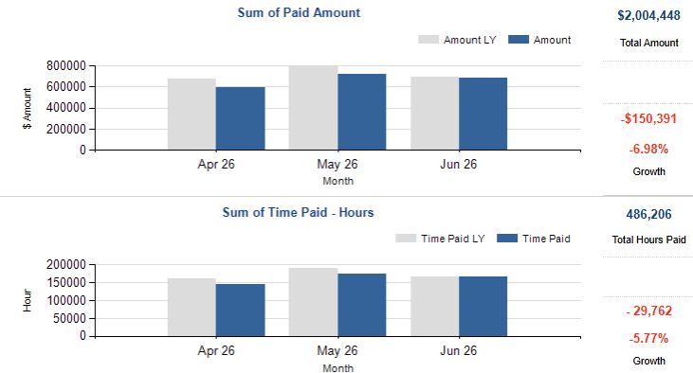
Quarter 4 Paid parking pay by phone
Pay by phone remains an active option for customers, and the data continues to show an increase in the number of transactions when comparing year on year Quarter 4 data (2024/25 to 2025/26):

- Quarter 4 2024/25 Pay by Phone Transactions: 400,742
- Quarter 4 2025/26 Pay by Phone Transactions: 436,454

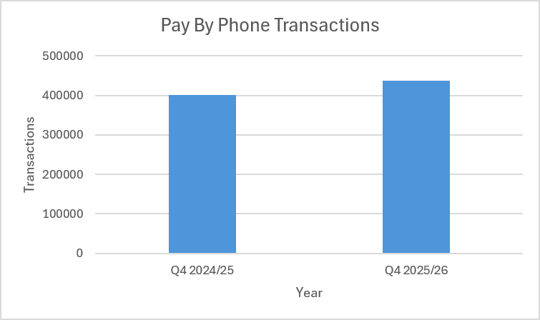

Revenue generated by pay by phone also shows a decrease when comparing year on year Quarter 4 data (2024/25 to 2025/26):

- Q4 2024/25 Pay by Phone Revenue: $2,098,084.18
- Q4 2025/26 Pay by Phone Revenue: $1,997,079.68

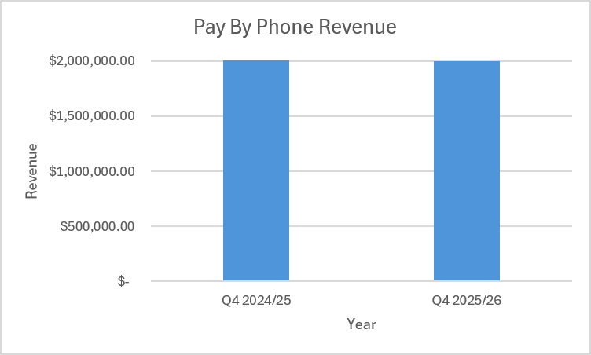

Quarter 4 Parking infringement revenue

Revenue from infringements issued during Quarter 4 shows a decrease when comparing year on year data over 2024/25 and 2025/26:

- Quarter 4 Infringement Revenue 2024/2025: $5,373,179.00
- Quarter 4 Infringement Revenue 2025/2026: $5,191,248.00

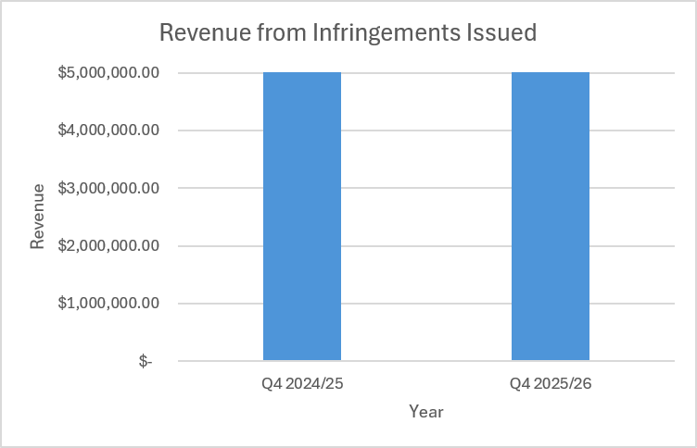
Activity Centre paid parking

Each shopping strip in Yarra is unique, influenced by a variety of factors such as the types of attractions and businesses located on the street. As a result, it is not possible to directly compare paid parking revenue across the business centres.

Several important variables to consider when looking at the various centres include different tariffs (hourly fee) applied across the centres, amount paid for on-street parking, and breadth of hours that paid parking is in effect.

A twelve-month trial of free one-hour parking in Richmond commenced on 1 July 2025. This trial is occurring on Bridge Road, Swan Street, and Victoria Street. A report regarding conclusions from this trial will be presented to Council in September.
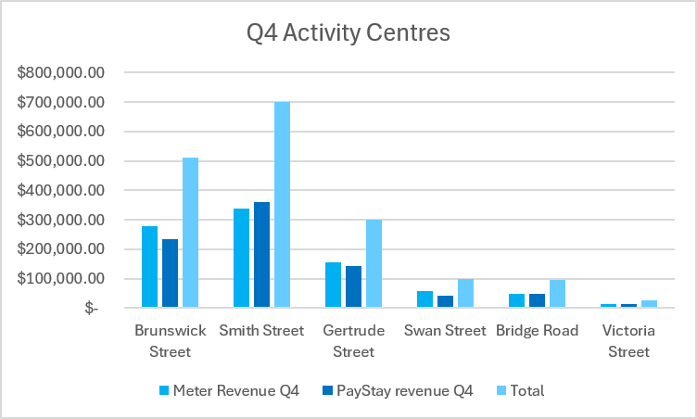

Council Plan Action Plan performance

Council adopted its 2025–2029 Council Plan on 17 June 2025. The Council Plan articulates the medium-term strategic direction of Council and outlines the key outcomes that Councillors aim to achieve during their four-year term.
The 2025–2029 Council Plan has four Strategic Objectives that align with the Community Vision and define the strategic direction of Council. At the June 2025 Council Meeting, Council also adopted the 2025/26 Council Plan Action Plan and 2025/26 Budget. Together, the Action Plan and Budget operationalise the Council Plan by turning medium term goals into achievable shorter-term work of the Council.
The 2025/26 Action Plan identifies initiatives under each Strategic Objective which are significant projects that Council will undertake towards achieving the Strategic Objectives in the Council Plan. This financial year, the Action Plan included 26 actions and related milestones that demonstrate Council’s commitment to delivering meaningful outcomes for the community.
At the end of June 2026, overall performance reached 97%, exceeding the performance target of 75%. To meet the performance target, actions must achieve 75% or higher of their target.

Action summary by performance:
- 22 Actions (85%) On track - At least 90% of target achieved
- 3 Actions (12%) Monitor - Between 75% and 90% of target achieved
- 1 Actions (3%) Off track - Less than 75% of target achieved.

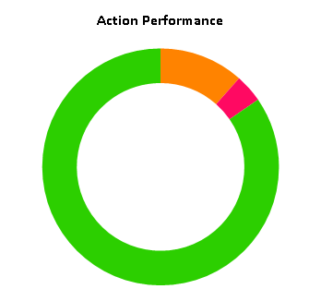

 | (43%
  1
  Off track (Less than 75% of action target achieved)
 | (12)%
  3
  Monitor (Between 75% and 90% of action target achieved)
 | (85)%
  22
  On Track (At least 90% of action target achieved)
 | (0)%
  0
  Not Applicable (Actions with no target set)

Annual Plan 2025/26 Progress Q4

Living in the City

Action Title: 1.1.2.1 Year 2 Climate Emergency Plan Implementation
Status: In Progress – Green
Completion Percentage: 99%
Target Percentage: 100%
Action Progress Comments: The Climate Emergency Plan Annual Report 2025/26 will provide an update on the implementation of Year 2 of the Climate Emergency Action Plan 2024-2027 and the impact of these actions as measured by the Climate Emergency Plan indicators. This annual report will be published on Council’s website and highlights will be included in Council’s Quarterly Community Report.
The Yarra Home Energy Upgrade Program 2025/26 is complete. This year the program supported 45 households at risk of climate impacts who face barriers to installing home energy upgrades.
The program delivered 71 home energy upgrades to the 45 households, including: draughtproofing, reverse cycle air conditioning, hot water heat pumps, ceiling insulation, honeycomb blinds, other upgrades including switchboard upgrades, electrical compliance works, downlight replacement, carbon monoxide detector, and decommissioning gas heaters. 20 households received more than one upgrade.

Action Title: 1.1.3.1 Conduct a localised Community Safety Audit
Status: Completed – Green
Completion Percentage: 100%
Target Percentage: 100%
Action Progress Comments: Findings from the localised Crime Prevention Through Environmental Design (CPTED) investigation have been finalised.

The investigation identified priority safety, amenity and public realm issues within the southern Brunswick Street corridor and adjacent streets, including opportunities to improve lighting, visibility, passive surveillance, pedestrian movement and environmental conditions. This work was informed by specialist CPTED advice, engagement with key local stakeholders, and work with CitiPower on lighting-related considerations.

The findings will inform targeted implementation planning through the FY26/27 CPTED capital allocation. The next stage will focus on confirming a practical first phase of works, including feasibility, costing, stakeholder engagement and cross-divisional delivery planning, so that available funding is directed to locations and actions where risk, evidence, Council control and deliverability align.

Action Title: 1.2.1.1 Minor Richmond Library renewal works with business case for major redevelopment of the Library
Status: Completed – Green
Completion Percentage: 100%
Target Percentage: 100%
Action Progress Comments: The business case, containing multiple concept options was presented to Councillors for consideration. Each of the options contained massing plans and cost plans to assist Council in determining the next steps for the Richmond Library project.
Richmond Library’s minor works project delivered targeted upgrades to improve functionality, accessibility and user experience, including lighting enhancements, updated signage, staff facility upgrades and various smaller improvements such as furniture, CCTV monitor, acoustic panels, reception desk works, and coordinated maintenance repairs across the site.
Council has made provision in its 26/27 budget to progress a feasible proposal at the site – either to progress a major development or continue to make modest improvements and upgrades. Ongoing Councillor engagement is planned.

Action Title: 1.2.3.1 Kindergarten Infrastructure and Services Plan for Yarra
Status: Completed – Green
Completion Percentage: 100%
Target Percentage: 100%
Action Progress Comments: The Kindergarten Infrastructure and Services Plan for the Yarra municipality has been finalised and co-signed by Council and the Victorian Department of Education. It will be posted online by the Department of Education.

Action Title: 1.2.4.1 Design and delivery of programs arising from the New Municipal Public Health and Wellbeing Plan
Status: Completed – Green
Completion Percentage: 100%
Target Percentage: 100%
Action Progress Comments: The Social Connection and Belonging Guide, key initiatives of the Municipal Public Health and Wellbeing Plan, was completed and launched at Finbar Neighbourhood House on 23 June, supported by a community celebration event attended by the Mayor, Councillors and key project partners. The guide brings together local activities, volunteering opportunities, community spaces, services and wellbeing supports to help residents find practical pathways to connection and participation. The launch also highlighted Council’s partnership with Ending Loneliness Together and the rollout of Social Connection Literacy training for staff, volunteers and community organisations.
The updated Community Food Guide suite has also been completed in English, with mapping undertaken across food relief, community meals, markets and fresh produce, food education and community gardens. The guide includes information on local providers, locations, available supports, access conditions and timing, helping residents identify affordable food options and food relief pathways across Yarra. Translated versions are still to come, with a new interactive online portal and map planned for release in the new year.

Building the City

Action Title: 2.1.1.1 Progress New Deal for Cycling corridor projects
Status: In Progress – Amber
Completion Percentage: 75%
Target Percentage: 100%
Action Progress Comments:
Council has delivered and continues to work on a number of improvements to the cycling network:
Elizabeth Street: Bike lanes have been constructed.
Wellington Street: Council determined next steps for this project at its meeting in May 2026. Further work will be completed in the 2026/27 Financial Year.
Langridge and Gipps Streets: Community engagement on this project has been delayed and is now scheduled to commence in early 2026/27 Financial Year.
Coppin Street: Community engagement for Stage 1 was completed, this project has not been funded to progress to Stage 2 of community engagement.

Action Title: 2.1.2.1 Progress the preparation of a Kerbside and Parking Strategy
Status: In Progress – Green
Completion Percentage: 91%
Target Percentage: 100%
Action Progress Comments: Preliminary investigations and background work have been completed within the current financial year. The next phase of the project, including preparation of a draft strategy and suite of policies and community engagement, will be undertaken during the 2026/27 financial year.

Action Title: 2.1.3.1 Update the Transport Action Plan and implement
Status: In Progress – Red
Completion Percentage: 71%
Target Percentage: 100%
Action Progress Comments:
The preparation of a new Transport Action Plan has been paused, a new approach to determining project is being formalised that includes a range of Council priorities that projects will be assessed against. This will lead to a more cohesive consideration of transport and safety projects across Council.

Action Title: 2.2.1.1 Strategic Planning Agility: Implementing the State Government’s housing target and activity centre program
Status: In Progress – Green
Completion Percentage: 96%
Target Percentage: 100%
Action Progress Comments: Background analysis for identifying strategic redevelopment sites and assessing their suitability has been completed. Engagement with the State Government will continue to progress discussions on potential sites and precincts, subject to collaboration outcomes.

Action Title: 2.2.4.1 Reactivate the Collingwood Town Hall precinct housing proposal
Status: Completed – Green
Completion Percentage: 100%
Target Percentage: 100%
Action Progress Comments: Planning for the future of the Collingwood Town Hall precinct is progressing well. Community consultation has been undertaken, and a consultant is being appointed to support the development of an expressions of interest process. At the same time, early market testing with community housing organisations and developers is taking place to ensure the project is viable and delivers strong benefits for the community. Council will shortly consider whether to proceed to the next phase of the project.

Action Title: 2.3.3.1 Finalise the Community Infrastructure Plan
Status: Completed – Green
Completion Percentage: 100%
Target Percentage: 100%
Action Progress Comments: The initial stages of the Developer Contributions Plan is in review, which will consider the impact of the State Government’s proposed infrastructure contributions plan reform. Milestones for this work are completed for this financial year, and the project will continue into the 2026/27 financial year.
The State Government has commenced engagement with Council on the infrastructure contributions plan reform as part of the Train and Tram Activity Centre Program. Council has provided an officer submission to the draft Infrastructure Contributions Plan.

Action Title: 2.3.4.1 Strategic rollout of electric vehicle charging stations across Yarra
Status: Completed – Green
Completion Percentage: 100%
Target Percentage: 100%
Action Progress Comments:
Council has continued to Increase options for EV charging across the City:
- In June, Council launched 26 locations of pole mounted EV chargers across the municipality. This represents the most pole mounted chargers of any Victorian council.
- In April, a new neighbourhood battery and dual public EV charger were launched outside Collingwood Leisure Centre in Clifton Hill, delivered by the Yarra Energy Foundation with support from Yarra City Council and funded through a Victorian Government grant. The project includes a 60 kW EV charger with two wheelchair-accessible charging bays.
- Council officers have also been engaging with Councillors around the strategic EV charging direction, and incorporation into a Kerbside and Parking Strategy.

Action Title: 2.4.1.1 Continuation of the Brunswick Street Oval Project
Status: In Progress – Amber
Completion Percentage: 80%
Target Percentage: 100%
Action Progress Comments: The redevelopment of the Brunswick Street Oval Precinct is moving at pace following an extensive State Government landowner approval process between January and April 2026 and the official Ministerial ceremony in late May 2026.
All permits and statutory regulatory approvals have been obtained, and key enabling and construction packages have advanced across the eight works packages. The tennis court modernisation works have commenced on site, with construction activities to deliver the tennis pavilion and clubhouse relocation programmed to commence in early Quarter 1 of 2026/27. The new two-storey sports pavilion project is planned to go to tender in July 2026, with construction planned to commence later in 2026.

Action Title: 2.4.1.1 New Open Space
Status: In Progress – Green
Completion Percentage: 98%
Target Percentage: 100%
Action Progress Comments:
The contract of sale for Mater St Collingwood has been executed, and officers are progressing the subdivision process. Upon finalisation of the subdivision plan, settlement will occur and the land will be transferred to Council. In parallel, the road discontinuance process for the adjacent Mater St Collingwood has now been completed.
Wangaratta Street, Richmond:
The acquisition has been completed. The subdivision process has been finalised, and any associated road discontinuance considerations are complete.
Budd Street, Collingwood:
The road discontinuance process has been completed, resulting in the creation of an additional parcel of open space for the local community in Collingwood.

Action Title: 2.4.1.2 Deliver Capital Works Projects
Status: In Progress – Green
Completion Percentage: 95%
Target Percentage: 100%
Action Progress Comments:
Council has delivered 95% of its capital works program in 2025/26. Some of these achievements include significant road renewal, drainage upgrades, sport and recreation improvements, open space upgrades and renewals, electric charging stations, footpath renewals, tree planting and garden bed improvements, play space upgrades, library resources, information technology equipment, public art installations, community safety upgrades, aquatic centre improvements, furniture renewals and kindergarten upgrades.

Working and Playing in the City

Action Title: 3.1.2.1 Activate our local economy by working with local trader group and associations
Status: Completed – Green
Completion Percentage: 100%
Target Percentage: 100%
Action Progress Comments:
Officers have continued to support trader led activations in retail precincts across Yarra with the event planning for LOJO festival initiated with traders for an upcoming event in the Lower Part of Johnston Street and the ‘Every day Nicholson’ marketing campaign kicking off for the Nicholson Street traders.
Officers have completed the final precinct audit specifically for the one-hour free parking pilot program and an additional precinct as a benchmark. Promotion of the pilot program has continued with businesses, residents, and the wider community.
The one-hour free parking project has involved collaboration across multiple teams, supported by independent research to gather and analyse relevant data. This work is helping to assess the effectiveness of the trial and inform future decision-making. The analysis is expected to be completed in August, with findings to be presented to Council in September 2026.

Action Title: 3.2.2.1 Implement planning service review outcomes
Status: Completed – Green
Completion Percentage: 100%
Target Percentage: 100%
Action Progress Comments:
Work continues on reviewing the website and associated public information materials, with the latest updated content being drafted to reflect the State Government’s planning reforms including Activity Centre programs and how they impact Yarra. Efforts to find efficiencies in processes are having a positive impact on decision timeframes. In the first half of 2026, decision timeframes have improved, with 63% of decisions made within statutory timeframes, compared to 45% of decisions made within statutory timeframes in 2025.

Action Title: 3.2.3.1 New Economic Development Strategy
Status: Completed – Green
Completion Percentage: 100%
Target Percentage: 100%
Action Progress Comments:
The draft Economic Development Strategy was placed on public exhibition in May 2026, with a variety of engagement activities provided, including direct engagement with the Business Advisory Committee, Your Say Yarra online community survey, online industry workshops, two drop-in sessions and more. Feedback has been considered and the final strategy will be presented at the August Council meeting for endorsement.

Action Title: 3.2.3.2 Urban Renewal Strategy for Victoria Street
Status: In Progress – Green
Completion Percentage: 97%
Target Percentage: 100%
Action Progress Comments: At the 12 May 2026 Council meeting, Council approved a draft Victoria Street Revitalisation Plan to go on public exhibition for community feedback. The draft Plan aligned with the key milestones and actions outlined in the April 2025 resolution by engaging with key stakeholders, seeking expert advice and incorporating the ideas of the Community Reference Group (CRG) and the broader community.

Running the City

Action Title: 4.1.1.1 Implement recommendations from the Financial Sustainability Strategy
Status: In Progress – Green
Completion Percentage: 93%
Target Percentage: 100%
Action Progress Comments: A Procurement Policy is essential as it sets the principles and processes to ensure all purchasing is conducted legally, transparently and aligned with Yarra’s long term social, environmental and economic goals with value for money at the core. Council is currently reviewing the adequacy of its procurement settings to ensure they best reflect strategic direction for annual procurement. This review remains on track.
The Financial Sustainability Advisory Committee has met twice since its appointment and is currently progressing its review of the Financial Sustainability Strategy which is well underway.
Draft development of the 2026/27 Budget and Financial Plan is underway and progressing on schedule, with community engagement insights to be incorporated into the final budget.

Action Title: 4.1.2.1 Local Law Review
Status: Completed – Green
Completion Percentage: 100%
Target Percentage: 100%
Action Progress Comments: The new draft Community Local Law was adopted by Council on 9 June 2026 with an alternative motion following stage two engagement.
The Community Local Law has now been adopted, and work will now progress to ensure it is implemented by 1 September 2026.

Action Title: 4.1.3.1 Develop the Benefits Management Framework
Status: In Progress – Green
Completion Percentage: 95%
Target Percentage: 100%
Action Progress Comments: There are no scheduled milestones to report for this quarter.

Action Title: 4.2.1.1 Development of a Waste and Recycling Strategy
Status: In Progress – Green
Completion Percentage: 90%
Target Percentage: 100%
Action Progress Comments:
The draft strategy was presented to Council and released for a second stage of community consultation in June 2026. Following the consultation period, officers will review the community feedback and make any necessary amendments to the draft strategy to ensure it reflects the views and priorities of the community. Council will be asked to adopt the final strategy later in 2026.

Action Title: 4.3.1.1 Implement the Yana Ngargna Policy and increase and strengthen partnerships with Aboriginal Controlled organisations
Status: In Progress – Green
Completion Percentage: 95%
Target Percentage: 100%
Action Progress Comments: Delivery of the emerging Yana Ngargna Policy framework has taken longer than planned, with targeted engagement paused based on feedback. Targeted engagement is set to resume in Quarter 1 2026. Engagement continued with Wurundjeri on the Whole of Country Plan 2025-2035, Yana Ngargna Advisory Committee advice was sought on the Council’s policy framework, Leaps and Bounds, NAIDOC, grants and Sorry Day planning; Walk for Truth support; Sorry Day delivery; and VACCHO Cultural Festival planning.

Action Title: 4.5.1.1 Commence implementation of an Enterprise Resource Planning technology system
Status: In Progress – Amber
Completion Percentage: 96%
Target Percentage: 100%
Action Progress Comments: The Program Release One is tracking on time and to budget allocations. The delivery phase of the project has commenced, tracking to go live at the end of February 2027.

Action Title: 4.5.1.2 Improve Customer Experience
Status: In Progress – Amber
Completion Percentage: 77%
Target Percentage: 100%
Action Progress Comments: The initiative to pilot AI-driven solutions that capture real-time customer feedback, measure satisfaction, and fast-track system improvements has been deferred pending the development of the AI Strategy and the identification of pilot AI use cases, scheduled for the next financial year.

