Yarra City Council

2025/26 Quarterly Community Report

Quarter 3
Contents
Yarra City Council 1
2025/26 Quarterly Community Report 1
Quarter 3 1
CEO Message 5
Quarter 3 Report 7
Strategic objective 1: Living in the City 7
Municipal Public Health and Wellbeing Plan – Implementation 7
Neighbourhood House Partnership Framework 8
Strategic objective 2: Building the City 9
Car share 9
Capital works 9
Major Q3 adjustments 11
Feature projects 13
Collingwood Leisure Centre 13
Fairfield playground upgrade 13
Wombat crossings across the municipality 14
Planning scheme amendments 14
City-Wide 14
Local-Area 14
Statutory planning activity 15
Statutory planning – expired 16
Statutory planning – VCAT activity 16
Statutory planning – social and affordable housing approved 19
Strategic planning Services Review implementation 20
Statutory Planning 20
Strategic Planning 20
Strategic objective 3: Working and Playing in the City 21
Activity centre utilisation 21
Arts update 21
Vietnamese Commemorative Marker 21
Strategic objective 4: Running the City 23
Acquittal of Council resolutions 23
Advocacy update 24
Community engagement update 25
Domestic Animal Management Plan update 26
Financial report 27
Quarter Three Forecast 28
Comprehensive Income Statement 29
Revenue 30
Expenses 32
Capital Works 33
Cash Position 34
Financial Sustainability Ratios 35
Adjusted underlying surplus (deficit) / adjusted underlying revenue 35
Treasury Corporation of Victoria (TCV) Loan financial covenants 37
Statement of Financial Position 38
Statement of Cash Flow 39
Statement of Capital Works 40
Operating Performance 40
Financial Sustainability Strategy 42
Parking revenue 43
Quarter 3 Paid Parking Revenue 43
Quarter 3 Paid parking meters 44
Quarter 3 Paid parking pay by phone 44
Quarter 3 Parking infringement revenue 46
Activity Centre paid parking 46
Council Plan Action Plan performance 48
Action summary by performance: 48
Living in the City 50
Action Title: 1.1.2.1 Year 2 Climate Emergency Plan Implementation 50
Action Title: 1.1.3.1 Conduct a localised Community Safety Audit 50
Action Title: 1.2.3.1 Kindergarten Infrastructure and Services Plan for Yarra 51
Action Title: 1.2.4.1 Design and delivery of programs arising from the New Municipal Public Health and Wellbeing Plan 51
Building the City 52
Action Title: 2.1.1.1 Progress New Deal for Cycling corridor projects 52
Action Title: 2.1.2.1 Progress the preparation of a Kerbside and Parking Strategy 52
Action Title: 2.1.3.1 Update the Transport Action Plan and implement 52
Action Title: 2.2.1.1 Strategic Planning Agility: Implementing the State Government’s housing target and activity centre program 53
Action Title: 2.2.4.1 Reactivate the Collingwood Town Hall precinct housing proposal 53
Action Title: 2.3.3.1 Finalise the Community Infrastructure Plan 53
Action Title: 2.3.4.1 Strategic rollout of electric vehicle charging stations across Yarra 53
Action Title: 2.4.1.1 Continuation of the Brunswick Street Oval Project 54
Action Title: 2.4.1.1 New Open Space 54
Action Title: 2.4.1.2 Deliver Capital Works Projects 55
Working and Playing in the City 55
Action Title: 3.1.2.1 Activate our local economy by working with local trader group and associations 55
Action Title: 3.2.2.1 Implement planning service review outcomes 55
Action Title: 3.2.3.1 New Economic Development Strategy 56
Action Title: 3.2.3.2 Urban Renewal Strategy for Victoria Street 56
Running the City 56
Action Title: 4.1.1.1 Implement recommendations from the Financial Sustainability Strategy 56
Action Title: 4.1.2.1 Local Law Review 57
Action Title: 4.1.3.1 Develop the Benefits Management Framework 57
Action Title: 4.2.1.1 Development of a Waste and Recycling Strategy 57
Action Title: 4.3.1.1 Implement the Yana Ngargna Policy and increase and strengthen partnerships with Aboriginal Controlled organisations 58
Action Title: 4.5.1.1 Commence implementation of an Enterprise Resource Planning technology system 58
Action Title: 4.5.1.2 Improve Customer Experience 58

CEO Message

I am pleased to report on Yarra City Council’s progress in Quarter 3 of 2025/26. Quarter 3 shows Yarra delivering strongly across all four strategic objectives, with practical action, strong partnerships and a clear focus on community wellbeing.
Under Living in the City, we advanced major work, to improve food access and strengthen social connection. The new Community Food Guide – to be released in both digital and printed formats – has been shaped by detailed mapping of community food initiatives and direct engagement with local providers to ensure accuracy and accessibility. This expanded guide brings together community meals, markets, fresh produce, food education programs and community gardens, supporting a broader community food systems approach.
We have launched a focused research initiative to deepen our understanding of loneliness and social isolation in Yarra, drawing on specialist researchers who incorporate lived-experience insights and examine factors such as stigma, language and social influences while mapping existing connection programs.
Under Working and Playing in the City, a key milestone was progress on the Vietnamese Commemorative Marker, marking the 50 years of Vietnamese settlement in Richmond and Abbotsford. Following Council’s endorsement of Mythical Crane Boat by artist Van Phu Le, formal engagement with the Artist commenced this Quarter, with the artwork to be launched in June.
Under Running the City, our advocacy efforts - guided by the Advocacy Roadmap 2025–29 – focused on protecting access to free primary health care for vulnerable residents, maintaining the independence of VicHealth, and addressing State Government cost shifting to local government. This Quarter saw confirmation that Victoria’s Pride Street Party will remain in Fitzroy beyond 2026 (subject to the re-election of the current state government), and the successful award of Victorian Government grants to support park upgrades in Clifton Hill and business revitalisation along Victoria Street.
The council’s financial position remains stable and responsible, with a strong focus on long‑term sustainability. At the end of Quarter 3, 52.71% of the capital works program has been delivered, representing $20.30 million invested in community assets, infrastructure and facilities.
Council also approved $1.15 million in mid‑year review reallocations to priority projects including contaminated soil remediation, playground upgrades, cycling infrastructure, drainage works and building renewals. Several projects received external funding from the Victorian Government, the Transport Accident Commission and the Victorian School Building Authority, strengthening Council’s financial capacity and reducing pressure on ratepayers.
These results demonstrate disciplined financial management, strategic investment in community priorities and a continued commitment to financial sustainability while delivering high‑quality services and infrastructure.
Regards,
Sue Wilkinson

Quarter 3 Report

Strategic objective 1: Living in the City

Municipal Public Health and Wellbeing Plan – Implementation
Council continues to help residents with access to food support, affordable community food options, and feel a stronger sense of belonging in Yarra.
Council provides an online list and interactive map of local food relief providers for residents. And work is now well advanced towards producing a new Community Food Guide in both digital and printed formats.
The guide consolidates and expands existing resources to include community meals, markets and fresh produce, food education programs and community gardens; reflecting a broader community food systems approach. This recognises that food security is not only a crisis support – it also helps people connect with affordable, healthy and community-based food options close to home.
Council has also completed a detailed mapping of community food initiatives across Yarra and checked information directly with local providers to make sure it is accurate and up to date. This work is shaping both the new guide and improvements to Council’s digital food map, helping people more easily find nearby options and understand what is available.
Council has also started important work to better understand loneliness and social isolation in Yarra. A dedicated research program is underway to explore the local drivers of loneliness, including the role of stigma, language and other social factors. Specialist researchers have been engaged to bring lived experience into this work and to map the programs, services and activities already helping people connect across the community.
The loneliness project is building the evidence base for future resources, training and community awareness work to support safe, respectful and inclusive conversations, and help more people feel connected to community life.

Neighbourhood House Partnership Framework
In February 2025, Council unanimously endorsed a decision to increase funding for Yarra’s nine neighbourhood houses by 3.5% or CPI, whichever is greater, for the next four years. Council’s decision enables neighbourhood houses to now seek additional support through the Yarra Community Grants Program for new initiatives. This investment reflects Council’s recognition that neighbourhood houses are vital to our residents .
Across Yarra, neighbourhood houses offer everything from cycling groups, bike repair, clothes mending and draughtproofing workshops to gardening, recycling and food security programs focused on growing, cooking and composting. They provide digital and AI literacy classes, men’s groups, social support services, counselling, music and choir groups, art and craft activities, and wellbeing classes such as yoga, pilates and tai chi.
Neighbourhood houses continue to create inclusive opportunities for a wide range of communities, including programs for people with disability, language-specific playgroups for grandparents, water safety education for newly arrived communities, and support for international students.
Council and neighbourhood houses continue to work together through the Yarra Neighbourhood Houses Climate Resilience and Action Plan to respond to climate emergency priorities and strengthen local community resilience.

Strategic objective 2: Building the City

Car share
Yarra currently has 183 Car Share Bay permits, down from 194 in Quarter 2. The reduction is due to FlexiCar surrendering 12 of their 70 permits because of low utilisation and incidents of theft or attempted theft.

Capital works
In 2025/26, Council is investing $38.51m through its Capital Works Program, including $2.75m of projects carried over from the previous financial year (2024/25).
A summary of the capital program delivery at the end of Quarter 3 (January to March 2026) is provided below.
Overall performance
The program is progressing as planned with measures in place to manage any potential risks. A total of $20.30m (52.71%) of the adopted capital works budget was spent to the end of Quarter 3.
Project Status | Year-To-Date totals  (Q1+Q2+Q3)
Completed | 61
Underway | 118
Cancelled/ deferred | 10

More details about each category of capital works are provided below.
Infrastructure (including open spaces, transport, and stormwater)
This category includes planned renewals, upgrades to open spaces, footpaths, roads, kerb and channel, drainage and cycling infrastructure across 138 projects. At the end of Quarter 3, expenditure on the infrastructure category was $13.62m, representing 57.81% of the category spend for the financial year. 21 projects were completed in this Quarter, listed below:

Completed open space projects
Projects completed in Q3
Citizens Park sportsfield lighting upgrade – planning and design, Richmond
Open space sporting asset renewals
Flockhart Reserve turf renewals, Abbotsford
Alan Bain Reserve sportsfield renewal (design), Richmond

Completed roads projects
Projects completed in Q3
Infrastructure asset renewal - reactive program developer initiated
Footpath renewal works - McKean Street, Fitzroy North (Brennand St to Rushall Cres)
Laneway renewal works - BS ROW adjacent 142 Fenwick Street, Carlton North
Road, kerb and channel, footpath renewal works - Old Heidelberg Road, Alphington
Road, kerb and channel, footpath renewal works - St Heliers Street, Abbotsford (Wombat crossing to Children’s Farm)
Road, kerb and channel, footpath renewal works - Stephenson Street, Cremorne (Cubitt Street to Dunn Street)
Garton/ Richardson and Garton/Patterson wombat crossings, Princes Hill
Road safety - Old Heidelberg Road, Alphington
Turner street road humps and Victoria Park entrance upgrade, North Abbotsford
Road works on Dover Street, Cremorne (Kelso Street to Balmain Street)
Kerb and Channel renewal works - McKean Street, Fitzroy North (Micheal St and Rushall Cr)
Implement recommendations of New Deal for Walking Audit

Completed stormwater projects
Projects completed in Q3
Drainage design - Palmer Street, Fitzroy
Drainage renewal project (section 2) - Amess Street, Carlton North
Drainage design – McKean/Michael, Fitzroy North
Drainage renewal project - Gore Street, Fitzroy (Section 1 - Cecil Street and Alexandra Parade)
Drainage renewal project - Gore Street, Fitzroy (Section 2 - Westgarth Street to Cecil Street)

Plant and equipment
This category includes plant, machinery, and equipment renewals, along with the purchase of library books, computers, and telecommunications. There are 11 projects in this category.
At the end of Quarter 3, expenditure in this category was $0.93m, representing 61.11% of the category spend for the financial year. Three projects were completed in this Quarter, listed below:
Completed plant and equipment projects
Projects completed in Q3
Mobile phone replacement to support the delivery of services
Mobile tablet replacement to support the delivery of services
Lockable mobile device charging station at library services

Property (including land and buildings)
This category covers planned renewals, upgrades, and refurbishments across council-owned buildings and facilities, includes 40 projects with allocated funding in 2025/26. Year-to-date expenditure is $5.76m, representing 42.83% of the category spend for the financial year. The seven projects that were completed during this Quarter are listed below:
Completed building projects
Projects completed in Q3
Community charge – community facilities leading the energy transition
Princes Hill Kindergarten inclusive playground and internal upgrade, Princes Hill
Public toilet renewals works
Yarra Community Youth Centre veranda, Fitzroy
Neighbourhood houses shade sails
Richmond Town Hall – security upgrade, Richmond
Whitegoods replacement

Major Q3 adjustments
Budget adjustments are made throughout the financial year to respond to external and unexpected factors.

During Quarter 3 the following changes were made to the budget.

Council approved the reallocation of $1.15m from mid-year review to fund the following projects;
- Contaminated soil remediation – $25K additional funding.
- Plumbing renewals and inspections – $50K additional funding.
- Fairfield Park playground upgrade – $109K additional funding.
- Futsal Pitch at Atherton Gardens, Fitzroy – Design stage – $75K additional funding.
- New Deal for Cycling – building a better Elizabeth Street, Richmond North – $520K additional funding.
- Fitzroy Town Hall risk mitigation and improvement works – $50K additional funding.
- Richmond Recreation Centre air conditioner replacement– $100K new project funding.
- Administration communications – $30K new project funding.
- Fitzroy Town Hall swipe cards for security – $40K new project funding.
- Urgent drainage reactive works – $150K additional funding.
- Victoria Street Revitalisation - $100K for a new project to deliver improved place outcomes for the North Richmond precinct funded by the Department Family Fairness and Housing.
- Highett Street, Richmond (Davidson Street to Gardner Steet) – $40K budget reduction due to delivery savings.
- Highett Street, Richmond (Gleadell Street to Coppin Street) – $40K budget reduction due to delivery savings.
- Kerb and Channel Design Works – $80K additional funding for more designs for the future program funded by delivery savings identified in the Highett Street, Richmond project.
- Merri Creek Primary upgrade school crossing to wombat (Miller Street, Fitzroy North) – $87.5K additional funding for Merri Creek Primary School crossing upgrade through the Transport Accident Commission (TAC)’s Local Government Grant Program.
- Yallabirrang Kindergarten renewal works – $57K for a new project to deliver building renewal works funded through the Building Blocks Improvement Grant from the Victorian School Building Authority (VSBA).
- Clifton Childcare Co-op design for toilet upgrades – $40K for a new project to deliver building renewal works funded through the Building Blocks Improvement Grant from the Victorian School Building Authority (VSBA). Construction of the upgrades is planned for FY 2627 for $160K funded by the same grant.

Feature projects

Collingwood Leisure Centre
Significant progress is being made towards electrification of Collingwood Leisure Centre. Procurement for new heat pumps to replace the existing gas-fired boilers is nearing completion, and the tender process to appoint a construction contractor is underway. Construction works are expected to commence in August–September 2026. During Quarter 3, preparatory works are being delivered, including for the new substation and installation of eight bays of double-glazed windows to improve energy efficiency and reduce heat loss in the pool hall.
Once completed, the centre will operate on 100% renewable electricity, reducing annual emissions by approximately 304t CO₂. The project is partially funded by a $2.9 million grant from the Australian Government.

Fairfield playground upgrade
The existing play space is being upgraded to provide a new play experiences and expanded facilities to enhance visitor experience; accessibility, social gathering and protection from extreme weather events.
The new space will include; new play equipment, nature and water play elements, furniture (including picnic tables, a sheltered barbeque area, bicycle hoops) and new garden beds and planting. All existing trees at the park will be retained and protected.
A First Nations narrative has been integrated into the play space, featuring a canoe play element and Wurundjeri stone paver season markers.
Preliminary site works commenced on Tuesday 3 March, with temporary fencing and tree protection established, and underground services proofed. Existing play equipment is being demolished – earthworks, civil, water and electrical services will follow the demolition.
It is anticipated that the new playground will be complete in July 2026.

Wombat crossings across the municipality
Three wombat crossings were installed in Abbotsford and Princes Hill between October 2025 and January 2026.
In Abbotsford, Turner Street received a new wombat crossing with kerb extensions, along with two road humps and a painted median delivered through the Clifton Hill Road Safety Study. In Princes Hill, two wombat crossings were constructed on Garton Street, and another near Richardson Street. These projects were jointly funded by the Victorian and the Australian Governments to support students accessing Princes Hill Secondary College and Princes Park.

Planning scheme amendments

City-Wide
Since Council’s adoption of Amendments C331 (introduce live music precincts into the planning scheme), C334 (reduce planning permit triggers for businesses and simplify application processes in some circumstances) and C335 (addresses administrative fixes within the planning scheme) on 16 December 2025, Council Officers have submitted each of these to the Minister for Planning.
Authorisation has been sought to publicly exhibit Amendments C331 and C334, and to approve Amendment C335. A response from the Minister is anticipated to be provided by June 2026.

Local-Area
Since requesting Amendment C271 (Fitzroy and Collingwood built form provisions) to be referred to the Standing Advisory Committee (SAC) for a public hearing, the Minister for Planning directed the Department of Transport and Planning (DTP) to translate all proposed Design and Development Overlays (DDOs) into the new Built Form Overlay. Officers have reviewed the translated material and Council resolved to form the same position on C271 as it did on 14 October 2025 when it considered submissions received during exhibition. The SAC hearing is due to commence on 8 April 2026.
The Minister for Planning informed Council that they have directed the DTP to translate all proposed DDOs as in Amendments C291 Bridge Road and Victoria Street and C273 Heidelberg Road into the new BFO. The translated BFOs are anticipated to be received in April and will be presented to a Council Meeting likely in May 2026.
Amendment C318 Cremorne permanent built form provisions and the Urban Design Framework were publicly exhibited from 3 November to 8 December 2025. Officers are continuing to analyse the submissions and are preparing responses. A report is scheduled to be presented to Council in the second Quarter of 2026. Exact timing will be communicated with submitters directly and via the website once confirmed.

Statutory planning activity
During Quarter 3, Council received 256 applications and determined 283 (some of these were lodged in previous periods).
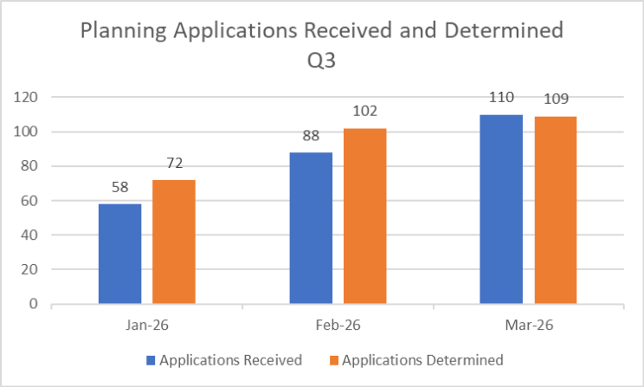
Timeframes
Council has two types of applications:
- Standard applications – 60-day statutory timeframe (inclusive of weekends and public holidays)
- VicSmart applications – 10 business day timeframe
During Quarter 3, Council determined 49% of its Standard applications within the 60-day timeframe and 95% of its VicSmart applications within the 10 business day timeframe. The table below shows monthly decision timeframes for the 2025-26 financial year:
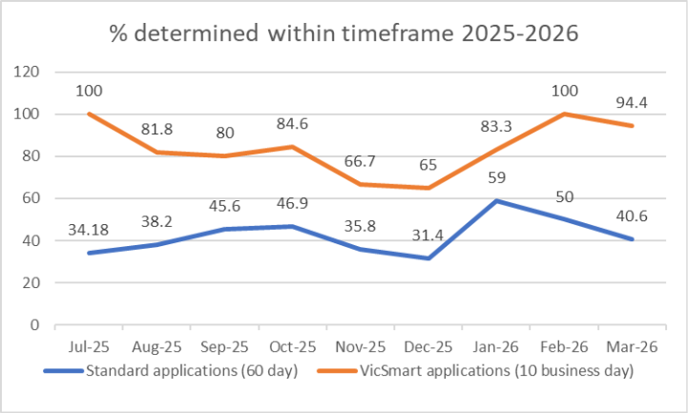

Statutory planning – expired
Council has commenced reporting on the number of extensions granted to existing planning permits, as well as on the number of new dwellings approved under those planning permits.
The purpose of sharing this information is to draw attention to the many live planning permits that have not been acted upon, which could contribute to housing supply across Yarra. In Quarter 3, Council granted 41 planning permit extensions (150 new dwellings were approved under the permits extended).

Statutory planning – VCAT activity
Appeals in Quarter three of 2025-2026
There were 6 applications that were reviewed to the Victorian Civil and Administrative Tribunal (VCAT) in the Quarter 3 2025/26, one less application than for the previous quarter.
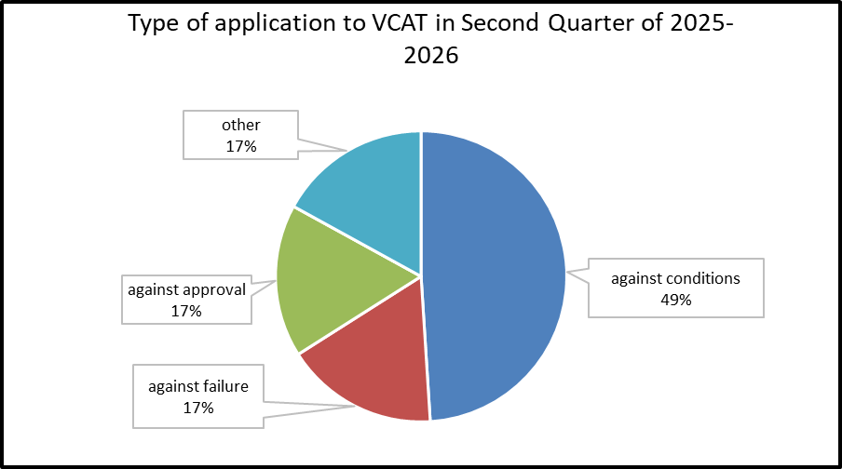
Total number of applications reviewed to VCAT: 6

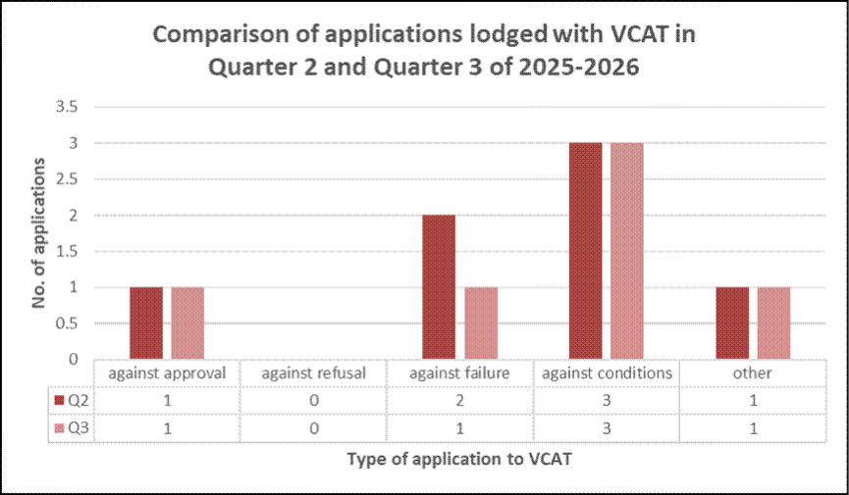

When comparing the type of applications reviewed with VCAT in Quarter 3 compared with the previous quarter, there were:
- the same number of applications ‘against approval’;
- the same number of applications ‘against refusal’;
- the same number of applications ‘against failure’;
- the same number of applications ‘against conditions’; and
- One less application against ‘Other’.

The graph below shows the type of applications determined by VCAT in Quarter 3 and whether Council’s decision was affirmed, varied or overturned. A total of 11 decisions were made by the Tribunal, with one application being withdrawn.

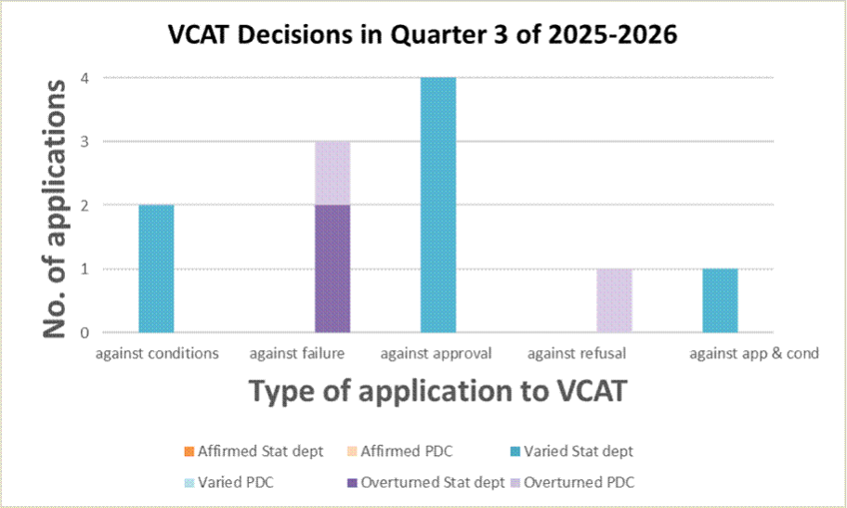
Total number of VCAT decisions: 11

Of the 11 VCAT Decisions in Quarter 3:
- Zero Statutory Department decisions affirmed;
- Zero PDC decisions affirmed;
- Seven Statutory Department decisions varied;
- Zero Statutory Department decisions varied;
- Two Statutory Department decisions overturned;
- Two PDC decisions overturned.

The graph below shows whether the VCAT decisions were via the consent of the parties.
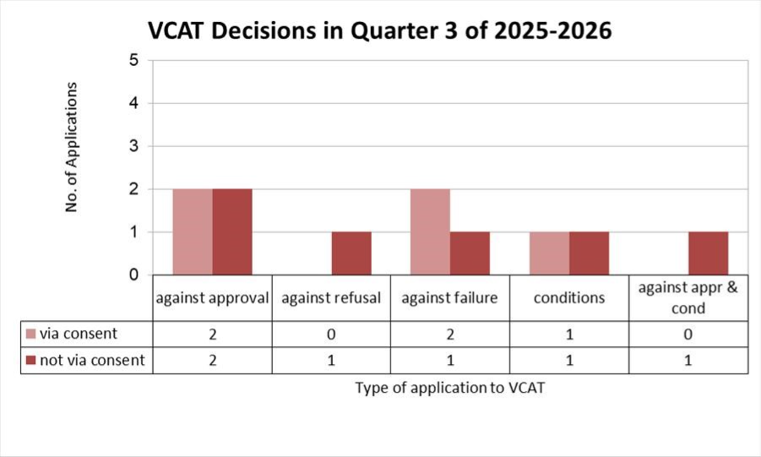
Of the 11 VCAT Decisions in Quarter 3, five decisions (45%) were via the consent of the parties.

Statutory planning – social and affordable housing approved
In Quarter 3, 216 new dwellings were approved by Council. None of these were social or affordable housing properties.
In Quarter 3, the Department of Transport & Planning approved a total of 281new dwellings within Yarra. The permits issued require a contribution of 10% affordable dwellings (unless an alternative contribution is proposed and accepted by the Minister for Planning). This equates to approximately 28 affordable dwellings.

Planning Application & Address | Total number of dwellings approved | Total number of social & affordable housing approved
PPE25/0291 - 675 Victoria Street, Abbotsford | 123 | 10%
PPE25/0652 - 201 Queens Parade, Fitzroy North | 98 | 10%
PPE25/0776 - 9 Victoria Street, Fitzroy | 60 | 10%

Strategic planning Services Review implementation

Statutory Planning
During Quarter 3 a review of processes was underway to find ways to improve decision timeframes for simple matters. This includes reviewing report templates and procedures for finalising and issuing decisions. Work was also underway to continue to improve and promote the service provided to applicants for business-related planning permits.

Strategic Planning
The Strategic Planning website will continue to be updated, and background reports uploaded as an ongoing item. Officers ensured that information on recently adopted and progressed amendments are up to date (see Planning Scheme Amendments update for this Quarter).

Strategic objective 3: Working and Playing in the City

Activity centre utilisation
Plan for Victoria, announced by the Victorian State Government, outlines that Yarra has been declared an activity centre in its entirety. Yarras Housing Target means the planning scheme needs to demonstrate a potential capacity for a further 44,000 dwellings. The planning scheme was amended on 2 September 2025 to incorporate this into the Yarra Planning Scheme.
The Victorian State Government announced that in the case of Yarra, strategic sites should be identified to help achieve this, next to existing work programs on activity centers.
This Quarter, Officers have continued to liaise with the Department of Transport and Planning to understand how the retention of necessary employment land to secure the long-term viability of an economically diverse City can be balanced with demonstrating how the housing targets could be achieved. The background work is due for completion in June 2026.

Arts update

Vietnamese Commemorative Marker
The Vietnamese 50th Anniversary commission is a collaboration with the Vietnamese community to create an enduring commemorative marker to recognise 50-years since the arrival of Vietnamese refugees in Australia, including to Richmond and Abbotsford.
In December 2025, Council endorsed Mythical Crane Boat, an artwork design by artist Van Phu Le, as the artwork to be made for the commission. The recommendation for the design came from the 10 member Vietnamese community consultative group, who also supported the now confirmed location of the Lennox and Butler Street Park, Richmond.
The artwork consists of a boat shaped bronze sculpture which will be raised up by a powder-coated steel plinth. Van Phu Le said the marker embodies themes including family, community, migration journeys, freedom and resilience, new beginnings, reflection and respect, and cultural symbolism through motifs such as the boat and mythical crane.
In this Quarter the project formally engaged the Artist, supported by co-applicant and auspice organisation, Belgium Avenue Neighbourhood House, to commence work on the next stage of the project. This includes finalising the design and creating a life size clay model of the artwork. A fabricator has been engaged to work with the Artist to create the artwork in its finished form and to install the work on location.
The launch of the Vietnamese Commemorative Marker will take place in June 2026.

Concept design illustration of Mythical Crane Boat by Van Phu Le. Images provided by Artist.

Artist Van Phu Le has created the artwork Mythical Crane Boat to mark the 50th anniversary of Vietnamese settlement in Richmond and Abbotsford.

Strategic objective 4: Running the City

Acquittal of Council resolutions
Council Meetings are the decision-making forum constituted under the Local Government Act 2020 where Councillors come together as a Council and are responsible for making decisions on behalf of the community.
Meetings are conducted in accordance with the Local Government Act 2020 & Yarra Governance Rules.

Council decisions are made at meetings of the Council. These decisions are made by a resolution of the Council and actions are assigned accordingly.

The table below shows a record of Council resolutions for Quarter 3. Open resolutions are those where there are still actions in progress to be implemented.

The total number of resolutions refers to the tally of resolutions from Council meetings during the Quarter.

Council Resolutions between 1 January 2026 – 31 March 2026
Total number of resolutions  allocated | Open  Resolutions – January | Open resolutions -  February | Open resolutions -March | Total number of  Open resolutions | % of open resolutions
21 | No Council meeting in January | 0 | 6 | 6 | 28%

Advocacy update
Council’s advocacy to the Victorian and Federal Governments is guided by the Advocacy Roadmap 2025-29.
Free primary health care must continue to be accessible to our most vulnerable residents in Collingwood and Fitzroy. During the Quarter Council made a submission on behalf of the community to the Independent Review of cohealth GP and Related Services on the importance of these services to the community. Council also resolved in February to advocate to the Victorian Government for the continuation of the Victorian Health Promotion Foundation, VicHealth, as an independent statutory body. Absorbing VicHealth into the Department of Health will reduce its independence and budget autonomy, and limit the State’s capacity for health promotion and prevention.
State Government cost shifting to local government is a threat to local services provided for residents. Councils are the primary delivery partners for many services co-funded with the State Government, such as libraries, maternal and child health, and school crossing supervisors. Over time the State’s contribution has fallen considerably. Council is advocating to the Victorian Government to pay its fair share.
The Mayor has joined forces with Council counterparts across the State to raise the awareness of the community and stakeholders to this issue and its impact on ratepayers and the community. Opposition and cross bench MPs have been briefed and invited to commit to end cost shifting if elected. Multiple media stories have been published and momentum is growing.
At this year’s Victoria's Pride Street Party, the Victorian Government announced that the Street Party would be ‘staying alive’ in Fitzroy beyond 2026, should Labor be re-elected in November. This follows years of Council advocacy to make the event permanent.
Council has been awarded two Victorian Government grants:
- $250,000 through the Pick My Park program, to upgrade George Knott Reserve in Clifton Hill
- $230,000 through the Multicultural Business Precinct Revitalisation Program, to deliver a vacant shop program and shopfront improvement program on Victoria Street.

Council has lodged submissions to the Victorian Government’s:
- Inquiry into renewable and affordable energy for apartments.
- Consultation on Remaking the Electric Line Clearance Regulations.

Community engagement update
Yarra continues to prioritise the community voice in its decision making. Over the past two Quarters, Council has engaged on 19 projects, with more than 2,020 community members provide feedback across these projects.
Council during this time engaged on the development of a new Community Engagement Policy, as required under the Local Government Act 2020. Staff made a significant effort to engage with traditionally harder to reach communities to ensure their voice was heard on the policy, including:
- 15 stakeholder group and targeted sessions
- engaging with 90 children using tailored engagement activities such as a simplified survey, dotmocracy activity, drawings, and a group workshop
- four multicultural groups, including from Italian, Greek, Vietnamese and Chinese communities.
Council also consulted the community on the Waste and Recycling Strategy. A variety of engagement opportunities were available to increase reach and participation, including:
- 15 targeted engagement sessions delivered to ensure the reach of traditionally underrepresented communities.
- Different types of engagement opportunities provided, such as a detailed online survey, a dotmocracy activity combined with a shorter survey for in-person opportunities, and engagement activities for young people and children.
In Quarter 3, Council completed engagement on stage 2 of the Local Law Review 2025/26, with the Your Say Yarra page receiving 143 individual pieces of feedback.
Council also engaged on stage 2 of two park upgrades: Annettes Place in Richmond and Garryowen Park in Fitzroy. Consultation also opened on proposed changes near Princess Hill Primary School to connect streets for active transport.
Council continued to keep the community involved and aware of upcoming opportunities to have their say, with 3,360 subscribers receiving our Your Say Yarra email newsletter, an increase of 1,009 from the same time in 2025.
Finally, Council is focused on ensuring all our in-person pop-up events are inclusive for our diverse community who require accessible venues. This is now regularly promoted in our advertising material and social media to encourage all in the community to come along and share their views.

Domestic Animal Management Plan update
Post adoption of the Domestic Animal Management Plan (DAMP), the following initiatives have been implemented this financial year to date:
- Dog-poo education campaign launched. Community feedback has been positive
- Desexing subsidy feasibility study commenced. Preliminary findings confirm cost is a major barrier for residents, and participating clinics have indicated support for a future program
- Pound contract review
- Officer training
- Education initiatives, including:
  - Department of Families, Fairness and Housing (DFFH) sessions with adults on dog behaviour, dog attacks and responsible pet ownership.
  - DFFH sessions with children on dog behaviour.
  - Willow View sessions with senior community members on dog behaviour, dog attacks and responsible pet ownership.
Overall, Year one delivery is on track, with major feasibility work nearing completion and operational activities progressing.

Financial report
The Quarter three financial position reflects Council’s continued commitment to careful and responsible financial management, consistent with the 2025/26 Annual Budget and the objectives of the Financial Sustainability Strategy.
Like all Victorian councils, Yarra continues to face significant financial headwinds. These include rising costs, capped revenue, cost-shifting from other levels of government, and strong population growth that is increasing demand for services and infrastructure.
Councils across Victoria are also experiencing higher costs in areas such as infrastructure delivery, waste management (including landfill levies), information technology, energy, and labour. These increases are largely driven by factors outside local government control, including sustained high prices, supply constraints, competition from major state infrastructure projects, and service costs growing faster than the Consumer Price Index (CPI).
Recent instability in the Middle East has added further pressure by causing fluctuations in fuel and energy prices, increasing both costs and financial risk. In addition, on 20th April the Fair Work Commission issued a Road Transport Contractual Chain Order (RTCCO), which requires Council to absorb fuel price increases for certain contracted services—even where contracts were originally set at fixed prices.
Council is currently assessing the financial impact of these changes, which are expected to place unplanned cost pressures on key services such as waste collection, road maintenance and civil works.
Despite these challenges, Council continues to manage its finances carefully and remains committed to delivering the Financial Sustainability Strategy to support long-term financial stability. Council has previously reported the challenge of generating sufficient cash to fund future asset renewal without borrowing, and there is no change to the overall financial sustainability risk rating compared to the adopted budget.
The financial information and reports below show how Council is continuing to deliver on its commitments whilst maintaining financial discipline. They present actual year-to-date results and updated full-year forecasts compared with the adopted 2025/26 budget, and demonstrate the progress made since the financial position of three years ago.

Quarter Three Forecast
Yarra City Council Financial Sustainability Strategy (FSS), Strategic lever 6, requires ongoing review of operating costs with the goal of identifying permanent savings.
To achieve the objectives of the FSS, Yarra City Council performs a quarterly forecasting process and a CEO-led mid-year review process annually.
The quarter three review forecasts a net surplus of $25.5m, which is $10.0m favorable to the 2025/26 adopted budget of $15.5m. Capital works are projected at $36.2m, which is $2.31m below the adopted budget of $38.5m. The main drivers of these variances are:
- Forecast revenue is $1.6m above budget, reflecting higher than budgeted revenue from statutory fees and fines and user fees of $3.4m, together with favorable movements in reimbursements, interest on term deposits and sale of assets of $4.1m, partially offset by a reduction of approximately $3.8m in revenue collected for open space reserves.

- Forecast expenditure has reduced by $8.4m compared with budget. This reduction is mainly due to materials and services savings identified by the business of $6.5m, largely attributable to delays in Council’s Information Technology initiatives as well as prudent management of licensing and consultant costs. Employee costs are also forecast to be $2.4m favorable to budget, mainly due to a considered approach to filling non-critical vacancies, delays in the EBA process, and the later commencement of the ERP implementation program, which included staffing costs. These favorable movements are partly offset by an increase in the provision for doubtful debts of $0.4m, which has increased in line with higher parking infringement revenue. Any unspent funds budgeted for the ERP program at the end of the financial year will be reported as a carryover into Release 2 of the program.

- Forecast capital expenditure at year end is $36.2m, $2.3m below budget. This variance is mainly timing-related and reflects revised delivery timeframes for a small number of major projects, most notably Brunswick Street Oval and Yambla Pavilion. Of this, $1.8m relating to Brunswick Street Oval is now expected to be carried forward into the next financial year.
While Council is forecasting an operating surplus, the economic environment remains volatile. Fuel and energy price uncertainty, together with the financial impacts of the recently introduced RTCCO, present potential cost pressures that are still being assessed. In line with Council’s Financial Sustainability Strategy, it is therefore recommended that any year end operating surplus be transferred to reserves to ensure Council can manage emerging risks without compromising service delivery.

Comprehensive Income Statement
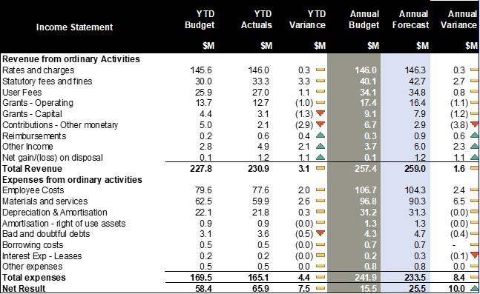
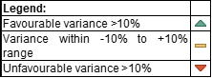
YTD actual results to YTD budget are favourable by $7.5m. The full year forecast result to annual budget is $10m favourable. This result is driven by the following:

Revenue
- Rates and Charges
YTD performance is $0.333m favourable to budget, primarily driven by income from interest revenue expected from overdue payments and $0.255m favourable from supplementary valuations.
- Statutory Fees
Key favourable variances include increased parking infringement income $2.84m, paid parking $0.646m and parking permit income $0.326m. There are partially offset by higher than budgeted withdrawal of fines issued (-$0.506m).
The full-year forecast has been adjusted to show additional $2.660m of revenue to budget, mainly driven by increase in infringement revenue $1.550m as well as increased volume of lodgement fees $0.450m, parking fees $0.800m and parking permits issued $0.110m.
- User Fees
A favourable year to date variance of $1.102m is being driven by sustained demand across regulatory and infrastructure-related services, together with stronger utilisation of commercial assets. The most significant contributor is Traffic and Civil Engineering $1.514m, reflecting higher-than-forecast activity levels. This has been supported by improved performance at Burnley Golf Course $0.460m. Statutory Planning $0.233m also exceeded budget, indicating continued development activity within the municipality.
These favourable movements are partially offset by lower-than-anticipated utilisation in Children’s Services (-$0.350m), Construction and Planning Enforcement (-$0.283m), and the Learn to Swim program (-$0.158m).
The full-year forecast has been updated to reflect increased activity in Civil Engineering and Construction Management $0.779m, as well as Statutory Planning $0.270m. These increases are partially offset by a reduction in income expected from Childcare Centres (-$0.448m) and the Learn to Swim program (-$0.223m), reflecting lower utilisation than budgeted.
- Grants - Operating
The YTD unfavourable variances in operating grant income are mainly driven by the VLGC grant, which was partially received early in the previous financial year (-$1.629m), and the timing of Child Care Subsidy receipts associated with the summer closure period of Child Care services (-$0.518m). These timing-related unfavourable movements are offset by unbudgeted grant income received for School Crossing Supervisors $0.438m and additional unbudgeted, non-recurrent State grants ($0.510m favourable), primarily relating to Combustible Cladding Services and the 30km/h Trial.
The full-year forecast has been reduced to reflect the expected non-recurrence of the VLGC grant prepayment at year-end. This reduction is partly offset by additional income from recurrent and non-recurrent State grants, resulting in a more accurate representation of expected full-year grant income.
- Grants – Capital
The YTD unfavourable variance is driven by the delayed commencement of the Brunswick St Oval project (-$1.821m), partly offset by grant income received for the Community Charge project $0.280m, Atherton Gardens Kindergarten $0.158m, Connie Benn ELC $0.150m, Princess Hill Playground $0.110, and the Get Off Gas project at Collingwood Leisure Centre $0.082m.
The full-year forecast is (-$1.226) unfavourable to budget, mainly due to delays in the Brunswick Street Oval project, which is now expected to be carried over to the next financial year (-$1.820m), partly offset by additional grant funding secured for the projects noted above.
- Contribution – Other Monetary
YTD revenue from developer contributions is $2.903m below budget, reflecting slower-than-expected development activity across the municipality. This is mainly due to Open Space Contributions being below budget (-$3.064m), partly offset by slightly stronger than anticipated DCP fee income $0.152m favourable.
The full-year forecast has been revised to reflect an expected shortfall of $3.82m against budget for Open Space Contributions by year end.
- Reimbursement
The YTD favourable variance of $0.429m is primarily driven by advanced income received in Traffic Engineering from the previous financial year relating to Mollison Street $0.090m and Engineering resource funding $0.113m, as well as reimbursements recouped on Council-owned property $0.077m. In addition, reimbursements have been received for the Business Renewables Buying Group $0.109m.
The full-year forecast has been adjusted to reflect an expected $0.604m increase in revenue against budget from the above-mentioned activities.
- Other Income
The year-to-date favourable variance to budget is primarily attributable to higher interest income from term deposits ($1.799m), reflecting the combined impact of sustained elevated interest rates and stronger-than-forecast cash balances available for investment. In addition, funds were received from the VEC for fines and infringements collected in relation to the Council elections ($0.287m).
The full-year forecast has been adjusted to reflect the additional VEC funding $0.287m and increased income from term deposits and savings of $2.024m.

- Net gain on disposal of assets
The net gain on disposal of assets is favourable to budget, driven by proceeds from right-of-way (R.O.W) sales at 101 Bridge Road and 106 Balmain Street $0.430m, and 74 -76 Rose Street $0.360m and 261- 263 Holden Street $0.176m. Additional favourable outcomes were realised from fleet sales $0.071m following the cessation of private use agreements.
The full-year forecast has been adjusted to reflect the increased revenue against budget from asset disposals already completed, as well as those planned for sale by the end of the financial year.

Expenses
- Employee Costs
YTD results show a $2.000m favourable variance to budget, largely driven by $2.727m in salaried staff savings arising from a combination of higher-than-anticipated vacancy levels and the timing of the EBA increment. Of this amount, $1.229m relates to the EBA outcome, with an actual increase of 2.5% applied compared with the budgeted 3.5%. These favourable results are partially offset by the unbudgeted Early Education Retention Payment $0.769m, which is fully grant-funded, together with higher-than-budgeted WorkCover premiums (-$0.336m) and increased expenditure on agency staff (-$0.166m) to backfill a number of critical vacant roles.

The full-year forecast has been updated to reflect expected full-year savings, with reduced reliance on agency staff $0.467m favourable as vacant positions are progressively filled in line with the organisation’s approved structure and planned recruitment activity. In addition, the timing benefit associated with the EBA increment does not continue into the second half of the year, resulting in a more normalised salary cost profile.
- Materials & Services
YTD, a favourable variance of $2.630m, is mainly driven by lower grant payments following Council resolutions made after budget adoption $1.064m favourable, together with lower contractor expenses due to the delay or postponement of several Digital Transformation projects $0.545m favourable. Additional favourable variances have arisen from lower legal fees relating to Statutory Planning services $0.567m and lower waste processing costs within City Works $0.610m. Further timing-related favourable variances include grant payments for the Richmond and Collingwood Youth Program $0.205m, Strategic Transport $0.252m, and Business Transformation $0.215m.
These favourable movements are partly offset by higher Fines Victoria lodgment costs, driven by stronger infringement income (-0.635m), higher than expected legal costs (-$302m), and increased building maintenance costs (-$0.312m).
The full-year forecast $6.47m favourable has been updated to reflect permanent savings, primarily within the DTS portfolio, driven by ERP program delays and lower software licensing costs arising from a combination of timing impacts and prudent license consolidation, totalling $3.00m. Additional savings have been recognised in Community Development from lower payments under the Contributions and Community Grants program $0.950m, and in City Strategy from lower than anticipated tipping and waste costs $0.467m as well as lowering reliance on consultancy costs $0.850m. These favourable movements are partially offset by higher lodgement costs payable to Fines Victoria $0.540m.
- Bad and Doubtful Debts
The YTD unfavourable variance is driven by higher-than-budgeted bad debt expense, reflecting an increase in the number of infringement notices issued (-$0.473m). As a portion of infringement revenue is not expected to be collected, higher infringement activity results in a corresponding increase in bad debt expenses.
The full-year forecast has been updated to reflect bad debt expenses in line with the higher expected volume of infringement notices.

Capital Works
The adopted capital works budget for FY2025/26 is $38.5m, comprising a $35.75m budget allocation on planned capital projects and a carry forward budget of $2.748m from the FY2024/25 capital program. The full year forecast has now been updated to $36.20m.
Actual expenditure at the end of March 2026 was $20.3m, being 32% behind the YTD Budget of $29.7m.
Financial Results Summary | YTD  Budget | YTD  Actuals | Annual  Var  To Budget | Annual  Budget | Forecast | Annual  Var to Forecast
Financial Results Summary | $’000 | $’000 | $’000 | $’000 | $’000 | $’000
New asset expenditure | 5,649 | 3,033 | 2,616 | 9,069 | 7,263 | 1,806
Asset renewal expenditure | 13,052 | 11,439 | 1,612 | 14,877 | 15,415 | (538)
Asset upgrade expenditure | 10,978 | 5,829 | 5,149 | 14,567 | 13,517 | 1,050
Total capital works expenditure | 29,679 | 20,301 | 9,377 | 38,513 | 36,195 | 2,318

Cash Position
At 31 March 2026, Council has total cash of $142.98m, of which $22.48m is funded by borrowings. Unrestricted and unallocated cash position is $56.12m, moving from $38.78m as at 30 June 2025.
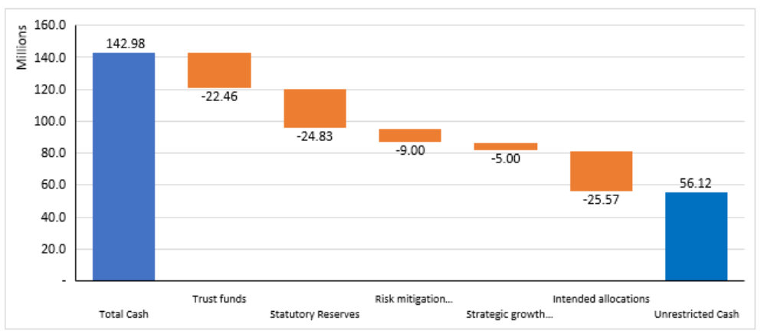

Financial Sustainability Ratios

Adjusted underlying surplus (deficit) / adjusted underlying revenue
This ratio measures an entity's ability to generate its own cash. A positive result indicates a surplus, and the larger the percentage, the stronger the result. The result highlights Councils challenges in generating enough cash to fund future capital works without borrowing.

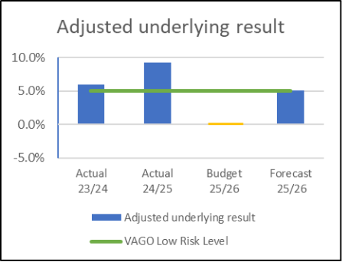

Current assets / current liabilities
Compares current assets to current liabilities, which provides a measure of the ability to pay existing liabilities in the next 12 months. This year's result expected to be in the low-risk range.

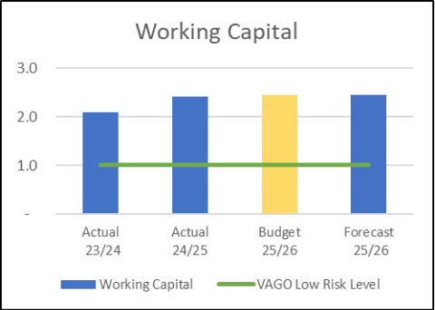
Renewal & upgrade spend/ depreciation
Ratios higher than 1.0 indicate that spending on existing assets is faster than the depreciation rate. This year's result is expected to stay in the low-risk range.

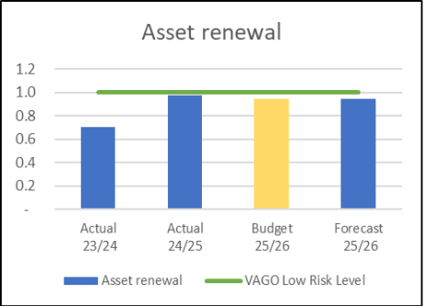
Non-current liabilities / own-source revenue
Measures Council's ability to pay the principal and interest on its borrowings when they are due from the funds it generates. This year's result is expected to stay in the low-risk range.

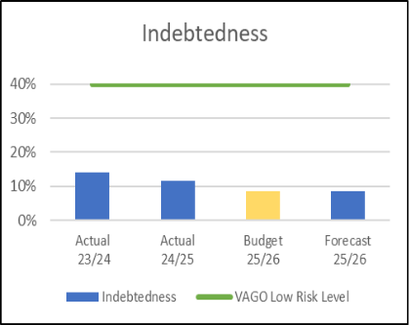

Treasury Corporation of Victoria (TCV) Loan financial covenants
TCV Loan Requirements |  | Target | Current Month
Interest Cover | EBITDA/Interest Expense | >2.0 | 168
Interest Bearing Loans | Interest Bearing Liabilities/Own Source Revenue | <60% | 10.55

TCV financing is conditional upon Council maintaining a sustainable financial position when measured by the interest cover and interest-bearing loans ratios. YTD results indicate that the Council meets the minimum requirements. TCV loan requirements are well within target given limited borrowing compared to own source revenue and liability obligations.
Statement of Financial Position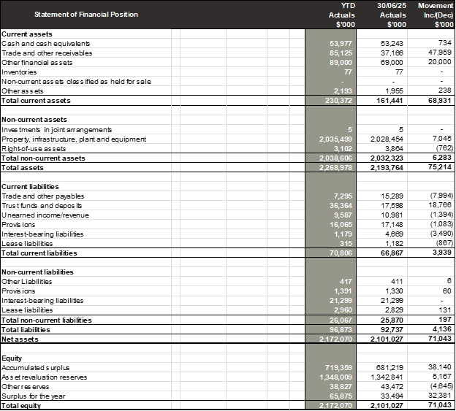
Statement of Cash Flow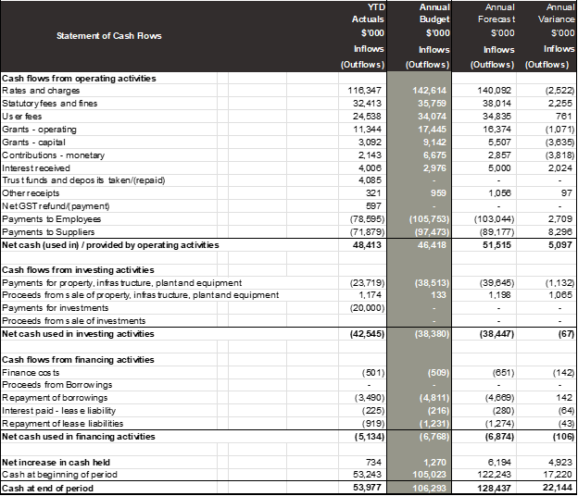

Statement of Capital Works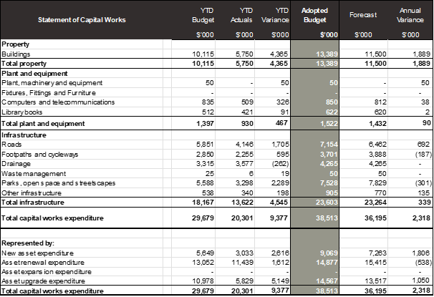

Operating Performance
Statutory Fees
Statutory fees and fines include infringement notices, parking permits and parking meter income. Current results are ahead of budget mainly attributed to improved management of operational environments.
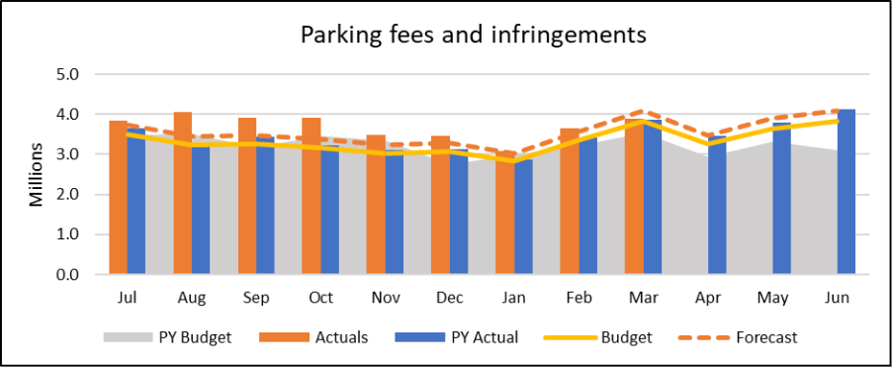
Recreation and Leisure Income
Recreation and leisure income is currently tracking ahead of last year's actuals and is on par with this year’s budget, forecast is to come in (-$0.200M) below budget, driven by reduced Learn to Swim class uptake and reduced Pavillion and Facility Hire.
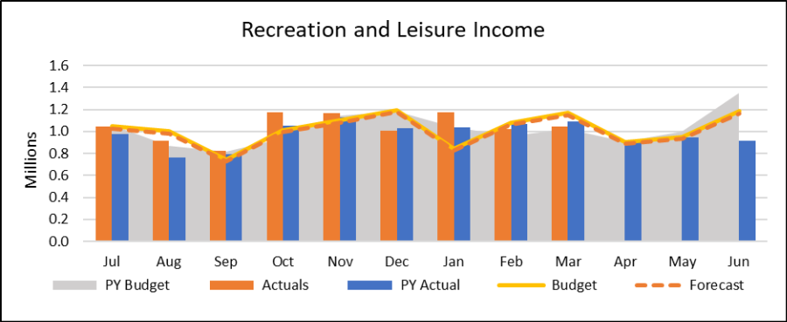
Rates Collection
The cash collections from rates are currently ahead of the average collections achieved in the last three years.
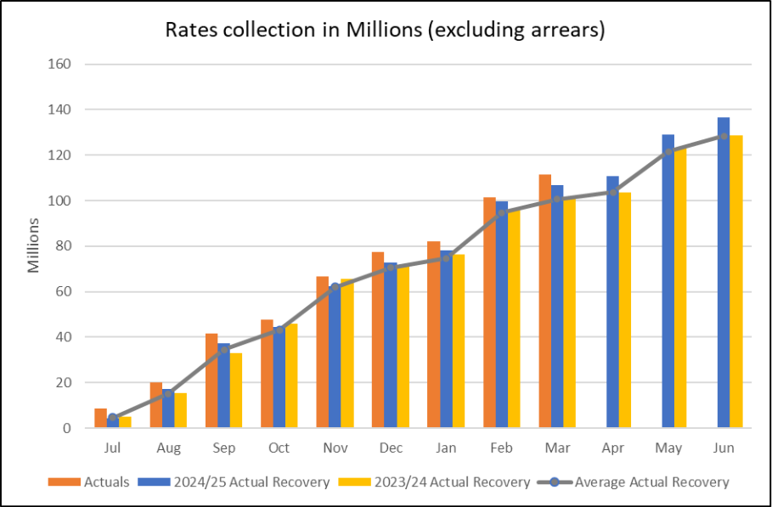

Financial Sustainability Strategy
Council’s Financial Sustainability Strategy was adopted on 12 December 2023
The Strategy was created to guide future decision-making so Council can transparently, proactively and prudently plan to be financially sustainable. With this strategy, Council aims to ensure financial sustainability remains consistent whilst delivering efficient and effective services and infrastructure.
The Financial Sustainability goals set for years 0-2 of the strategy have been achieved, namely:
- Maintain a net positive position by delivering a surplus,
- ensure our operating activities no longer relies on borrowings, and
- hold costs and start to build cash reserves for specified purposes.
Achievement of these goals are all evidenced in Council’s Financial Statements
The Financial Sustainability goals set for 3–5 years include:
- Achieve a financial position where we have sufficient cash reserves to repay borrowings,
- generate new revenue,
- cover all known operating expenses without borrowing,
- deliver a long-term financial plan that more reliably reflects future financial requirements (‘unknown risks’), and
- have approximately $20m available in reserves for risk and strategic growth.
Council has either achieved or is on track to achieve all of the year 3-5 goals listed above.

Parking revenue
Below you can find parking revenue data for Quarter 3. It is intended to provide the community with an overview of parking revenue and identify any trends or patterns. Parking revenue is broken down into two categories:
- paid parking
- parking infringements.

Paid parking revenue includes income generated from both pay-by-phone (PayStay) and meter payments made by drivers.

Quarter 3 Paid Parking Revenue

Total revenue for Quarter 3 decreased by 2.52% compared to Quarter 3 2024/25. The graph shows however that the forecast for Quarter 3 was exceeded by 3.54%.

Comparison of Quarter 3 for 2024/25 and 2025/26 are shown below detailing total paid parking revenue, which shows a year-on-year decrease of $103,023.89:
- Quarter 3 2024/2025: $4,095,951.83
- Quarter 3 2025/2026: $3,992,927.94

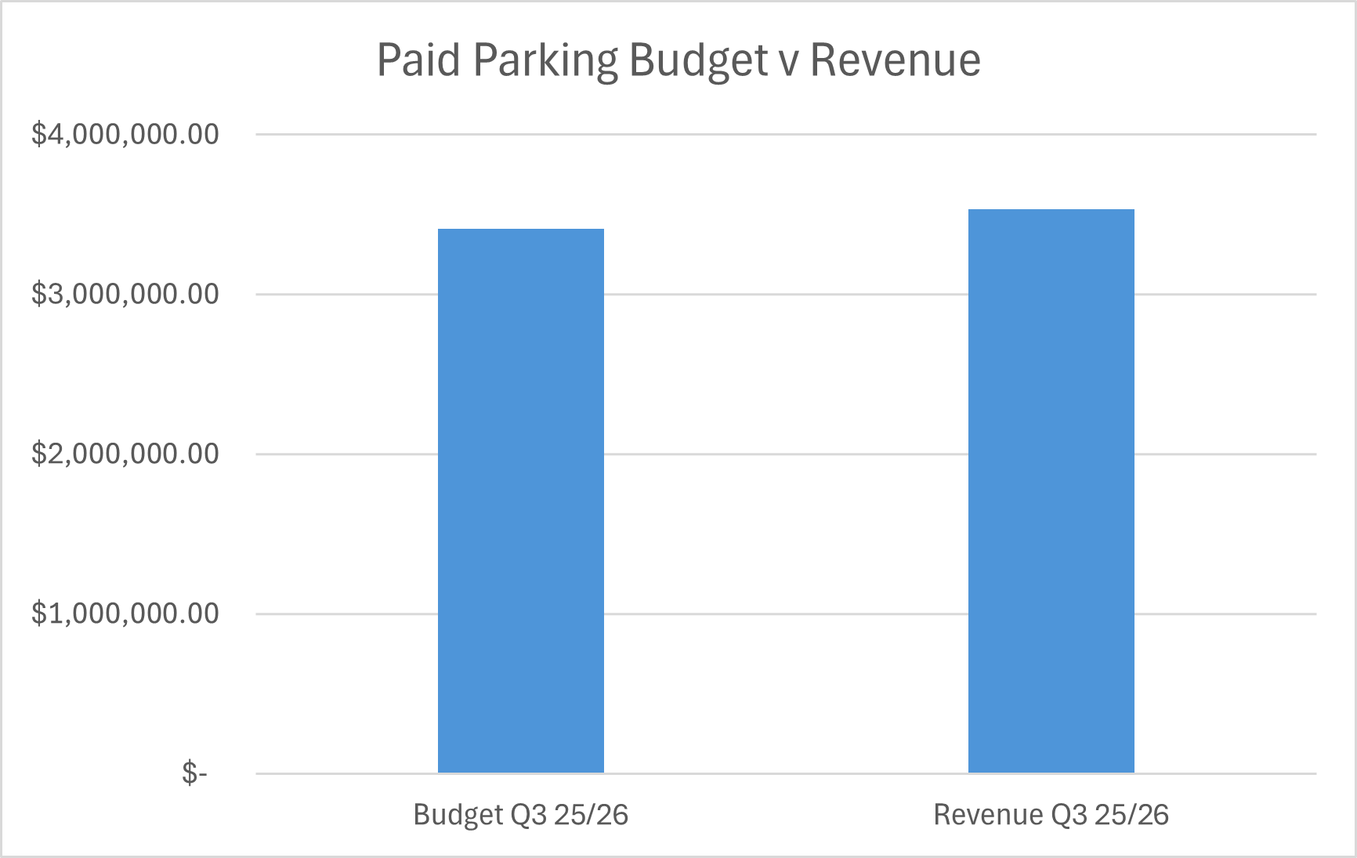
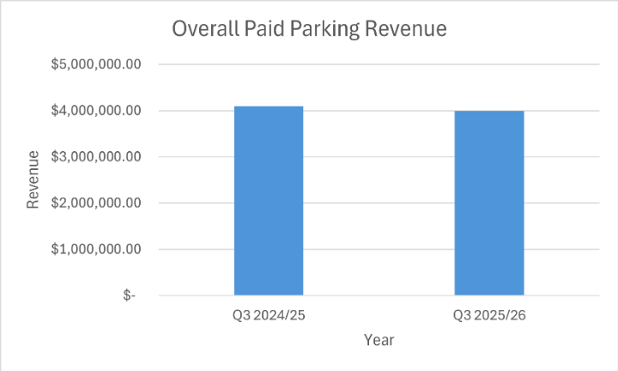

Quarter 3 Paid parking meters

The graph shows the parking meter data including revenue and time paid (or length of stay). A total of 295,450 transactions occurred during Quarter 3:

- Quarter 3 2024/25 Meter Revenue: $2,132,801.00
- Quarter 3 2025/26 Meter Revenue: $2,030,004.00

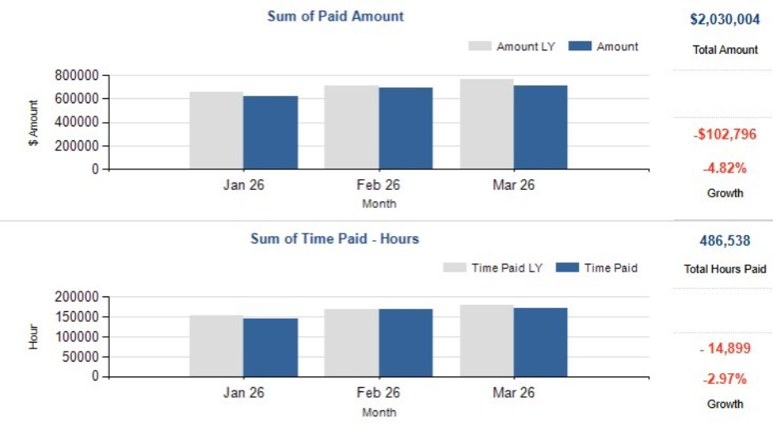

Quarter 3 Paid parking pay by phone
Pay by phone continues to show an increase in the number of transactions when comparing year on year Quarter 3 data (2024/25 to 2025/26):

- Quarter 3 2024/25 Pay by Phone Transactions: 380,286
- Quarter 3 2025/26 Pay by Phone Transactions: 423,820

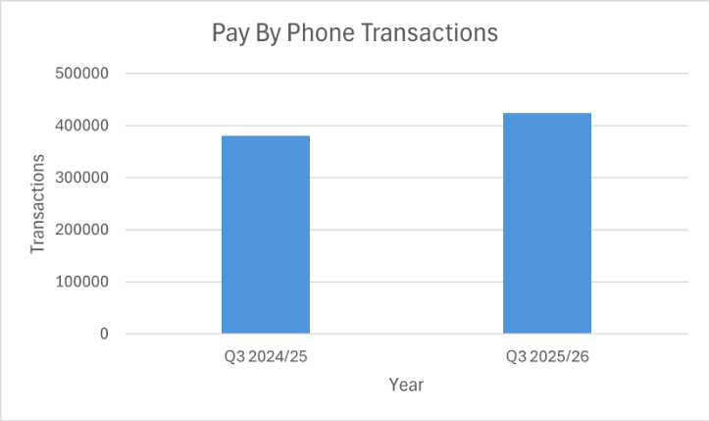

Revenue generated by pay by phone also shows a decrease when comparing year on year Quarter 3 data (2024/25 to 2025/26):

- Quarter 3 2024/25 Pay by Phone Revenue: $1,963,150.83
- Quarter 3 2025/26 Pay by Phone Revenue: $1,962,923.94

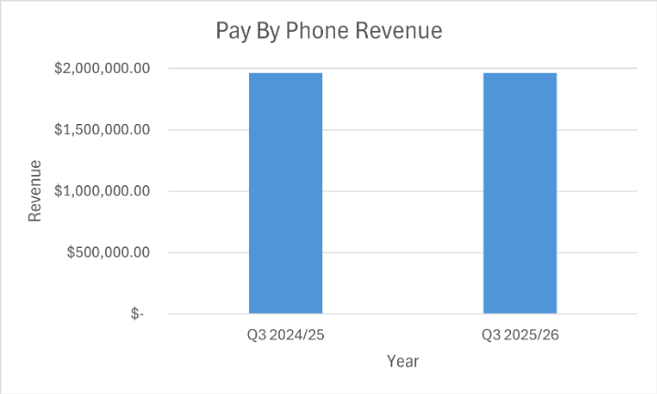

Quarter 3 Parking infringement revenue

Revenue from infringements issued during Quarter 3 shows an increase when comparing year-on-year data over 2024/25 and 2025/26:

- Quarter 3 Infringement Revenue 2024/2025: $4,725,377.00
- Quarter 3 Infringement Revenue 2025/2026: $5,007,566.00

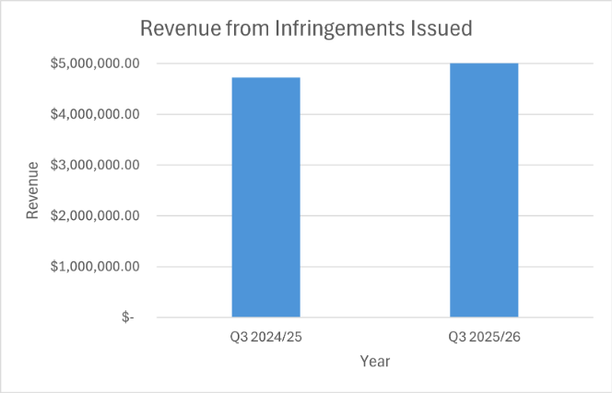

Activity Centre paid parking

Each shopping strip in Yarra is unique, influenced by a variety of factors such as the types of attractions and businesses located on the street. As a result, it is not possible to directly compare paid parking revenue across the business centres.

Several important variables to consider when looking at the various centres include different tariffs (hourly fee) applied across the centres, amount paid for on-street parking, and breadth of hours that paid parking is in effect.

A twelve-month trial of free one-hour parking in Richmond commenced on 1 July 2025. This trial is occurring on Bridge Road, Swan Street, and Victoria Street. A Quarter 3 update on the trail will be reported to Council in April.

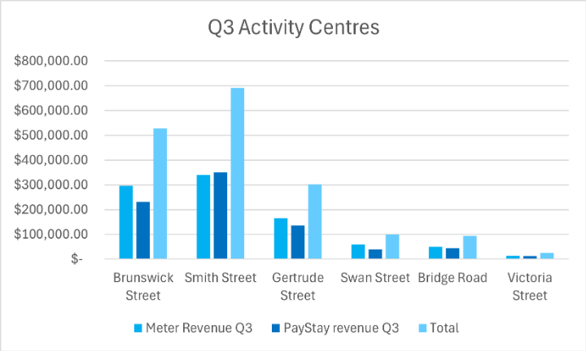

Council Plan Action Plan performance
Council adopted its 2025–2029 Council Plan on 17 June 2025. The Council Plan articulates the medium-term strategic direction of Council and outlines the key outcomes that Councillors aim to achieve during their four-year term.
The 2025–2029 Council Plan has four Strategic Objectives that align with the Community Vision and define the strategic direction of Council. At the June 2025 Council Meeting, Council also adopted the 2025/26 Council Plan Action Plan and 2025/26 Budget. Together, the Action Plan and Budget operationalise the Council Plan by turning medium term goals into achievable shorter-term work of the Council.
The 2025/26 Action Plan identifies initiatives under each Strategic Objective which are significant projects that Council will undertake towards achieving the Strategic Objectives in the Council Plan. This financial year, the Action Plan includes 26 actions and related milestones that demonstrate Council’s commitment to delivering meaningful outcomes for the community.
At the end of March 2026, overall performance reached 100%, exceeding the performance target of 75%. To meet the performance target, actions must achieve 75% or higher of their target.

Action summary by performance:
- 19 Actions (73%) On track - At least 90% of target achieved
- Seven Actions (27%) Monitor - Between 75% and 90% of target achieved
- 0 Actions (0%) Off track - Less than 75% of target achieved.
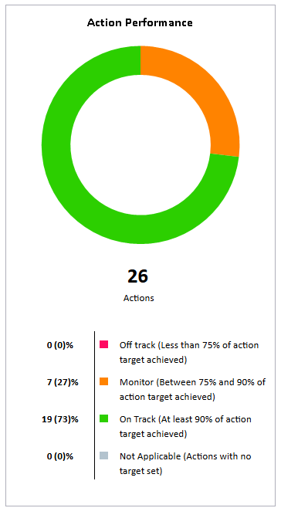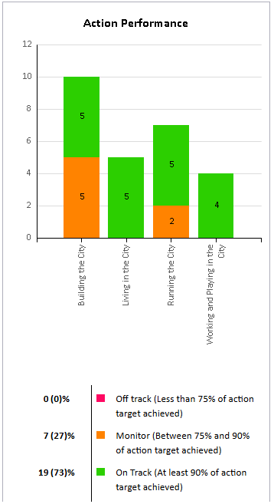

Action Plan 2025/26 Progress Q3

Living in the City

Action Title: 1.1.2.1 Year 2 Climate Emergency Plan Implementation
Status: In Progress – Green
Completion Percentage: 80%
Target Percentage: 75%
Action Progress Comments:
Council has continued to support our community’s resilience to climate change, including through collaboration with a range of community organisations, including:
- Coordinating a Climate risk and resilience sub-committee – a formal sub-committee of the Yarra Municipal Emergency Management Planning Committee (YMEMPC), comprising a range of community organisations and facilitated by Council’s climate emergency team. The sub-committee meets four times per year and its purpose is to support the Yarra Municipal Emergency Management Planning Committee in strengthening resilience to climate-related risks; foster coordination and communication between community organisations, emergency agencies, and local residents; strengthen organisational and community resilience through delivering resilience building initiatives which recognise and build upon the strengths of local communities; and advocate for systemic change and resources to address climate-related vulnerabilities.
- Supporting a Yarra Neighbourhood House Network (YNHN) – Council, in partnership with the YHNH, has developed and partly delivered (delivery to continue until end of FY), a series of workshops designed to increase our community’s ability to prepare for and cope with the impacts of climate change.

In late 2025, Council delivered a workshop focussed on EV charging in your business. Officers are currently finalising additional workshop(s) this financial year which will continue to support the development of this work.

Action Title: 1.1.3.1 Conduct a localised Community Safety Audit
Status: In Progress – Green
Completion Percentage: 75%
Target Percentage: 75%
Action Progress Comments:
A report detailing the findings and associated recommendations from the CPTED Brunswick St assessment will be finalised, outlining key safety interventions and priority actions. The draft 2026-2027 budget has an allocation for intervention delivery based on the key findings from the CPTED assessment.

Action Title: 1.2.1.1 Minor Richmond Library renewal works with business case for major redevelopment of the Library
Status: In Progress – Green
Completion Percentage: 75%
Target Percentage: 75%
Action Progress Comments:

The development of the feasibility study and business case for any future development of the Richmond Library are in the final stages. Architects and cost planners have been appointed to progress options and inform the business case for a redevelopment of the library. Various options have been prepared (from modest interventions to a complete re-build) and will shortly be shared with councillors.

Action Title: 1.2.3.1 Kindergarten Infrastructure and Services Plan for Yarra
Status: In Progress – Green
Completion Percentage: 98%
Target Percentage: 75%
Action Progress Comments:

The draft Kindergarten Infrastructure and Services Plan for Yarra has been completed and is currently being reviewed by the Victorian Department of Education prior to sign off by the Victorian Government and Council.

Action Title: 1.2.4.1 Design and delivery of programs arising from the New Municipal Public Health and Wellbeing Plan
Status: In Progress – Green
Completion Percentage: 70%
Target Percentage: 75%
Action Progress Comments:
There are no scheduled milestones to report for this quarter. The next milestone update will be included in the Quarter 4 report.

Building the City

Action Title: 2.1.1.1 Progress New Deal for Cycling corridor projects
Status: In Progress – Amber
Completion Percentage: 60%
Target Percentage: 75%
Action Progress Comments:

Langridge and Gipps Street: Stage one of community engagement has been rescheduled to quarter four to allow further progression on other corridors to progress.

Coppin Street: Officers are currently discussing concept design options with Councillors and determining next steps, moving into the community engagement stage.

Elizabeth Street: Capital works are in progress to deliver this project.

Wellington Street: A high level of engagement though the consultation process. Offices are currently working through the feedback and developing options for a way forward.

Action Title: 2.1.2.1 Progress the preparation of a Kerbside and Parking Strategy
Status: In Progress – Amber
Completion Percentage: 60%
Target Percentage: 75%
Action Progress Comments:

Officers are currently working closely with Councillors on the Kerbside Management and Parking Strategy that is in development, Community Consultation will be undertaken later this calendar year.

Action Title: 2.1.3.1 Update the Transport Action Plan and implement
Status: In Progress – Amber
Completion Percentage: 57%
Target Percentage: 75%
Action Progress Comments:

The Transport Action Plan has been temporarily paused to enable officers and Council to focus on the Parking and Kerbside Management Strategy and corridor studies.

New Deal for Schools Update:
The 2025/26 program includes two schools—West Richmond Primary, undertaking Stage one behaviour change activities, and Princes Hill Primary, progressing Stage two works to support school travel.

Action Title: 2.2.1.1 Strategic Planning Agility: Implementing the State Government’s housing target and activity centre program
Status: In Progress – Amber
Completion Percentage: 62%
Target Percentage: 75%
Action Progress Comments:
Preliminary strategic background analysis to inform potential planning amendments is underway. This foundational work will facilitate further engagement with the State Government. Council is yet to receive the HCAP relevant to Council’s Housing Targets from the State.

Action Title: 2.2.4.1 Reactivate the Collingwood Town Hall precinct housing proposal
Status: In Progress – Green
Completion Percentage: 100%
Target Percentage: 75%
Action Progress Comments:

Planning for the future of the Collingwood Town Hall precinct is progressing well. Community consultation has been undertaken, and a consultant is being appointed to support the development of an expressions of interest process. At the same time, early market testing with community housing organisations and developers is taking place to ensure the project is viable and delivers strong benefits for the community. Council will shortly consider whether to proceed to the next phase of the project.

Action Title: 2.3.3.1 Finalise the Community Infrastructure Plan
Status: In Progress – Green
Completion Percentage: 75%
Target Percentage: 75%
Action Progress Comments:
Officers have conducted a comprehensive current-state analysis of the Developer Contributions Plan (DCP) and have scoped a potential DCP review. Council awaits engagement with the State Government around a potential infrastructure contribution mechanism as part of the Train and Tram Activity Centre Program, which is likely to impact the direction Council takes with the DCP review.

Action Title: 2.3.4.1 Strategic rollout of electric vehicle charging stations across Yarra
Status: In Progress – Green
Completion Percentage: 75%
Target Percentage: 75%
Action Progress Comments:
Council has continued to work towards installation of pole mounted EV charging across Yarra and has kept Councillors updated on progress. Council officers have also been engaging with Councillors around the strategic EV charging direction, especially in relation to the potential Kerbside and Parking Strategy.

Action Title: 2.4.1.1 Continuation of the Brunswick Street Oval Project
Status: In Progress – Amber
Completion Percentage: 62%
Target Percentage: 75%
Action Progress Comments:

The Brunswick Street Oval redevelopment is moving steadily forward, with construction of this important community project set to commence in early 2026. The upgrade will enhance sporting facilities, preserve heritage features, and improve public spaces for the community. The tennis pavilion and clubhouse modernisation tender process is nearing completion and works anticipated to commence on site this financial year. Tennis court works are expected to commence in April 2026, subject to final approval from the State Government. The sports pavilion tender process will commence in April, with on-site works expected to begin later in 2026. All things going well, significant construction progress can be expected before the end of calendar year 2026.

Action Title: 2.4.1.1 New Open Space
Status: In Progress – Green
Completion Percentage: 97%
Target Percentage: 75%
Action Progress Comments:

The contract of sale for Mater St Collingwood has been executed, and officers are progressing the subdivision process. Upon finalisation of the subdivision plan, settlement will occur and the land will be transferred to Council. In parallel, the road discontinuance process for the adjacent Mater St Collingwood has now been completed.
Wangaratta Street, Richmond:
The acquisition has been completed. The subdivision process has been finalised, and any associated road discontinuance considerations are complete.
Budd Street, Collingwood:
The road discontinuance process has been completed, resulting in the creation of an additional parcel of open space for the local community in Collingwood.

Action Title: 2.4.1.2 Deliver Capital Works Projects
Status: In Progress – Green
Completion Percentage: 75%
Target Percentage: 75%
Action Progress Comments:

The annual capital works program remains on track. 82% of the capital works program has commenced and a range of key projects that keep our city running were delivered in quarter three. This includes turf renewals at Flockhart Reserve, new raised pedestrian crossings in Abbotsford and Princes Hill, renewal of drainage infrastructure on Amess Street in Carlton North, a playground upgrade at Princes Hill Kindergarten, and several footpath and road renewal projects. Council is on target to deliver greater than 90% of the capital works program before 30 June 2026.

Working and Playing in the City

Action Title: 3.1.2.1 Activate our local economy by working with local trader group and associations
Status: In Progress – Green
Completion Percentage: 70%
Target Percentage: 75%
Action Progress Comments:

Officers have supported businesses in three key retail precincts to successfully deliver street activations, including Pride, Luna New Year and Johnston Street fiesta.

Officers have completed an audit of vacant properties in the precincts for the one-hour free parking pilot program and an additional precinct as a benchmark. Promotion of the pilot program has continued with businesses, residents and the wider community.

Action Title: 3.2.2.1 Implement planning service review outcomes
Status: In Progress – Green
Completion Percentage: 75%
Target Percentage: 75%
Action Progress Comments:

Work continues on reviewing the website and associated public information materials, with the latest updated content being drafted to reflect the State Government’s planning reforms including Activity Centre programs and how they impact Yarra.

Action Title: 3.2.3.1 New Economic Development Strategy
Status: In Progress – Green
Completion Percentage: 75%
Target Percentage: 75%
Action Progress Comments:
Officers have completed a draft Strategy based on the engagement report and the background analysis. The draft strategy will be presented at the April Council meeting for endorsement and to proceed to stage two of community engagement.

Action Title: 3.2.3.2 Urban Renewal Strategy for Victoria Street
Status: In Progress – Green
Completion Percentage: 71%
Target Percentage: 75%
Action Progress Comments:
The Victoria Street Revitalisation Project progressed with the completion of expert analysis and three Community Reference Group meetings to inform the draft Revitalisation Plan. This will be presented to Council and the community for feedback in the next quarter. Physical improvements continued, including new line marking, reduced signage, and enhanced accessible parking. Proactive graffiti removal expanded, with 28 businesses now receiving regular roller door cleaning. Greening efforts were supported through a planter box program for businesses, alongside resources to address safety considerations. Council secured additional Victorian Government funding to deliver a vacant shop window activation program and a roller door removal initiative.

Running the City

Action Title: 4.1.1.1 Implement recommendations from the Financial Sustainability Strategy
Status: In Progress – Green
Completion Percentage: 82%
Target Percentage: 75%
Action Progress Comments:

A Procurement Policy is essential as it sets the principles and processes to ensure all purchasing is conducted legally, transparently and aligned with Yarra’s long term social, environmental and economic goals with value for money at the core. Council is currently reviewing the adequacy of its procurement settings to ensure they best reflect strategic direction for annual procurement. This review remains on track.

The Financial Sustainability Advisory Committee has met twice since its appointment and is currently progressing its review of the Financial Sustainability Strategy which is well underway.

Draft development of the 2026/27 Budget and Financial Plan is underway and progressing on schedule, with community engagement insights to be incorporated into the final budget.

Action Title: 4.1.2.1 Local Law Review
Status: In Progress – Green
Completion Percentage: 81%
Target Percentage: 75%
Action Progress Comments:

Stage two engagement was completed in March on the draft Local Law.
Feedback from stage two engagement is being considered and the document is now being finalised for adoption.

Action Title: 4.1.3.1 Develop the Benefits Management Framework
Status: In Progress – Green
Completion Percentage: 80%
Target Percentage: 75%
Action Progress Comments:
The Benefits Management Framework has been drafted following extensive input gathered through workshops with key stakeholders. Feedback is being finalised and work on a detailed implementation plan is underway. This remains on track for presentation to Council for further feedback and adoption next quarter.

Action Title: 4.2.1.1 Development of a Waste and Recycling Strategy
Status: In Progress – Green
Completion Percentage: 90%
Target Percentage: 75%
Action Progress Comments:

Officers have been through an extensive community consultation process which has informed the draft strategy that will be presented to a Councillor workshop in early April. Officers will make any changes and adjustments based on Councillors’ feedback. Council’s draft 2026/27 budget will make provision for the implementation of priority tasks identified through the strategy.

Action Title: 4.3.1.1 Implement the Yana Ngargna Policy and increase and strengthen partnerships with Aboriginal Controlled organisations
Status: In Progress – Amber
Completion Percentage: 58%
Target Percentage: 75%
Action Progress Comments

Key engagement activities were completed this quarter, including the first meeting of the Yana Ngargna Advisory Group to share and receive feedback on the draft Yana Ngargna Policy Framework, amongst other emerging issues, and briefings with Councillors on the draft Framework. Stakeholders were also mapped for the Marnelong Network to support structured sector engagement and identification of shared priorities, service gaps and partnership pathways aligned with Closing the Gap priorities.

Action Title: 4.5.1.1 Commence implementation of an Enterprise Resource Planning technology system
Status: In Progress – Amber
Completion Percentage: 67%
Target Percentage: 75%
Action Progress Comments:

Delivery team has been mobilised. Project execution plan has been prepared, requirements and scope has been clarified, design has commenced for Release 1 of the Enterprise Resource Planning (ERP).

Action Title: 4.5.1.2 Improve Customer Experience
Status: In Progress – Green
Completion Percentage: 71%
Target Percentage: 75%
Action Progress Comments:

Twenty-eight new service benchmarks have been introduced following a major review of turnaround times for high-volume customer requests across parking, waste and cleansing, building, construction, rates, animal registration and general enquiries. Significant improvements have already been achieved, including a 70% reduction in average processing times from 50 business days to under 15. This represents a substantial lift in efficiency and customer experience. Progressive publication of the new benchmarks on the website is underway as backend systems are updated.

