Asset Plan 2025-2035
  - Part of Council’s Integrated Strategic Planning Framework

Adopted 14 October 2025
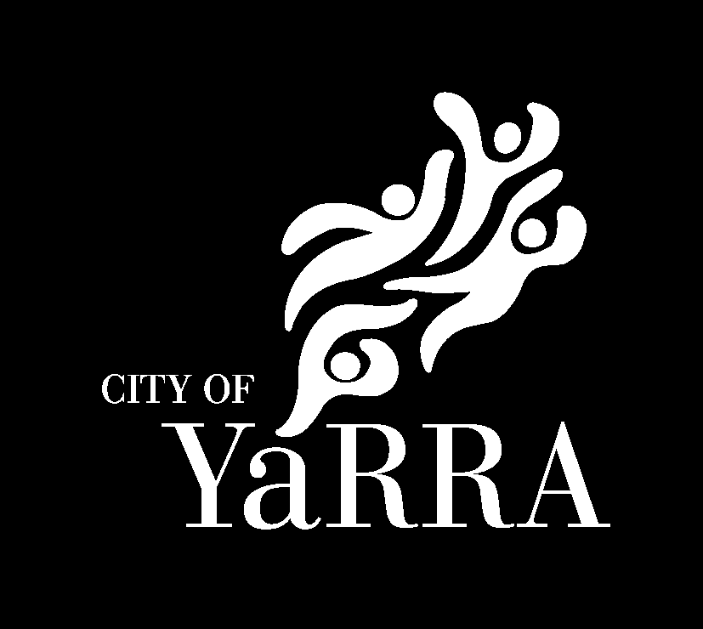

Yarra City Council acknowledges the Wurundjeri Woi Wurrung people as the Traditional Owners and true sovereigns of the land now known as Yarra. We also acknowledge the significant contributions made by other Aboriginal and Torres Strait Islander people to life in Yarra. We pay our respects to Elders from all nations and to their Elders past, present and future.

State of the assets

Asset Management Objective | 25/26 | Predicted 10-year average
Customer Satisfaction | 53.3 (24/25)
Infrastructure Assets Per Person ($) | $27,864 | $28,755
Depreciation Expense Per Person | $258.51 | $268.09
Renewal / Depreciation | 63.1% | 64.0%
Annual Maintenance / Replacement Cost | 0.66% | 0.67%
Capital delivery (% of budget) | 89% (24/25)

Council is investing in growing its assets to meet growth while also investing in renewing assets as they need it

What is asset management
The delivery of services to the community is guided by the Yarra 2036 Community Vision, Council Plan 2025-29, and Council’s other strategic documents including strategies, plans and policies. These services to the community rely on assets and the Asset Plan describes our how we use these assets to deliver services and managing these assets throughout their lifecycle in a financially sustainable manner.
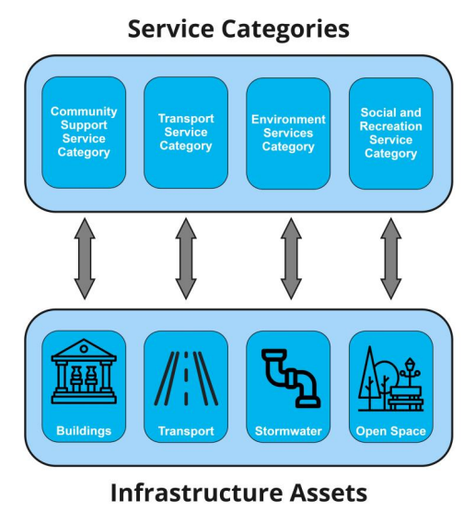
The Local Government Act 2020 requires all Victorian councils to develop, and keep current, an Asset Plan. The plan must cover a period of at least ten financial years and applies to the infrastructure assets under the control of Council.
The Asset Plan 2025-2035 contains information about how Council, in strategic and financial terms, will manage the portfolio of infrastructure assets under its control. The Asset Plan is linked with the budget and projections outlined in our Long Term Financial Plan to ensure the ongoing affordability and financial sustainability of the management of assets. Each year Council will review the asset plan alongside its budget to ensure spending matches needs and is based on the latest data.
Asset management includes all the activities Council does to assets to help deliver services to the community. This includes activities throughout the asset lifecycle including planning, acquisition / construction, maintenance, renewal/replacement, upgrade/expansion and disposal of assets. Asset related activities can broadly be grouped into the below categories.
 | Category | Description
Operating Expenditure | Operations | The regular activities to ensure the assets support the service (cleaning, utilities etc. excludes costs of the service itself such as early years staff/librarians etc.)
Operating Expenditure | Maintenance | The activities to preserve an asset including preventative maintenance and reactive repairs
Capital Expenditure | Renewal | Replacement of all or part of existing assets to improve condition, may be with a modern equivalent asset,
Capital Expenditure | Upgrade | Increase the service provided by existing assets. These may include functionality improvements to existing assets
Capital Expenditure | New | Creating new assets to allow service that did not exist previously

Management approach
The services that the community needs in the future to achieve the Community Vision 2036 will be different to what Council delivers today. This is due to population growth, changing demographics, climate change, demand change and many other factors. Council first focuses on looking after what we have before building more to ensure financial sustainability. Where the assets that Council needs to deliver these future services changes, this is guided by infrastructure planning strategies such as the Community Infrastructure plan, Transport Action Plan and Open Space Strategy. These changes are delivered through upgrade and new capital budgets.
Council regularly inspects its assets to determine their condition. These inspections may identify:
- Defects – minor issues to be addressed through maintenance (e.g. vertical displacements in footpaths, leaking taps)
- Functional issues – where the existing asset aren’t suitable for service delivery. Addressed through upgrade budgets (e.g. buildings without equitable access)
- Overall Condition – used to identify renewal capital projects that restore all or part of an asset’s condition. (e.g. resurfacing a road, refurbishing a toilet)
In addition to identifying short term renewal projects the current condition of assets is utilised to predict the future condition of assets. This allows Council to predict what renewals may be required in the future as well as predicting future maintenance demand. The condition scale used by Council and indicative maintenance demand at each condition score is outlined below.
Score | Description of condition | Maintenance demand
0 - Excellent | Brand new asset or recently refreshed to as new condition. | Nil
1 - Very Good | Asset is in very good overall condition | Proactive only
2 - Good | Minor defects may be present | Proactive & minor
3 - Average | Moderate deterioration. | Proactive & moderate
4 - Poor | High deterioration is evident. | High
5 - Very Poor | High level of deterioration, approaching unserviceability. | High, unplanned failures
6 – End of Life | Asset is no longer serviceable | NA, out of service
By taking a long term view of our asset spending Council has the ability to plan and optimise when we do projects, resulting in savings. Examples include:
- Undertaking upgrades at the same time as major renewals resulting in economies of scale (better prices by doing more at once) and less disruption to users
- Creating packages of work that can be delivered for better prices than the individual projects
- Upgrading assets to adapt to climate change when doing renewals (e.g. increasing drainage pipe sizes, increasing AC capacity)
Whilst Council has allowed for operational budgets to grow over time, in some cases maintenance needs can grow more than this. The maintenance we need to deliver may grow in excess of CPI due to; Council building more assets, Council becoming responsible for additional assets (built by developers or gifted from the state), assets in poor condition, or due to increased usage causing quicker deterioration. To continue delivering our existing service levels within constrained budgets Council may need to find efficiencies in how maintenance is delivered.
Asset management objectives help us to ensure our Assets are delivering for the community. These are aligned with Council’s Running the City Strategic Objective and focus on measuring how well we are delivering to the community. These are also aligned with the Vision Themes identified below.

State of the assets - Transport

Asset Management Objective | 25/26 | Predicted 10-year average
Customer Satisfaction | 60.6 (24/25)
Assets Per Person ($) | $10,310 | $10,485
Depreciation Expense Per Person | $166.24 | $166.31
Renewal / Depreciation | 44.9% | 43.4%
Annual Maintenance Budget / Asset Value | 0.38% | 0.39%

Transport renewal budgets have been set considering the current needs of the network. Transport financial value and deprecation are a focus in 25/26 with new condition assessment planned.

State of the assets – Buildings

Asset Management Objective | 25/26 | Predicted 10-year average
Customer Satisfaction | 69.4 (24/25)
Assets Per Person ($) | $4,829 | $5,227
Depreciation Expense Per Person | $50.02 | $53.91
Renewal / Depreciation | 76.2% | 90.6%
Annual Maintenance Budget / Asset Value | 0.88% | 0.84%

Council is growing its building portfolio and addressing functionality challenges through upgrade projects. This is balanced with our existing buildings’ needs.

State of the assets - Drainage

Asset Management Objective | 25/26 | Predicted 10-year average
Customer Satisfaction | 60.8 (24/25)
Assets Per Person ($) | $2,036 | $2,125
Depreciation Expense Per Person | $16.60 | $17.13
Renewal / Depreciation | 196.3% | 125.8%
Annual Maintenance Budget / Asset Value | 0.56% | 0.56%

Council is investing in both upgrading our drainage network to address climate change and managing our assets over their 100 year life to keep them in overall good condition

State of the Assets - Open Space

Asset Management Objective | 25/26 | Predicted 10-year average
Customer Satisfaction | 66.4 (24/25)
Assets Per Person ($) | $876 | $1,030
Depreciation Expense Per Person | $25.65 | $30.75
Renewal / Depreciation | 69.6% | 95.6%
Annual Maintenance Budget / Asset Value | 10.45% | 9.25%

Council is investing in enhancing our open spaces and managing the significant maintenance these spaces need

Asset Management Strategic Direction and Expenditure Categories
 |  | Transport | Buildings | Drainage | Open Space
Strategic Direction | Community Vision | Yarra is a vibrant, safe and inclusive environment. We celebrate and embrace our diversity and connection to each other and the land. Our community is empowered to work together and support one another with respect and trust.
Strategic Direction | Council Plan alignment | Building The City  3. Ensure people can move safely across the city using all modes of transport | Building the City  5. Provide infrastructure that responds to the current and future needs of a growing Yarra |  | Living in the City  1. Make our streets and shopping strips safer and more beautiful
Building the City
6. Provide green spaces and beautify the city
Strategic Direction | Council Plan alignment | Running the City  10. Ensure all decisions are financially sound, transparent and accountable to the community.  11. Ensure we deliver services that are fit for purpose and provide value to the community.  13. Manage Council’s land and building assets to maximise value to the local community.
Strategic Direction | New & Upgrade infrastructure planning | Moving Forward: Transport Action Plan | Community Infrastructure Plan, Property Strategy | Integrated water management plan | Yarra Open Space Strategy, Community Infrastructure Plan, Property Strategy
Strategic Direction | New & Upgrade infrastructure planning | Development Contributions Plan
Strategic Direction | New & Upgrade Programs (may include renewal) | Transport action plan and Road safety program, Street furniture program, Street light program, EV Charging and Parking Technology | Getting off gas, Pavilions, Grandstands, Youth centres, Maternal & Child Health Centres, Kindergarten, and Childcare | Flood mitigation works | New Open Space Program, Sports field and playing courts, Open Space and playgrounds, Rewilding and planting project
Strategic Direction | Ongoing Asset Renewal Programs | Roads, Laneways, Footpaths, Kerb and Channel Renewals | Whitegoods, Closed Circuit TV, Fire indicator panels, Plumbing, leisure centre works, Contaminated soil remediation, Asbestos management | Brick Drains, Drainage, Urgent drainage renewals | Open space furniture, Horticulture, Irrigation, Minor lighting, Minor turf, Pathways, Playgrounds, Signage, Sporting assets, Walls and Fences, Tree planting
Strategic Direction | Maintenance  (not limited to) | Inspections, Pavement, Kerb & Channel, Footpaths | Security, Programmed maintenance, AC maintenance | Inspections, unclogging | Weed management, streetscapes, bushlands
Strategic Direction | Asset Operations  (not limited to) | Street Lighting | Cleaning, Utilities | Street Sweeping | Cleaning, Mowing, utilities, graffiti management

Deliberative Community Engagement
We received feedback from people across Yarra as part of three stages of community engagement in late 2024 to late 2025. The engagement was structured to ensure it was as representative as possible of our diverse community, so everyone had a voice. The community engagement process was also designed to meet our obligations under the Local Government Act 2020 and Gender Equality Act 2020.

What you said
As part of the Yarra’s broad community engagement for our Integrated Strategic Planning it was identified that across the almost 1800 respondents “Responsible Asset Management” ranked third in importance behind “Promoting a safe and secure community” and “preserving and protecting local natural environments”
We worked with independent consultants to recruit a representative sample of the Yarra community through expressions of interest to form a 45 person Community Working Group (CWG). The CWG told us the following key messages were priorities to be considered by Council:
- Evidence-based and transparent decision-making.
- Foster and promote community wellbeing and cohesion.
- Grow and build better.
- Operational excellence and accountability.
- Sustainability and holistic decision-making.
“Prevention is better than a cure… being ready beforehand instead of reacting to a situation”
CWG member

What we heard from the Community Working Group

What we’re doing
The Asset Plan provides the opportunity for Council to grow and build better through understanding the long term impacts of decisions. It supports Council in making evidence based decision about assets considering the impact on Assets and Sustainability. By understanding our depreciation, renewal, maintenance, and operation costs and how it is impacted by new and upgraded assets we take a long term picture of asset funding.
Our long term projections also help make sure we are spending enough renewing our assets. If we don’t renew assets we both provide a lower level of service to the community, increase maintenance need and may create long term economic challenges for future generations.

Asset Management Maturity
Council’s most recent asset management maturity assessment is show in the below graph. This highlights that Council is achieving appropriate levels of maturity however opportunities exist particularly in managing future demand for assets through strategies such as the community infrastructure plan, implementing this Asset Plan and Asset Management Strategy (combined to form the Strategic AM plan) and improving our AM culture.

Asset Data Status
Asset Class | Asset Inventory | Asset Condition | Renewal Planning | Maintenance data | Growth and Function data
Transport | High | High | High | High | Medium
Buildings | High | High | Medium | Medium | Medium
Drainage | High | Medium | Medium | Medium | Medium
Open Space | High | High | Medium | Medium | Medium

Improvement plan

