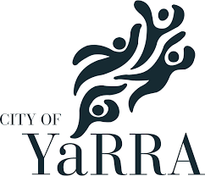

**Date:** 17 June. 10 am -12pm

**Venue:** Bargoonga Nagnjin

Community Room

182-186 St Georges Rd, Fitzroy North

**LUNCH PROVIDED**

**Preparing for Your NDIS Plan Review**

**This VALID Workshop includes:**

This **workshop** is aimed at assisting people with disability and their families make informed choices about how they set up and use their NDIS funding package and topics include:

* Why it is important to prepare for your NDIS Plan Review meeting
* Gathering your information e.g. quotes, schedule and evidence
* Key list of ‘what’s working well & what’s not working”
* Review your Participant Statement i.e. ‘about me’, goals
* Making decisions about how to you want to ‘manage the funds’

**Key Presenters:**

Each of the Family Team has worked in the disability sector for many years and have a family member with a disability who is funded as a participant of the NDIS. This combination of skills and knowledge provides the personal and professional perspective of working with the services and the NDIS to gain a good life for participants and their family members

**An NDIS Workshop for participants & families**

**For more information or to book this workshop contact:**

**Christine Scott ph:** 0418 567 518 **Email:** christine@valid.org.au