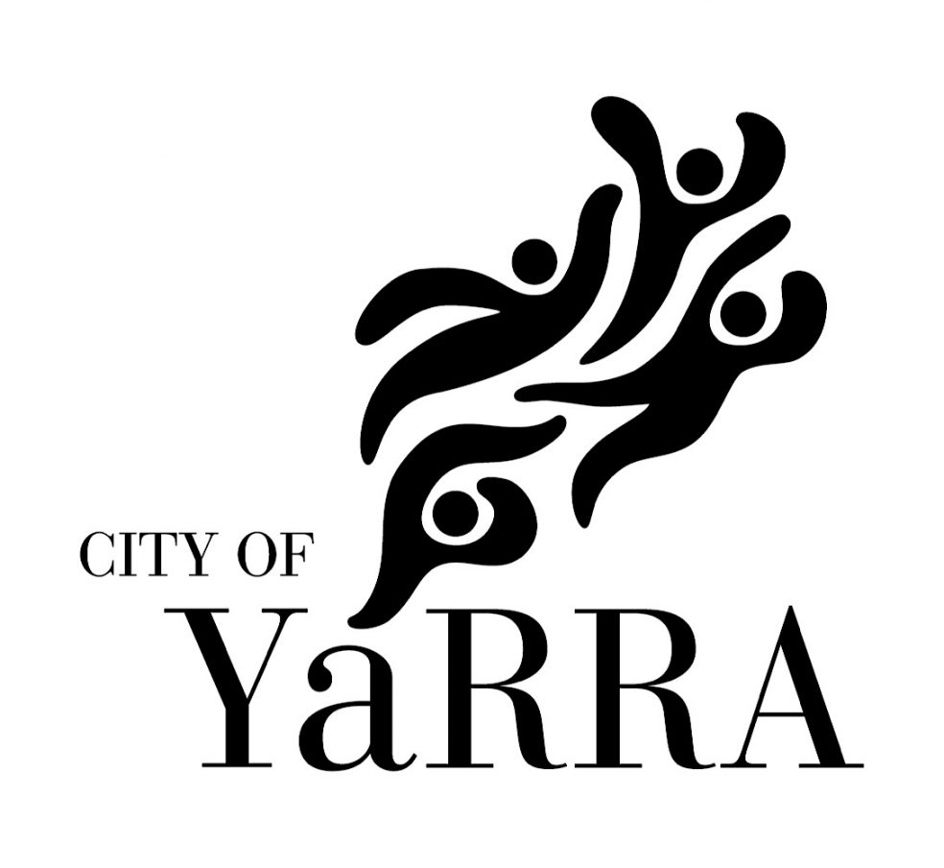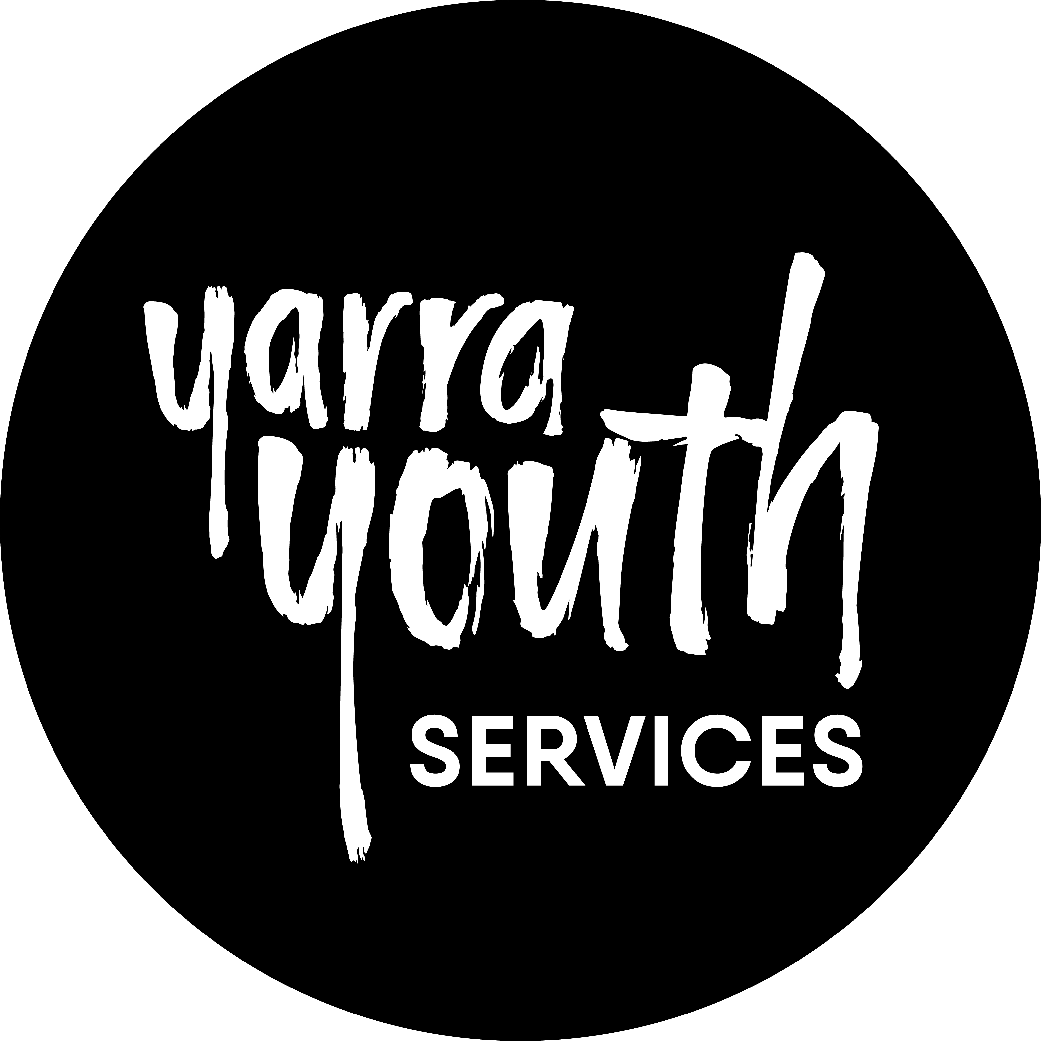

Yarra Youth Services
156 Napier St, Fitzroy 3065
www.yarracity.vic.gov.au/youngpeople
(03) 9205 5555
Date created : 1 November 2019
Date reviewed: 1 November 2020

The Yarra Youth Services Access key was developed by Madeleine Cleeve Gerkens and the City of Yarra.

Yarra City Council acknowledges the Wurundjeri as the Traditional Owners of this country, pays tribute to all Aboriginal and Torres Strait Islander people in Yarra, and gives respect to the Elders past and present.

Guidelines
- We take access and inclusion seriously. We are committed to making YYS as accessible and inclusive as possible for all members of our community. If you have a specific access requests, would like further information or want to provide any suggestions, we would love to hear from you! Please contact us via email at info@yarracity.vic.gov.au, or call us on 9205 5555.

Did You Know?
- Yarra Youth Services is a generalist service for young people aged between 12 and 25 years who live, work, study or have a connection to Yarra. The Yarra Youth Centre is a drug, alcohol and smoke free.
- Yarra Youth Services welcomes all young people from diverse backgrounds and lived experiences including CALD, ATSI, LGBTIQ young people and young people living with disability. The Yarra Youth Centre is an inclusive dedicated youth space that welcomes all young people.
- Yarra Youth Services run programs at lots of different places across Yarra like community centres, schools and parks. Many programs are held at the Youth Centre on Napier Street. To find out more visit www.yarracity.vic.gov.au/youngpeople, email info@yarracity.vic.gov.au, or call us on 9205 5555. You can also find us on Facebook (https://www.facebook.com/yarrayouthservices) and Instagram (@yarrayouthservices).
- Opening hours:
  - General opening hours: Monday – Friday 9.00am - 5:30pm
  - Program hours change daily, please see the City of Yarra website for details

Visitor map:

Parking:
- Visitor parking:
  - 2 hour restricted parking is available surrounding the Yarra Youth Centre:
    - 3 x 2 hour parks are available directly out the front of Yarra Youth Services
    - 4 x 2 hour parks are available near the Yarra Youth Centre’s accessible entrance
  - There is one accessible car park 100 metres from the Yarra Youth Centre (near corner of Napier and Condell Streets, outside the Fitzroy Town Hall)
- Employee parking:
  - 6 bay car park on Charles St side of the Yarra Youth Centre, with a cobbled stone floor
  - 3 bay car park on Little Charles St side of the Yarra Youth Centre, with a cobbled stone floor

Public Transport:
- The Yarra Youth Centre is located 210m from Brunswick St and the 11 tram line (King William/Brunswick St #14 is the closest stop). Trams on route 11 are usually low floor (wheelchair accessible), but sometimes high-floor trams are used in special cases. There are screens and automated announcements on all low floor trams and some high floor trams as well.
- The Yarra Youth Centre is located 294 metres from Smith St and the 86 tram (Charles St/Smith St #17 is the closest stop). Some trams on route 86 are low floor (wheelchair accessible), however, not always. There are screens and automated announcements on all low floor trams and some high floor trams as well. You can also get off the 86 tram on the corner of Gertrude St and Napier St (#14), YYS is 295m away.
- The closest train station to the Yarra Youth Centre is Parliament.
- 302, 303, 304, 305, 309, 318, 350, 906, 907 and 908 buses can be caught to the Australian Catholic University/Victoria Pde stop. Most buses in Victoria are low floored wheelchair accessible. Yarra Youth Centre is a 639m journey from this stop.
- 200 and 207 buses can be caught to the Napier St/Johnston St bus stop. The Yarra Youth Centre is a 555m journey from this stop.
Staff:
- Yarra Youth Services staff members wear yellow/orange City of Yarra lanyards
- There are photos of staff members to the left of the sink in the kitchen space
- If visitors require assistance please see staff

Main Entrances:
- There are two ways to access the main entrance of YYS
  - Path 1 (enter from Charles St) has an access ramp with handrails 7.5m length and 1.25m width.
  - Path 2 is on Napier St and has 3 steps with handrails
- There is wooden decking with no undercover area at the entrance of the Yarra Youth Centre
- Visitors enter by ringing doorbell and waiting for staff to come to the door
- The front door width is 92 cm, the door is not automated

Foyer:
- Once greeted by staff, visitors are welcome to wait in the foyer for a staff member to attend to them.
- The Foyer contains tables and seating with backrests and armrests
Sensory guide:
- Hear: people, kitchen sounds
- Feel: shared personal space, textured vinyl flooring
- Smell: food from kitchen, coffee
- See: natural lighting (glare), fluorescent lighting at night

Kitchen:
- Upon request tap and filtered hot and cold water is p in the kitchen (plastic straws can be provided)
- Backless stools are available to sit at kitchen bar
Sensory guide:
- Hear – whir from Fridge, people talking, music from upstairs/Main Space
- Smell – food, soap, coffee
- Feel – textured floor in the foyer and kitchen space
- See – automated sensor fluorescent lights, food preparation

Main Space:
- You can enter the Main Space via six steps with handrails, or travelling one level in the lift
- Female and male bathrooms and a non-binary/accessible bathroom are located to the left as you enter the Main Space
- The Main Space includes a ping pong table, pool table, chairs with padded backs, distorted mirrors, desk, printer and a computer
- The Main Space is often used for programs and occupied with young people hanging out/playing games
Sensory guide:
- See – sensor fluorescent lighting, mostly white walls, large windows overlooking trees and Charles St, glare
- Feel – shared personal space, heating/cooling, wooden floor boards
- Hear – heating/cooling vent, music, chatter from kitchen space, flushes from bathroom, loud talking/laughter (sometimes)

Lift:
- The lift is three levels high, it is accessible from every level
- Lift door width is 90cm.
Sensory guide:
- See – lights, mostly glass
- Hear - whirring noise once inside lift, loud beep when elevator opens, creaking
- Feel – weightlessness as lift takes off

Music Studio:
- Accessible via lift (2 levels up) or 20 steps with handrail
- The door to the music studio requires a staff key card to access. The door width is 87cm .
- The Music Studio is made up of a main room with four off shoot rooms with equipment for recording and creating music
- The main room has office chairs and sofas
Sensory guide:
- Feel – cooler/heater, shared personal space
- Sounds – music e.g. rap, electronic, instruments, people talking
- See – computer screens, equipment lights, sensory lights

Toilets:
- Toilets are located to the left as you enter the Main Space from the Foyer
- All toilets are clearly signed
- Entry to each toilet is via a manual door
- Includes:
  - There is a separate unisex, accessible toilet with manual door opening. The door width to this bathroom is 87.5cm.
  - There is a baby change area and shower in the accessible toilet.
  - Separate male and female toilets. With one ambulant toilet stall in each. The door widths to these bathrooms are 81.5cm.
  - There is an area to sit and wait (near the toilets, just within the Main Space) with back rests.
Sensory guide:
- See – blue, green, black, white tiles, sensory lights, mirror/reflections
- Hear – whir of fan, toilet flush, taps running, hand dryer, people
- Feel – cool, shared personal space, vinyl floor
- Smell – soap, disinfectant, bathroom smells

Block Studios (Art Studio):
- The main entry to Block Studios is through the Main Space and is accessible via two steps. The door width is 112cm.
- The wheelchair accessible path to the Studio is accessed via the staff carpark on Charles St (cobble stone flooring). Staff will open the padlocked gate to the courtyard and enter the Studio through the back door via the courtyard. The width of this gate is 348.5cm.
- There is also another ramp with railing access through Little Charles St
- There is a large central table that is used for arts programs and by Artists in Residence. The desk height is 76cm.
- The furniture set up often changes to the physical space.
Sensory guide:
- See – mirror, fluorescent lights
- Hear – fan noise, birds from outside, faint car noises, sometimes music
- Feel – heating/cooling, shared personal space, concrete floor
- Smell – faint odour of art supplies occasionally e.g. aerosol paint fumes

Digital Arts Hub:
- The Digital Arts Hub is accessible via both the Block Studios (door width 71.5cm) and the courtyard (door width 81.5cm).
- The Digital Arts Hub houses 3 Mac computers, used for programs and by Artists in Residence. The desk height is 72cm.
- There are plenty of comfortable office chairs with adjustable height and back rests.
- Artists in Residence have a small dedicated space in the Digital Arts Hub
Sensory guide:
- See – Computers, artwork on the wall, fluorescent lighting
- Hear – music, people
- Feel – shared space, carpeted floor
- Smell – no odour

Outdoor area:
- The main entrance to the outdoor area is through the Block Studios, this is not an accessible entrance due to the stairs that lead to the studio. The door width to the courtyard is 147cm.
- The wheelchair accessible path to the Studio is via Charles St staff car park (cobble stone flooring). Staff will open the padlocked gate to the courtyard The width of this gate is 348.5cm.
- The courtyard is often used for the Graffiti Diversion program and events
Sensory guide:
- See – graffiti over walls and floor, sunlight, boxing bag, small raised wooden stage and chairs
- Hear – wind, trees, birds, cars, music
- Feel – concrete flooring, slightly uneven due to some paving stones, breeze, shared personal space
- Smell – aerosol paint fumes at times

Back meeting room:
- While YYS doesn’t have a designated low-sensory space, this meeting room is a good option if someone is feeling overstimulated. The back room contains tables, seating with backrests and armrests, and a sofa for rest. Blinds can also be pulled down to make the room darker.
- The back meeting room is accessible via the Block Studio and via a ramp on Little Charles St. This ramp with railing is not suited to the circulation of wheelchairs due to a sharp turn. The door to the meeting room is 71.5cm (below the accessible width for doorway).
- The accessible entrance to this meeting room is to via Charles St staff car park (cobble stone flooring). Staff will open the padlocked gate to the courtyard enter through the back door of the Block Studios via the courtyard and pass through the Studio space.
- The back meeting room includes a sink and fridge. Hot and cold water is available.
- The back meeting room also contains a corridor of artist studios, up to two artists work in this space.
Sensory guide:
- See – Couches, tables, sink, microwave, kettle, toaster, fridge, storeroom
- Hear – occasionally people talking, music
- Feel – carpeted floor
- Smell – no odour

Exits:
- There are multiple exits at YYS, the two accessible exits are:
  - The main entrance, exit on to Charles St (door width is 92cm)
  - The secondary exit in the staff offices, exit onto Napier St (81.5cm)
- The side exit in the Main Space (near bathrooms) has a ramp, however, it is inaccessible to wheelchairs due to sharp turn. The door width is 99.5cm.
- The side exit from the back meeting room also has a ramp, however, it is inaccessible to wheelchairs due to sharp turn. The door width is 81.5cm.

Safety
- Varied terrain throughout including floorboards, textured vinyl, concrete, carpet
- TGSI (Tactile Ground Surface Indicators) on main entrance and before stairs
- Artificial and natural lighting throughout
- Clear space between furniture in the Foyer and Main Space to manoeuvre a mobility aid
- Often protruding objects in Block Studio, the furniture set up changes often
- Visible exit signs throughout
- Defibrillator is located in the Main Space, on the wall next to the bathrooms
- If first aid is required see a YYS staff member
- In the event of an emergency designated Wardens will communicate evacuation process.
- Evacuation map located on the wall left of sink next to kitchen

Accessibility:
- Lift access to all three levels
- Lift buttons are at an accessible height
- YYS staff are available to read information to visitors if required
- Assistance animals are welcome
- If you require an Auslan interpreter for Yarra Youth Services events please get in contact with Yarra Youth Services.
- If you require language interpretation please contact Yarra Youth Services

