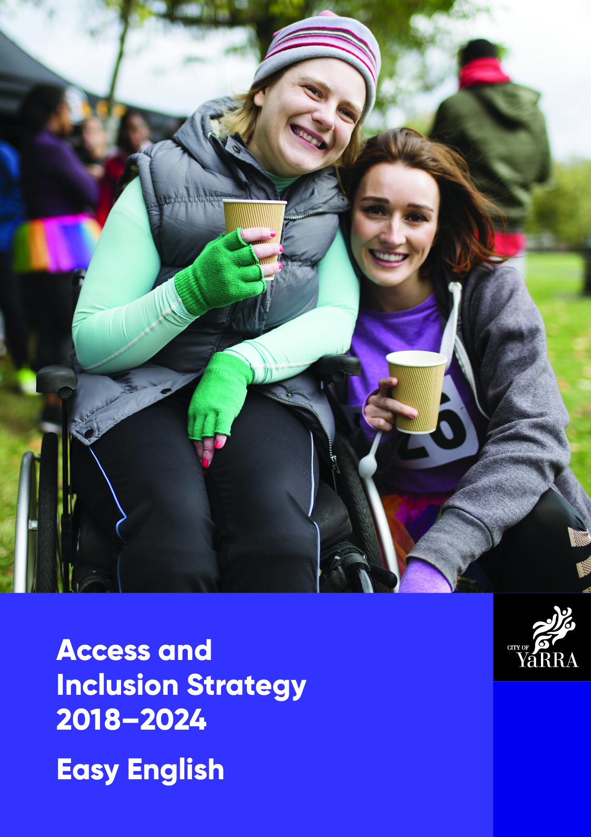

Access and Inclusion Strategy

2018-2024

About this booklet
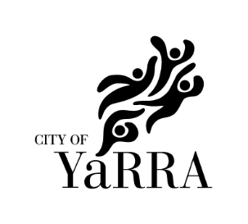
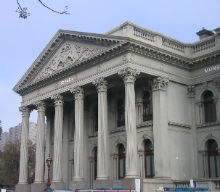
The City of Yarra Council wants to make sure
we support
- people with disability
- carers and families
and
- the local community.
We have made an Access and Inclusion Strategy.

This booklet explains our Strategy.

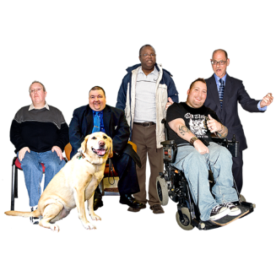
About our Strategy
To make our Strategy, we talked to people
with disability.

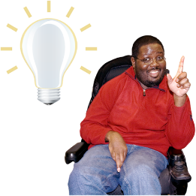
We asked people what would make their life better in the City of Yarra.

We listened to people’s ideas and are going to make changes.

Our Strategy says
- what we want to do
and
- how we will do it.
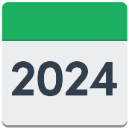
The Strategy will go from 2018 to 2024.

Every 2 years we will create an Action Plan.
The Action Plans will list the things we will do to achieve our goals.

What is in the Plan
Our Plan has 4 main ideas.
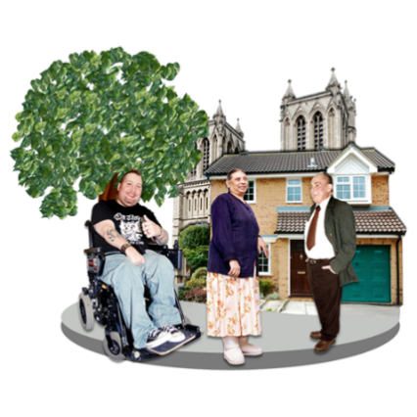
The City of Yarra will make it easier for people with disability to
- Access places in the community
- Enjoy programs in the community
- Get a job
- Feel welcomed and make choices
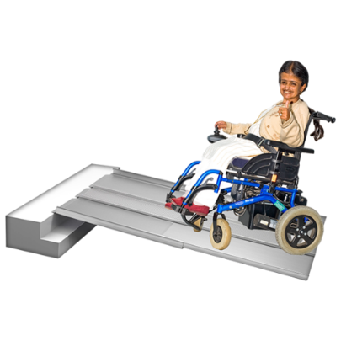

1. Accessing places in the community
Everyone should have equal rights to access services and community places like
- buildings, shops and cafes
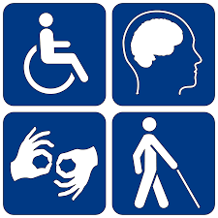
- buses, trains and trams
- houses
- parks
- footpaths
- public toilets.

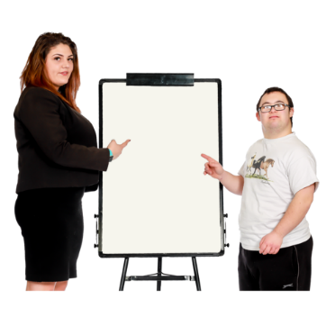
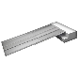
What the City of Yarra will do
We will help people who work for the
City of Yarra to make services and programs accessible for everyone.
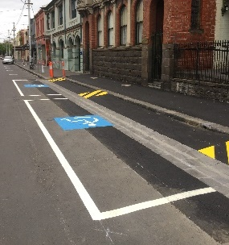
We will make better parking spots for
people with disability.

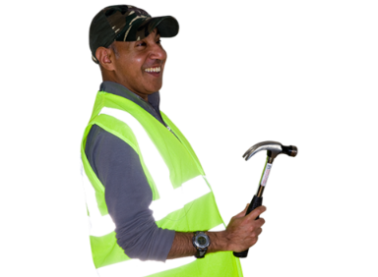
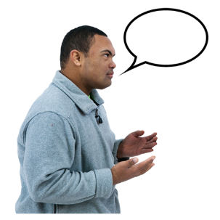
We will make buildings easier to access for everyone by sharing rules and ideas with
- people who make new buildings
- local businesses
- people who run shops and cafes.

2. Enjoying programs in the community
Everyone should be able to
- go out and meet friends
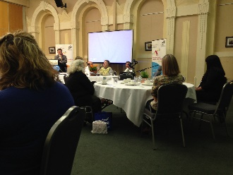
- enjoy movies, art shows and festivals
- play sport and be active
- go to City of Yarra meetings and events

What the City of Yarra will do

We will help people who work in the Leisure and Arts areas of the City of Yarra to make services accessible for everyone.

We will tell people who use City of Yarra places how to make their events accessible.

We participate in the Companion Card program.
With a Companion Card, people with disability can bring a support person to events for free.
We will provide more community transport for people with disability to get to events.

3. Getting a job
People with disability should have more support to find a job or learn skills at the City of Yarra.

What the City of Yarra will do
We will give 2 students with disability
work experience at the City of Yarra.

We will train 3 people with disability at the
City of Yarra.
We will advertise jobs at the City of Yarra where people with disability can see them.
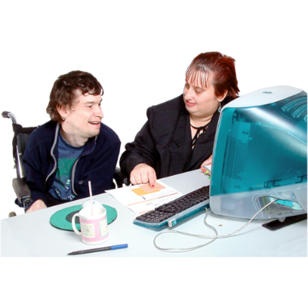
We will teach everyone who works at the City of Yarra how to empower people with disability in the workplace.

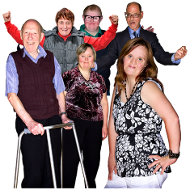
4. Feeling welcomed and making choices
Everyone should be able to learn about and access services from the City of Yarra.

We would like more people in the community to know about disability rights and needs.

What the City of Yarra will do
We will make all important documents easy to understand for everyone. We will use
- plain words
- good images
- clear designs
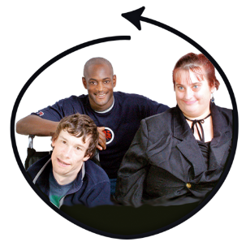
We will use pictures that show all the different kinds of people who live in our community.
We will have meetings and events to help people to learn about disability rights.

Questions
To learn more or ask questions about our Plan you can talk to the City of Yarra
Phone 03 9205 5555
Email info@yarracity.vic.gov.au

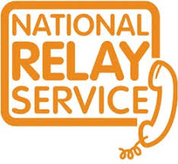
National Relay Service
If you are deaf or have a speech or hearing impairment you can call the City of Yarra by

Teletypewriter (TTY)
Phone 133 677
Ask for 03 9205 5555

Speak and listen
Phone 1300 555 727
Ask for 03 9205 5555

Internet relay
Visit the website relayservice.com.au
Ask for 03 9205 5555
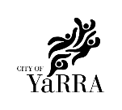
You can read the whole Plan on our website
Website yarracity.vic.gov.au

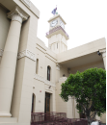
You can visit us to ask about the Plan at
Richmond Town Hall
333 Bridge Road
Richmond
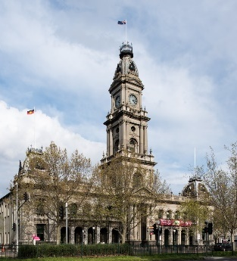
Collingwood Town Hall
140 Hoddle Street
Abbotsford

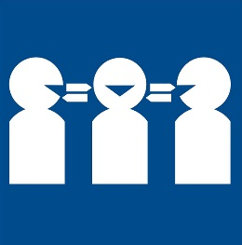
If you need the Plan in your language
Phone 9280 1940
Reference number 14025

Images from: Photosymbols www.photosymbols.com, OpenClipArt www.openclipart.org and Wikimedia Commons.
© City of Yarra – February 2019

