Date: 15 February 2019

Amendment C238 to the Yarra Planning Scheme

Yarra Development Contributions Plan

Part A Submission on behalf of Yarra City Council

TABLE OF CONTENTS
Introduction 3
Part A – Background to the Amendment 3
The Rationale for the Amendment 3
The Amendment 3
The Yarra Development Contributions Plan 2017 (30 July 2018) 5
Preparing and Processing the Amendment 6
Part B - Strategic context and assessment 7
Planning Policy Framework 7
Plan Melbourne 7
Precincts affected by current strategic land use planning 8
Policies and strategies 9
Part C - Chronology of events 12
Part D - Identification of issues raised in submissions and Council’s response 12
Part E - Proposed changes in response to issues raised in submissions 13
Conclusion 13

Introduction

These Part A submissions are prepared on behalf of the Yarra City Council (Council), the planning authority in respect of Amendment C238 to the Yarra Planning Scheme (the Amendment).

They respond to the Panel’s directions issued on 18 December 2018 and address the following matters:

a. background to the Amendment;

b. chronology of events;

c. strategic context and assessment;

d. identification of the issues raised in submissions and its response; and

e. changes to the Amendment documentation proposed as a result of the issues raised in submissions.
Part A – Background to the Amendment
The Rationale for the Amendment

The rationale for the DCP, and in turn for the Amendment, is succinctly stated at the commencement of the DCP:

The City of Yarra is experiencing significant development intensification on urban renewal sites and across established areas. The number of dwellings in the municipality is expected to increase from approximately 41,800 in 2016 to 64,600 in 2036. Retail and commercial floorspace is also expected to increase significantly whereas industrial floorspace is expected to reduce over time.

In this context, Council will be required to construct a range of new infrastructure items and upgrade, extend or replace existing infrastructure, in order to maintain and improve the functionality and amenity of the area.

To assist this significant task, the [DCP was prepared] to determine a fair and reasonable development contribution process for the City of Yarra. The purpose of the DCP is to ensure that the cost of providing new infrastructure is shared between developers and the wider community on a fair and reasonable basis. The funds collected via the developer contribution charge will be used to help deliver the required infrastructure.
The Amendment

Council has prepared Amendment C238 to the Yarra Planning Scheme to implement the DCP.

The Amendment applies to all land within the City of Yarra and affects new residential, retail, commercial and industrial development within the municipality within 10 charge areas (illustrated in Figure 1 below). Different levies are specified in respect of the different classes of development within each of the specified charge areas.

Figure 1: Subject Land

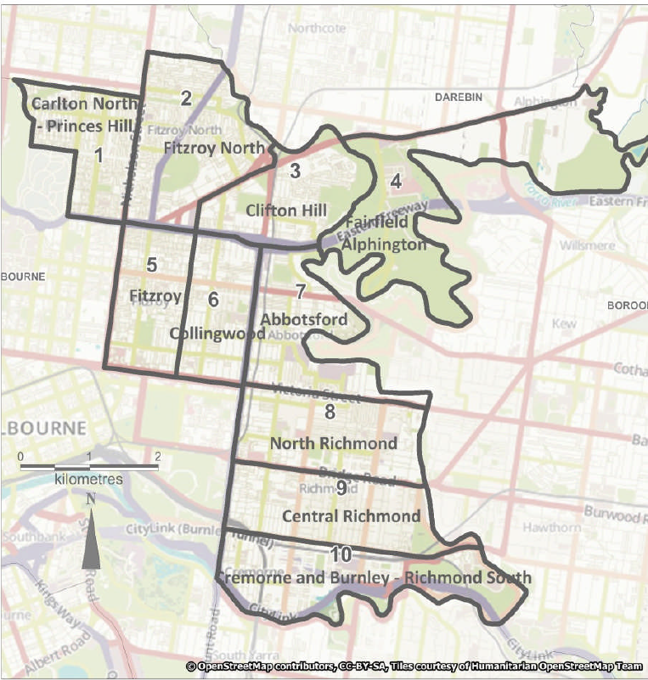

The Amendment proposes to make the following changes to the Yarra Planning Scheme (Scheme):

Insert a new Clause 45.06 (Development Contributions Plan Overlay) (DCPO) and a new Schedule 1 to Clause 45.06 (Yarra Development Contributions Plan 2017) (DCPO1).

Amend the Schedule to Clause 72.03 to include new Scheme maps.

Amend the Schedule to Clause 72.04 to incorporate the Yarra Development Contributions Plan 2017 into the Scheme.

DCPO1 is the main operative provision of the Amendment. It relevantly:

Provides that the DCP applies to all new development within the municipality within the 10 charge areas (at clause 1.0);

Contains a summary of the cost of the projects to be funded by the DCP, including the proportion of that cost that is to be attributable to new development (at clause 2.0);

Specifies that Council is both the Collection Agency and Development Agency in respect of the DCP and all of its projects (at clause 2.0);

Specifies the levies payable by residential development, retail development, commercial development, and industrial development in respect of both development infrastructure and community infrastructure within each of the 10 specified charge areas (at clause 3.0); and

Identifies classes of development that are exempt from the operation of the provision (at clause 4.0).

The project costs and levies specified in DCPO1 have been derived from, and are consistent with, the DCP.
The Yarra Development Contributions Plan 2017 (30 July 2018)

The stated purpose of the DCP is to ‘ensure that the cost of providing new infrastructure is shared between developers and the wider community on a fair and reasonable basis’.

The DCP has been prepared in accordance with the relevant requirements of the PE Act, the State Government’s Development Contributions Guidelines and the associated Ministerial Directions.

The DCP specifies a community infrastructure levy (CIL) and development infrastructure levy (DIL) to fund a range of social and physical infrastructure projects identified throughout the municipality. Development infrastructure is defined as infrastructure which is required for basic community health, safety or wellbeing (such as roads, paths, drainage and basic community infrastructure items). Community infrastructure includes construction of all other buildings or facilities that will be used for community or social purposes.

The DCP is based upon the following projections:

Type | 2016 | 2036 | Difference
Residential Dwellings | 41,740 | 64,602 | 22,862 (54.77%)
Retail Floorspace (sqm) | 709,091 | 1,150,961 | 441,870 (62.31%)
Commercial Floorspace (sqm) | 724,869 | 1,247,216 | 522,347 (72.06%)
Industrial Floorspace (sqm) | 987,239 | 807,035 | -180,204 (-18.25%)

These projections are based on a range of State and municipal-specific sources as described in the DCP.

Equivalence ratios are used where more than one land use is deemed to be a user of an infrastructure category. The common demand unit is one dwelling.

The exhibited DCP identifies 777 projects that qualify as either community infrastructure or development infrastructure and that are proposed to be undertaken within the municipality between 2016 and 2036. The total cost of these projects is $177.2 million.

Rather than collecting the entirety of the cost of these projects, however, the DCP is intended to collect only $55.8M over its life (such that the proportion of total cost attributable to new development is less than one third). This reflects the extent to which new development is anticipated to contribute toward the need for the infrastructure projects identified within the DCP.

Based on the summary of costs included in the draft DCPO1, $24.4M of the total $55.8M will be collected via the CIL, with the balance of funds (56%) being collected via the DIL. Contributions towards community facilities (funded via CIL) and paths (funded via DIL) make up 84% of the total funds to be collected.

There is no overlap between Council’s public open space levy and the DCP project items. This ensures there is no “double dipping” as the projects on each list would be accounted for separately.
Preparing and Processing the Amendment

The DCP was prepared by Hill PDA Consulting in consultation with Council Officers.

In November 2017, Council noted an officer report outlining the proposed DCP for the municipality, and resolved to seek authorisation from the Minister to prepare and exhibit the Amendment.

On 23 May 2018, Council wrote to the Department of Environment, Land, Water and Planning (DELWP) addressing the outcomes of a review conducted in respect of the project list proposed for the DCP.

By letter of 22 July 2018, the Minister authorised Council to prepare the Amendment subject to the following conditions:

The exhibited Yarra Development Contributions Plan 2017 is to include the revisions outlined in council's letter to the [DELWP] dated 23 May 2018. This includes removing projects that relate exclusively to repairs or maintenance of existing infrastructure that would be required irrespective of there being any new development in the municipality.

The exhibited Schedule 1 to the Development Contributions Plan Overlay is to be revised to improve clarity, generally in accordance with Attachment 1 to this letter.

The Minister’s authorisation noted that:

Throughout the amendment process, council should be prepared to demonstrate that each DCP project meets the 'need' and 'nexus' requirements of the legislative framework for development contributions in Victoria and as set out in the Development Contributions Guidelines …

The changes referred to in the Minister’s authorisation letter were made to the documents prior to the exhibition of the Amendment.

The Amendment was placed on public exhibition from 23 August 2018 until 21 September 2018. A total of 25 submissions were received.

In October 2018, Council noted an officer’s report regarding the exhibition of the Amendment and resolved (amongst other things):

to note and consider the submissions to the Amendment as detailed in Attachment 2 to the report;

to request the Minister to appoint an independent panel to consider the Amendment and all submissions received; and

that the wording of the exemptions in section 8 of the DCP (30 July 2018) be replaced with the exemption wording in Clause 4.0 of DCPO1.

The Amendment C238 Panel was appointed on 7 November 2018.

A directions hearing was conducted before the Panel on 17 December 2018. The hearing before the Panel will be commence on 25 February 2019.
Part B - Strategic context and assessment
Planning Policy Framework

Clause 19 of the Scheme encourages planning authorities to consider the use of development contributions in the funding of infrastructure in an efficient, equitable, accessible and timely way.

The Amendment is consistent with Clause 19.03-1S (Development and infrastructure contributions plans) which has the objective “to facilitate the timely provision of planned infrastructure to communities through the preparation and implementation of development contributions plans and infrastructure contributions plans.” The strategies to implement this objective are to:

Prepare development contributions plans and infrastructure contributions plans, under the PE Act, to manage contributions towards infrastructure.

Collect development contributions based on approved development and infrastructure contributions plans.

Require annual reporting by collecting and development agencies to monitor the collection and expenditure of levies and the delivery of infrastructure.

Planning authorities should consider as relevant the following policy documents:

the Development Contributions Guidelines when preparing a DCP (Department of Sustainability and Environment, June 2003 – as amended March 2007) (DCP Guidelines); and

Ministerial Direction on the Preparation and Content of Development Contribution Plans.

These documents were considered in the preparation of the DCP.
Plan Melbourne

The Victorian Government’s current metropolitan planning strategy, Plan Melbourne 2017-2050 (Plan Melbourne), aims to create a city where most of a person’s everyday needs are within a 20-minute walk, cycle or local public transport trip.

Plan Melbourne includes Yarra, along with the Cities of Melbourne and Port Phillip, in the inner metro region, which in 2015 had a combined estimated resident population of approximately 325,000. The Victoria in Future (VIF) 2016 projections forecast the regional population to grow to 495,000 by 2031, and to 695,000 by 2051.

To manage the supply of housing in Melbourne, it is expected that established areas (including Yarra) will accommodate a greater share of housing growth. Plan Melbourne provides an aspirational outlook of 70% of new housing being provided within Melbourne’s established areas.

It is also expected that new housing will be directed to activity centres and other places that offer good access to jobs, services and public transport.

Plan Melbourne identifies five major activity centres in Yarra:

Brunswick Street, Fitzroy;

Smith Street, Collingwood/Fitzroy;

Bridge Road, Richmond;

Swan Street, Richmond; and

Victoria Street, Richmond.

Yarra also has seven designated neighbourhood activity centres; including:

Johnston Street, Collingwood/Abbotsford;

Queens Parade, North Fitzroy/Clifton Hill;

Gertrude Street, Fitzroy;

Heidelberg Road, Alphington;

Nicholson Village, North Fitzroy/Clifton Hill;

Rathdowne Village, Carlton North; and

North Fitzroy Village (St Georges Road), North Fitzroy.

Whole of municipality DCPs have also been approved in Banyule, Brimbank, Darebin (now expired) and Moreland. These municipalities have adopted a similar approach to the Yarra DCP.
Precincts affected by current strategic land use planning

Council is presently in the process of preparing a series of structure plans, built form frameworks and local plans for each of its major and neighbourhood activity centres.

Interim controls have recently been approved for:

Johnston Street (DDO15 gazetted on 2 March 2018 via C237).

Queens Parade (DDO20 gazetted on 23 August 2018 via C241).

Swan Street (DDO17 gazetted on 22 November 2018 via C236).

Bridge Road (DDO21 gazetted on 15 November 2018 via C248).

Victoria Street (DDO22 gazetted on 15 November 2018 via C249).

Table 2 identifies the land area proposed to be rezoned. The zone changes are being proposed through individual planning scheme amendments for each area. The proposed rezonings are generally located in or near to Yarra’s activity centres. If approved, they would support further commercial and residential development in the centres, consistent with state planning policies. The ultimate outcomes of these amendments are unknown and may vary from their exhibited form. For this reason the DCP has been prepared based on the existing statutory and strategic framework. The periodic review of the DCP will ensure that changing strategic conditions are factored into the subsequent iterations of the DCP.

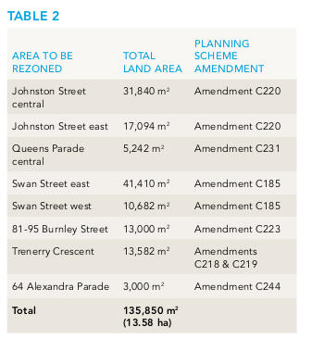
Policies and strategies

The development of the DCP was originally supported by three background papers:

Background Paper No. 1: Demographics – identifying the type and location of population changes in Yarra;

Background Paper No. 2: DCP projects – identifying the projects suitable for inclusion in the DCP and the process for identifying projects; and

Background Paper No. 3: DCP charge areas – outlining the basis for selecting the charge areas.

Using Council’s 10 year capital works program as a starting point, projects were identified as being suitable for inclusion in the DCP as either community infrastructure or development infrastructure. Then, depending on the charge area in which the infrastructure is located, and the growth that is predicted in that charge area, the contribution attributable to new development was calculated.

The DCP has two infrastructure charges which relate to:

Community Infrastructure which is currently capped at $1,150 per dwelling for the financial year beginning on 1 July 2018, and is referenced as community facilities community infrastructure (CFCI) in the DCP;

Development Infrastructure which includes land for infrastructure, engineering infrastructure, and is referenced as community facilities development infrastructure (CFDI), drainage development infrastructure (DRDI), pavement development infrastructure (PADI) and road development infrastructure (RDDI) in the DCP.

Council has developed the LTFS over a 10 year period to provide financial management and guidance to support service delivery and the capital works program.

New, renewal and upgrade projects were identified through the Council plan, policies, master plans, strategies, asset management plans and identified service needs. Renewal projects were principally derived from adopted asset management plans, whilst new and upgrade projects were sourced from adopted Council strategies/polices or master plans.

The strategic documents which form the basis of project selection are, for the most part, a product of a public consultation process which includes public exhibition and community engagement before being formally adopted by Council.

The asset management plans, strategies and policies that guide the capital works program include:

Access and Inclusion Plan 2014 to 2017

Arts and Cultural Strategy 2016 to 2020

Asset Management Policy 2011

Asset Management Policy 2017

Bike Strategy 2010-2015 part 1

Bike Strategy 2010-2015 part 2

Bike Strategy September 2016

Bridge Rd Streetscape Masterplan

Buildings Asset Management Plan adopted 2013

Buildings Asset Management Plan revision 2017

Community Infrastructure Planning Framework

Events in Public Places Policy

Early Years Strategy 2015-2018

Economic Development Strategy 2015-2020

Encouraging and Increasing Walking Strategy 2005

Final Stage Two Action Plan 2014-2017

Guidelines for Public Art in Private Development in Yarra

Local Area Traffic Management Policy 2013

Local Area Place Making Policy 2017

Long Term Financial Strategy June 2016

Long Term Financial Strategy 2017/18 to 2026/27

Middle Years Strategy 2014- 2017

Nicholson Street Place Making Initiative Concept Design

Night Time Economy Strategy 2014-2018

Open Space Strategy 2006-2016

Parking Management Strategy Action Plan 2013-2015

Positive Ageing Strategy 2007-2016

Public Art Policy 2015 to 2020

Road Management Plan 2013

Social and Affordable Housing Strategy 2012-2014

Strategic Advocacy Framework November 2013

Stormwater Drainage Management Strategy

Strategic Transport Statement 2006

Victoria Street Streetscape Masterplan

Urban Design Strategy 2011

Water Sensitive Urban Design Policy 2016

Yarra Health Plan 2013-2017

Yarra Youth Policy Action Plan 2013 to 2016

In response to the Panel’s direction at paragraph 12, electronic copies of all policies and other strategic documents listed in paragraph 49 above are available on Council’s website at:

www.yarracity.vic.gov.au/amendmentC238

For the sake of completeness, it is noted that post-exhibition, Council has endorsed the following additional economic and housing strategies:

On 4 September 2018, Council adopted the Yarra Housing Strategy.

On 4 September 2018, Council adopted the Spatial and Economic Strategy (SEES).

Part C - Chronology of events

The following table provides a chronology of key events in respect of the Amendment:

Description | Date
Council meeting regarding the Yarra Development Contributions Plan and Council resolution that, among other things, to seek authorisation from the Minister to prepare and exhibit Amendment | 21 November 2017
Letter from Council to DELWP regarding the project list | 23 May 2018
Minister for Planning authorisation to prepare the Amendment | 22 July 2018
Submissions made in response to the Amendment | 23 August 2018 until 21 September 2018
Council meeting regarding consideration of submission and Council resolution that, among other things:  Council note and consider submissions to the Amendment;  Council refer the submissions, including any late submissions, to an independent panel appointed by the Minister; and  Council request the Minister to appoint an independent panel. | 30 October 2018
Letter from Panel to Council confirming appointment of Panel | 7 November 2018
Panel directions hearing held | 17 December 2018
Panel directions letter | 18 December 2018
Part A submission to be circulated | 15 February 2019
Expert evidence to be circulated | 15 February 2019
Expert witness conclave to be held | 19-21 February 2019
Panel hearing scheduled to commence | 25 February 2019
Part D - Identification of issues raised in submissions and Council’s response

The Amendment was placed on public exhibition from 23 August 2018 until 21 September 2018.

In response to exhibition, a total of 25 submissions were made in respect of the Amendment. Of these submissions 7 oppose the amendment, 6 support the Amendment but request more to be included in the list of projects, and 12 support the proposal without qualification.

In summary those opposing the Amendment did so for a range of reasons including (but not limited to):

the projects being identified in the Council’s capital works program;

the alleged lack of relationship between the development and the proposed projects;

the lack of transitional arrangements; and

the impact of the DCP on affordability and commercial impacts.

Council has documented its initial analysis of, and responses to, these submissions. Council will provide further responses to these submissions during the course of the Panel hearing.
Part E - Proposed changes in response to issues raised in submissions

Council has been in discussions with Submitter 9 and Submitter [##] in respect of the operation of the Amendment as it concerns Cremorne. The status of any agreement reached between Council and the relevant submitters will be communicated to the Panel upon the commencement of the hearing.

Council only proposes one other substantive change in response to the issues raised in submissions.

The wording of the exemptions contained in the exhibited DCPO1 and the incorporated document DCP Report are slightly different. To avoid any confusion, the wording in the DCP is proposed to be altered to be consistent with the Overlay. The changes are contained in the report are shown as tracked changes in the document in Attachment 3.

Council also notes that Submission 20 with respect to the GTV9 site at 22 Bendigo Street, Richmond has requested that, on the basis that substantial contributions have been made as part of the redevelopment, the site be listed as an individual exclusion from the DCP. On the basis of the requirements of the Development Plan Overlay Schedule 5 (DPO5) ‘Channel Nine Site, Bendigo Street, East Richmond’ which applies to the site and includes a section 173 Agreement which deals with the provision of these contributions, officers agreed that the site should be exempted from the DCP. However, where possible, site specific exemptions in the planning scheme should be avoided. The exemption provisions in the Overlay are clear and cover the GTV9 site. Specific reference to the GTV9 site is accordingly unnecessary. Council’s position in this respect has been confirmed by letter from Council to the owner of the land.

It is noted finally that Council anticipates making a number of further modifications to the DCP in line with recommendations contained within the Mesh Consultants peer review conducted in respect of the DCP.

A working draft of the revised DCP and planning controls addressing these matters will be presented to the Panel as part of Council’s case.
Conclusion

These Part A submissions address the matters identified by the Panel in its directions of 18 December 2018.

Council’s final position on the Amendment, and its response to the submissions made in respect of the Amendment, will be addressed further in its Part B submission and in expert evidence heard before the Panel.
15 February 2019
HARWOOD ANDREWS
on behalf of Yarra City Council

See page 1 of the DCP.
See page 5 of the DCP.
See, for instance, at page 20.
See Table 2 of the DCP.
See Table 3 of the DPC for a summary of projects and Appendix 2 of the DPC for the full list of projects.
See Clause 2.0 to DCPO1.
Plan Melbourne 2017-2050, Five-Year Implementation Plan, page 43.
Banyule Amendment C115 (Adopted by Council on 8 October 2018 - awaiting Gazettal).
Brimbank Amendment C187 (Gazetted on 25 January 2018).
Moreland Amendment C133 (Gazetted 10 September 2015).
Yarra Housing Strategy, p 56.
Available at: https://www.yarracity.vic.gov.au/the-area/planning-for-yarras-future/yarra-planning-scheme-and-amendments/current-amendments/amendment-c238-development-contributions-plan.
Available at: https://www.yarracity.vic.gov.au/the-area/planning-for-yarras-future/adopted-strategies-and-plans/housing-strategy.
Available at: https://www.yarracity.vic.gov.au/the-area/planning-for-yarras-future/current-projects/spatial-economic-and-employment-strategy.
See Attachment 2 to the officer report regarding exhibition of Amendment dated 30 October 2018.
See Attachment 3 to the officer report regarding exhibition of Amendment dated 30 October 2018 at pages 41-42.

