Planning and Environment Act 1987

YARRA planning scheme

AMENDMENT C237

EXPLANATORY REPORT

Who is the planning authority?
This amendment has been prepared by the Yarra City Council, which is the planning authority for this amendment.

Land affected by the Amendment
The Amendment applies to land in Precincts 1 and 2 (Subject Land) as identified in the Johnston Street Local Area Plan (Figure 1).

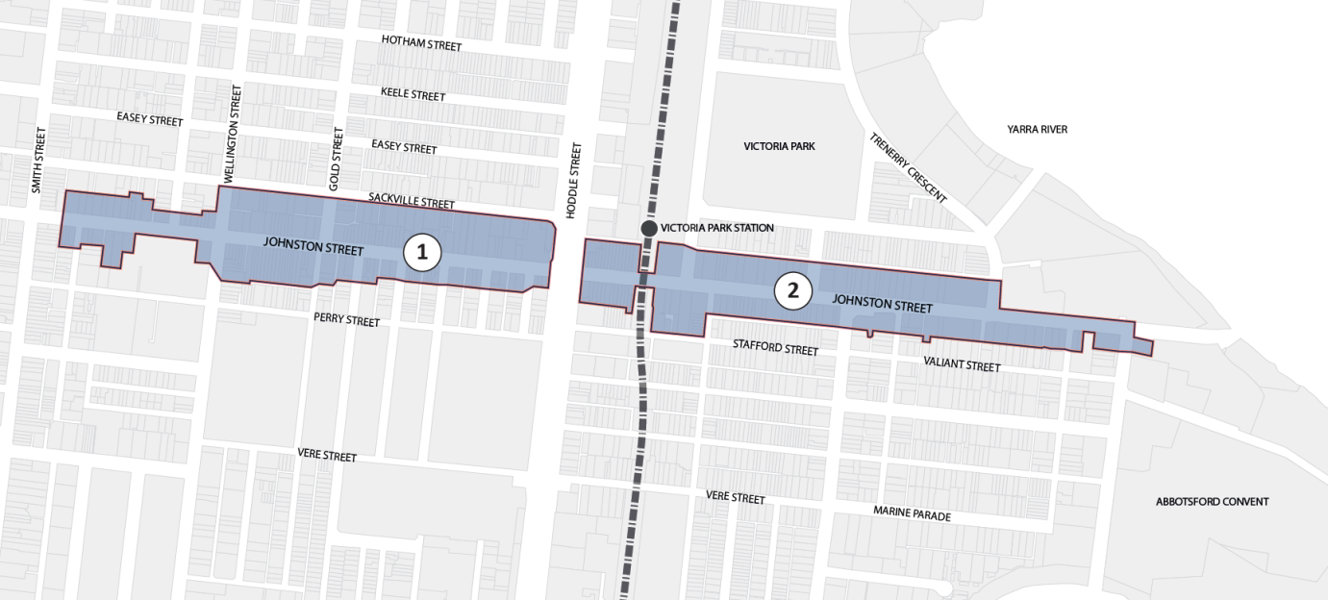
Figure 1: Subject Land

What the amendment does
The Amendment implements the land use and built form objectives and strategies within the Johnston Street Local Area Plan that relate to Precincts 1 and 2 (Johnston Street).
The Amendment proposes to make the following changes:
- Insert a new Schedule to Clause 43.02 Design and Development Overlay (DDO15), which applies to land in the Johnston Street Activity Centre.
- Amends Map Nos. 6DDO and 7DDO to apply Schedule 15 to the Design and Development Overlay to land in the Johnston Street Activity Centre.
- Apply a new Heritage Overlay precinct to the following properties:

HO Number | Precinct Name | Properties Included in HO
HO505 | Johnston Street East | 219-241 Johnston Street, Abbotsford  246-274 Johnston Street, Abbotsford
- Insert a new reference document at Clause 21.11 titled Heritage Gap Study: Review of Johnston Street East, March 2016 within clause 22.02 - Development Guidelines for Sites Subject to the Heritage Overlay;
- Amend the existing Appendix 8 incorporated document listed in the schedule to clause 81.01 to include the addresses and gradings of all new and revised places;
- Rename the existing Appendix 8 incorporated document in Clause 22.02 and in the schedule to clause 81.01 to refer to the new revised date; and
- Amend the schedule to Clause 43.01 (Heritage Overlay).

Strategic assessment of the Amendment

Why is the Amendment required?
The Amendment is required to implement the built form and land use recommendations of the Johnston Street Local Area Plan, 2015.
Amendment C237 is required to provide a DDO with mandatory and discretionary built form provisions for a period of 2 years while permanent provisions undergo the full planning scheme amendment process via Amendment C220, including exhibition, planning panel, adoption, and approval.
The Amendment will ensure that future development and land use change is in accordance with the vision, objectives and strategies outlined in the Johnston Street Local Area Plan, 2015.

How does the Amendment implement the objectives of planning in Victoria?
The Amendment implements the objectives in Section 4 of the Planning and Environment Act 1987 (the Act), in particular:
- to provide for the fair, orderly, economic and sustainable use, and development of land;
- to secure a pleasant, efficient and safe working, living and recreational environment; and
- to conserve and enhance those buildings, areas or other places which are of scientific, aesthetic, architectural or historical interest, or otherwise of special cultural value;
- to balance the present and future interests of all Victorians.
The Amendment is consistent with the VPPs by encouraging and facilitating positive change in the Johnston Street Neighbourhood Activity Centre.
The Amendment will facilitate dwelling and economic growth to create an economically viable, mixed-use activity centre that provides economic and social benefits for the local area.

How does the Amendment address any environmental, social and economic effects?
The Amendment is consistent with the overarching goal in the planning scheme to:
Integrate relevant environmental, social and economic factors in the interests of net community benefit and sustainable development.
The Amendment will have positive social and economic effects through the facilitation of well-designed buildings accommodating higher density housing above commercial activity, situated along an activity centre corridor that is well served by public transport.
The Amendment addresses any environmental effects or risks through the application of the Environmental Audit Overlay.

Does the Amendment address relevant bushfire risk?
There is no identified bushfire risk within the study area.

Does the Amendment comply with the requirements of any Minister’s Direction applicable to the amendment?
The Amendment complies with Ministerial Direction No. 1 in addressing the risk from Potentially Contaminated Land.
The Amendment complies with Ministerial Direction No. 9 in addressing and responding to the metropolitan planning strategy, Plan Melbourne.
The Amendment complies with Ministerial Direction No. 15 which sets out the requirements on the form and content of planning schemes.

How does the Amendment support or implement the State Planning Policy Framework and any adopted State policy?
The Amendment supports and implements State Planning Policy in responding to the following clauses:
- 11.01-2 Activity centre planning
To encourage the concentration of major retail, residential, commercial, administrative, entertainment and cultural developments into activity centres which provide a variety of land uses and are highly accessible to the community.
- 11.02-3 Structure planning
To facilitate the orderly development of urban areas.
- 13.03-1 Use of contaminated and potentially contaminated land
To ensure that potentially contaminated land is suitable for its intended future use and development, and that contaminated land is used safely.
- 15.01-1 Urban Design
To create urban environments that are safe, functional and provide good quality environments with a sense of place and cultural identity.
- 15.01-2 Urban Design Principles
To achieve architectural and urban design outcomes that contribute positively to local urban character and enhance the public realm while minimising detrimental impact on neighbouring properties.
- 15.01-4 Design for safety
To improve community safety and encourage neighbourhood design that makes people feel safe.
- 15.01-5 Cultural identity and neighbourhood character
To recognise and protect cultural identity, neighbourhood character and sense of place.
- 15.03-1
To ensure the conservation of places of heritage significance.
- 16.01-2 Location of residential development
To locate new housing in or close to activity centres and employment corridors and at other strategic redevelopment sites that offer good access to services and transport.
- 16.01-3 Strategic redevelopment Sites
To identify strategic redevelopment sites for large residential development in Metropolitan Melbourne.
- 17.01-1 Business
To encourage development which meet the communities’ needs for retail, entertainment, office and other commercial services and provides net community benefit in relation to accessibility, efficient infrastructure use and the aggregation and sustainability of commercial facilities.

How does the Amendment support or implement the Local Planning Policy Framework, and specifically the Municipal Strategic Statement?
The Amendment is consistent with and facilitates the following Clauses of the Local Planning Policy Framework:

21.03 Vision

21.04-2 Activity centres
Objective 4 To maintain a balance between local convenience and regional retail roles in Yarra’s activity centres.
Strategy 4.1 Increase the range of retail, personal and business services, community facilities, and recreation activities, within individual centres.
Strategy 4.3 Support the role of all activity centres, including Neighbourhood Activity Centres, in providing local day-to-day needs of residents of all abilities.
Objective 5 To maintain the long term viability of activity centres.
Strategy 5.2 Support land use change and development that contributes to the adaptation, redevelopment and economic growth of existing activity centres.
Strategy 5.3 Discourage uses at street level in activity centres which create dead frontages during the day.
Strategy 5.4 Permit residential development that does not compromise the business function of activity centres.
Objective 7 To encourage the arts and arts venues.
Strategy 7.1 Support a diversity of arts uses such as live music venues, performance spaces, galleries and artist studios in appropriate and accessible locations.

21.05-1 Heritage
Objective 14 To protect and enhance Yarra's heritage places.
Strategy 14.1 Conserve, protect and enhance identified sites and areas of heritage significance including pre-settlement ecological heritage.
Strategy 14.2 Support the restoration of heritage places.
Strategy 14.3 Protect the heritage skyline of heritage precincts.
Strategy 14.6 Protect buildings, streetscapes and precincts of heritage significance from the visual intrusion of built form both within places and from adjoining areas.

21.05-2 Urban design
Objective 16 To reinforce the existing urban framework of Yarra.
Strategy 16.2 Maintain and strengthen the preferred character of each Built Form Character Type within Yarra.
Objective 19 To create an inner city environment with landscaped beauty.
Strategy 19.1 Require well resolved landscape plans for all new development.
Strategy 19.2 Encourage opportunities for planting suitable trees and landscape areas in new development.
Objective 20 To ensure that new development contributes positively to Yarra's urban fabric.
Strategy 20.1 Ensure development is designed having particular regard to its urban context and specifically designed following a thorough analysis of the site, the neighbouring properties and its environs.
Objective 21 To enhance the built form character of Yarra’s activity centres.
Strategy 21.1 Require development within Yarra’s activity centres to respect and not dominate existing built form.
Strategy 21.2 Require new development within an activity centre to consider the context of the whole centre recognising that activity centres may consist of sub-precincts, each of which may have a different land use and built form character.
Strategy 21.3 Support new development that contributes to the consolidation and viability of existing activity centres.

The Amendment is consistent with and supported by the following local policies under Clause 22:

- 22.02 Development guidelines for sites subject to the Heritage Overlay
- 22.05 Interface uses policy
- 22.07 Development abutting laneways
- 22.09 Licenced premises
- 22.10 Built form and design policy
- 22.12 Public open space contribution policy

Does the Amendment make proper use of the Victoria Planning Provisions?
The Amendment is consistent with the objectives of State Planning Policy and the Victorian Planning Provisions.

How does the Amendment address the views of any relevant agency?
Council sought the views of VicRoads, the Department of Human Services, Public Transport Victoria and VicTrack in the drafting of the Johnston Street Local Area Plan which informs this Amendment and Amendment C220 which is to go through a formal exhibition process.

Does the Amendment address relevant requirements of the Transport Integration Act 2010?
The Amendment is consistent with the requirements of the Transport Integration Act 2010 and will facilitate development outcomes that promote the principles of transit oriented development.

Resource and administrative costs
The Amendment will have some impact on the general operation of Council’s statutory planning department which is covered by Council’s budget.

Where you may inspect this Amendment
The Amendment is available for public inspection, free of charge, during office hours at the following Yarra City Council locations:

Planning Counter  Richmond Town Hall  333 Bridge Road  Richmond VIC 3121 | Information Counter  Collingwood Town Hall  140 Hoddle Street  Abbotsford VIC 3067
Amendment C220 web page (Yarra City Council web-site):
www.yarracity.vic.gov.au/amendmentC237
The Amendment can also be inspected free of charge at the Department of Environment, Land, Water and Planning website at www.delwp.vic.gov.au/public-inspection.

