SCHEDULE 17 TO CLAUSE 43.02 DESIGN AND DEVELOPMENT OVERLAY
DD/MM/YYYY
Proposed C236

Shown on the planning scheme map as DDO17.

Swan street activity centre
1.0 General design objectives
DD/MM/YYYY
Proposed C236
- To recognise and respond to the distinct character and varying development opportunities defined by the four precincts along Swan Street:
- Precinct 1 – Richmond Station
- Precinct 2 – Swan Street Activity Centre
- Precinct 3 – Swan Street East
- Precinct 4 – Burnley Station.
- To support a new mid rise scale built form character (5 to 12 stories) with lower built form at the interfaces with streets and the adjoining low rise residential areas that:
- Maintains an active, high quality and pedestrian friendly environment.
- Provides a high quality interface to all streets and public spaces, and to laneway and pedestrian connections to Swan Street and each of the railway stations - Richmond, Burnley and East Richmond.
- Provides for variation in the skyline.
- To ensure new development respects the unique architectural form and the qualities of heritage buildings, precincts and the heritage streetscapes.
- To minimise the amenity impacts on residential properties adjoining the Swan Street Activity Centre including overlooking, overshadowing and visual bulk impacts.
- To ensure that vehicular access to development does not adversely impact the level of service, efficiency and safety of the arterial and tram network.

2.0 Buildings and works
DD/MM/YYYY
Proposed C236
A permit is required to construct a building or construct or carry out works.

2.1 Definitions
Street-wall is the facade of a building. Street wall height is measured at the vertical distance between the footpath at the centre of the frontage and the highest point of the building at the street edge, with the exception of architectural features and building services.
Building height is measured from the footpath to the highest point of the building, with the exception of architectural features and building services.
Building height does not include architectural features and service equipment including plant rooms, lift overruns, structures associated with green roof areas and other such equipment provided that all of the following criteria are met:
- The total roof area occupied by the equipment (other than solar panels) is minimised;
- The equipment is located in a position on the roof so as to minimise its visibility and minimise additional overshadowing of neighbouring properties and public spaces;
- The equipment does not extend higher than 3.6 metres above the maximum building height; and
- The equipment and screening is integrated into the design of the building to the satisfaction of the responsible authority.
Setback is the shortest horizontal distance from a building façade, including projections such as balconies, building services and architectural features, to the boundary.
Parapet height does not include features such as brackets, pediments, urns, finials or other decorative elements.
Road boundary is the boundary between the public road and the private property.
Shared zone is a road or network of roads where pedestrians, cyclists and vehicles share the roadway.
Upper level is development above the height of the street wall.

2.2 General design requirements
The following general design requirements apply to an application to construct a building or construct or carry out works and must be read in conjunction with the relevant precinct design requirements.

2.2.1 Building heights
A permit cannot be granted to construct a building or construct or carry out works which exceeds the mandatory maximum building height shown in the Height and Interface Plans (Plan 1, 3, 5 and 7).
A permit may be granted to construct a building or construct or carry out works which exceeds the preferred building height shown in the Height and Interface Plans (Plan 1, 3, 5 and 7) where all the following requirements are met to the satisfaction of the responsible authority:
- the built form outcome as a result of the proposed variation satisfies the general design objectives in Clause 1.0, the relevant precinct design requirements specified in this schedule, and the provisions of Clause 21.11-2;
- the proposed building height achieves the preferred future mid-rise character for Swan Street of generally 5 to 12 storeys; and
- the proposal will achieve each of the following:
- greater building separation than the minimum requirement in this schedule
- housing for diverse households types, including people with disability, older persons, and families, through the inclusion of varying dwelling sizes and configurations
- universal access, and communal and / or private open space provision that exceeds the minimum standards in Clauses 55.07 and 58
- excellence for environmental sustainable design measured as a minimum BESS project score of 70%
- no additional amenity impacts to residentially zoned properties, beyond that which would be generated by a proposal that complies with the preferred building height.

2.2.2 Street wall and setbacks
A permit can only be granted to construct a building or construct or carry out works which are in accordance with the relevant mandatory street wall height and setback requirements specified in the relevant Precinct Design Requirements.
A permit may be granted to vary the preferred maximum street wall height and the preferred minimum setbacks specified in the relevant table in Clause 2.3 of this schedule if the development meets the general design objectives and responds to the relevant Precinct Design Requirements to the satisfaction of responsible authority.

2.2.3 Overshadowing
A permit can only be granted to construct a building or construct or carry out works which is in accordance with the mandatory overshadowing requirements specified in the relevant Precinct Design Requirements.
A permit may be granted to construct a building or construct or carry out works which are not in accordance with the preferred overshadowing guidelines specified in the relevant precinct where the resultant overshadowing would not unreasonably prejudice the amenity of the public space to the satisfaction of the responsible authority.

2.2.4 Vehicle and pedestrian access
Development should provide vehicular access from rear lanes or from side streets in the preferred locations in the Access and Movement Plans (Plan 2, 4, 6 and 8) except in locations identified as “Left in - Left Out Access Permitted” in the Access and Movement Plans (Plan 2, 4, 6 and 8).
Development identified as “Left in - Left Out Access Permitted” in the Access and Movement Plan should limit the width of vehicle crossovers and incorporate ‘Left in’ and ‘Left out’ only vehicle access.
Development with redundant vehicle access points to Swan Street, Church Street and Burnley Street should reinstate the kerb, linemark parking bays, and relocate any parking signs.
Vehicle ingress and egress into development, including loading facilities and building servicing, should be designed to ensure a high quality pedestrian amenity and limit potential conflict between vehicle movements and pedestrian activity.
Pedestrian access to buildings, including upper level apartments, should be from a street or a shared zone shown on the Access and Movement Plans (Plan 2, 4, 6 and 8). Where pedestrian access can only be provided from a laneway at the rear of buildings the pedestrian entrance should be setback off the rear laneway to enable safe access for pedestrians.

2.3 Precinct design requirements
The following specific Precinct Design Requirements apply in addition to the general design requirements at clause 2.2.

2.3.1 Precinct 1 – Richmond Station
Shown on the planning scheme map as DDO17-1
The Precinct Design Requirements for Precinct 1 are as follows:
- Development should create an entry into Swan Street by reinforcing a consistent built form edge to the street.
- The street wall of development on the corner of Swan Street and Punt Road should mark the entry into the Swan Street Activity Centre.
- The street wall of new development east of Wellington Street should reflect the height and fine grain articulation of the heritage buildings.
- Development should improve the pedestrian environment and amenity of the streetscape along Swan Street and the streets leading to the Cremorne Employment Precinct through high quality architectural design and improvements to the public realm.

Building Height | Development should not exceed the preferred building heights shown on Plan 1.
Street wall heights and setbacks | Development should not exceed the relevant preferred street wall height requirements or reduce the preferred setbacks specified in Table 1 and shown on Plan 1.  Development should be designed to adopt the same street setback from all interfaces for a minimum of 65% of the height of upper levels to avoid repetitive stepped form.  Development at 1 Stephenson Street must be setback to accommodate the provision and construction of a 3.0 metre wide pedestrian connection between Stephenson Street and Swan Street as shown on Plan 2
Building Separation | Where development shares a common boundary and no interface treatment is shown in Plan 1, upper level development should:  - be setback a minimum of 4.5m from the common boundary, where a habitable window or balcony is proposed  - be setback a minimum of 3.0m from the common boundary where a commercial or non habitable window is proposed.  Where the common boundary is a laneway, the setback is measured from the centre of the laneway.
Building Facades and Street Frontages | Frontages at ground floor and within the street wall should be designed with floor to floor ceiling heights suitable to accommodate commercial activity.  Frontages at ground floor should incorporate verandahs, consistent with the form and scale of adjoining verandahs, into the façade design.
Upper Levels | Upper level development should be designed to ensure buildings are expressed in the round and provide detail on facades when viewed from all directions.
Overshadowing | Development should not overshadow any part of the opposite footpath of Cremorne Street (measured as 2.0 metres from the boundary of Cremorne Street between 10am and 2pm at 22nd September)
Heritage | For development within and immediately adjoining a Heritage Overlay the requirements in Table 5 apply.
Access and movement | Development at 1 Stephenson Street must construct a 3.0m wide pedestrian connection as shown on Plan 2 and be designed to activate and provide passive surveillance to this connection.  Vehicle and pedestrian access must be in accordance with the requirements of Clause 2.2.4 and Plan 2.

Table 1 – Street Wall Heights and Setbacks for Precinct 1
Interface Ref | Design Element | Mandatory Requirements | Preferred Requirements
A | Street wall height |  | 21m maximum
 | Street wall setback |  | 0m
 | Upper level setback |  | 5m minimum
C | Street wall Height |  | 11m maximum (3 storeys) or the parapet height of the adjoining individually significant or contributory building if higher than 11m.  8m minimum.  Match the parapet height of the taller adjoining heritage building.
 | Street wall setback | 0m
 | Upper level setback | Minimum 5m for individually significant heritage buildings. | Minimum 5m elsewhere.  Any part of a building above the street wall should be designed to ensure that it occupies no more than one third of the vertical angle defined by the whole building in the view from a sight line of 1.7 metres (on the opposite side of the street).
F | Street wall height |  | 11m (3 storeys).
 | Street wall setback |  | 0m.
 | Upper level setback |  | 3m minimum.
H | Street wall height |  | N/A.
 | Street wall setback |  | 0m minimum unless setback is identified on Plan 2.
 | Upper level setback |  | 0m.
I | Side and rear wall height |  | 8m maximum on a common boundary with a property in a residential zone.  11.5m maximum if boundary abuts a laneway.
 | Side and rear boundary setback |  | 0m.
 | Upper level setback |  | Development should be setback in accordance with Figure 1 and Figure 2.  Development should minimise repetitive stepped form.

Plan 1: Height and Interface Plan – Precinct 1 – Richmond Station

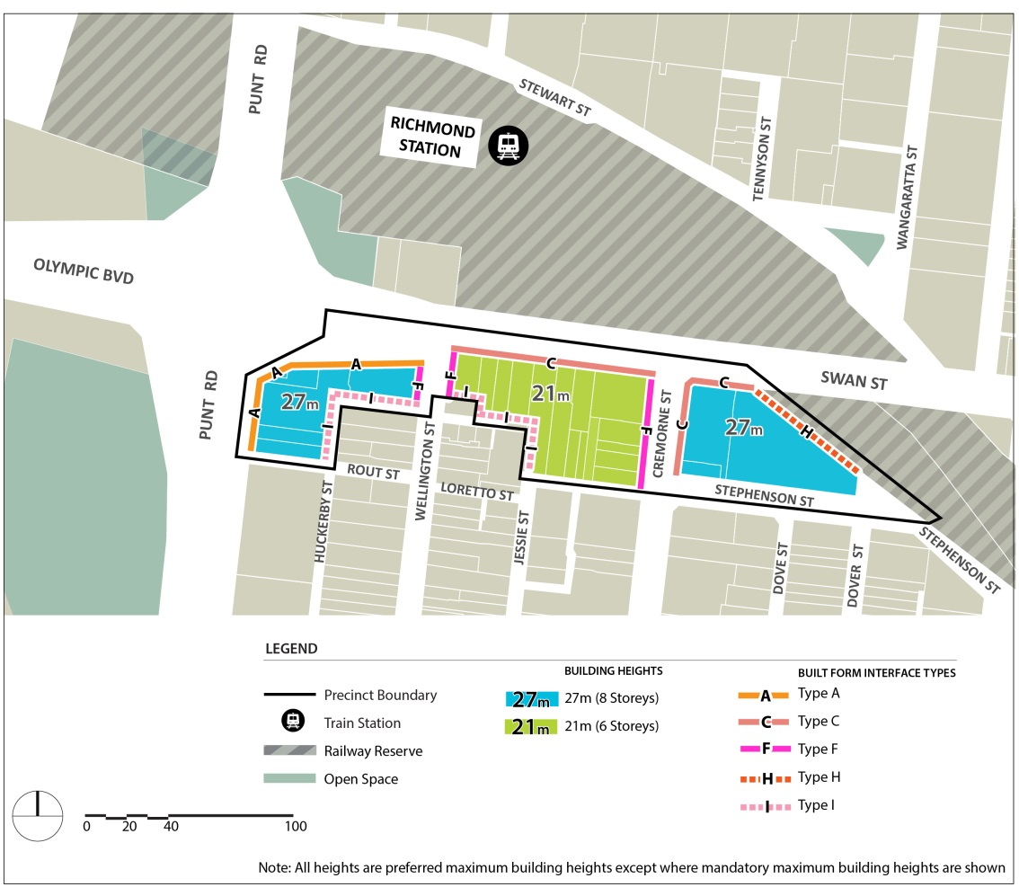
Plan 2: Access and Movement Plan – Precinct 1 – Richmond Station

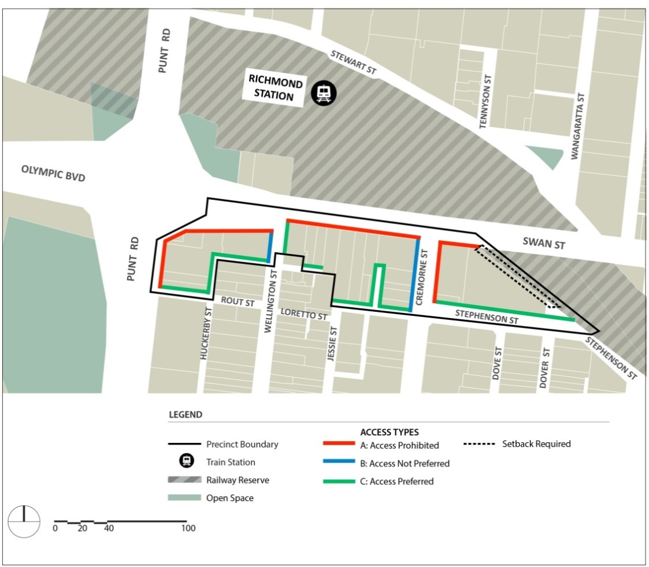

2.3.2 Precinct 2 – Swan Street Activity Centre
Shown on the planning scheme map as DDO17-2
The Precinct Design Requirements for Precinct 2 are as follows:
- Development should respect the consistent scale, grain and architectural quality of the heritage precinct, including the highly intact heritage streetscapes and the individually significant buildings in the precinct.
- Development along the rail corridor should avoid a continuous wall of taller development when viewed from local streets south of the rail corridor.
- Development on the south side of Swan Street should maintain Dimmey's Tower as the prominent landmark in the streetscape when viewed from the northern footpath of Swan Street east of the rail bridge and west of Church Street.
- Taller built form adjoining the rail corridor should not compete with the architectural form and complexity of the Dimmey's Clock Tower.
- Development should improve the pedestrian environment and amenity of streets and laneways that provide pedestrian connection to Swan Street, Church Street, East Richmond Train Station, and entrances to buildings.
- Development adjoining Milton Place should be designed to address the potential future public park adjoining East Richmond Railway Station.

Building Height | Development must not exceed the mandatory building heights shown on Plan 3.  Development should not exceed the preferred building heights shown on Plan 3.
Street wall heights and setbacks | Development must not exceed the relevant mandatory street wall height requirements or reduce the mandatory setbacks specified in Table 2 and shown on Plan 3.  Development should not exceed the relevant preferred street wall height requirements or reduce the preferred setbacks specified in Table 2 and shown on Plan 3.  Development should be designed to adopt the same setback from all street interfaces for a minimum of 65% of the height of upper levels to avoid repetitive stepped form.  Development of 108-120 Swan Street and 2 Kipling Street must be setback to accommodate the provision and construction of a widened laneway of 6.0m as shown in Plan 4.  Development of 94-98 Swan Street must be setback to accommodate the provision and construction of a widened laneway of 3.0m as shown in Plan 4.  Development must be setback to accommodate the provision and construction of a 2m pedestrian footpath on properties fronting Railway Place as shown on Plan 4.
Building Separation | Where development shares a common boundary and no interface treatment is shown in Plan 3, upper level development should:  - be setback a minimum of 4.5m from the common boundary, where a habitable window or balcony is proposed  - be setback a minimum of 3.0m from the common boundary where a commercial or non habitable window is proposed.  Where the common boundary is a laneway, the setback is measured from the centre of the laneway.
Building Facades and Street Frontages | Frontages at ground floor and within the street wall should be designed with floor to floor ceiling heights suitable to accommodate commercial activity.  Frontages at ground floor should incorporate verandahs, consistent with the form and scale of adjoining verandahs, into the façade design.
Upper Levels | Upper level development should be designed to ensure buildings are expressed in the round and designed to provide detail on facades when viewed from all directions.
Overshadowing | Development must not overshadow any part of the southern footpath of Swan Street (measured as 4.0 metres from the southern road boundary of Swan Street between 10am and 2pm at 22nd September).  Development must not overshadow any part of the opposite footpath of Church Street (measured as 4.0 metres from the road boundary of Church Street between 10am and 2pm at 22nd September).  Development should not overshadow any part of the opposite footpath of Lennox Street, Stanley Street, Clifton Street and Docker Street, (measured as 2.0 metres from the road boundary of the street between 10am and 2pm at 22nd September).  Development should not overshadow any part of the potential future open space adjacent to the East Richmond Station (measured as beyond 7.0m from the eastern road boundary of Milton Place and beyond 10.0m from the southern road boundary of Milton Place between 10am and 2pm at 22nd September).
Heritage | For development within and immediately adjoining a Heritage Overlay the requirements in Table 5 apply.
Access and movement | Development of 108-120 Swan Street and 2 Kipling Street must construct a widened laneway of 6.0m as shown on Plan 4.  Development of 94-98 Swan Street must construct a widened laneway of 3.0m as shown on Plan 4.  Development of properties fronting Railway Place must construct a pedestrian footpath of a minimum of 2m as shown on Plan 4.  Development should facilitate the creation of a shared zone where properties abut a future shared zone as shown on Plan 4.  Vehicle and pedestrian access must be in accordance with the requirements of Clause 2.2.4 and Plan 4.

Table 2 – Street Wall Heights and Setbacks for Precinct 2
Interface Ref | Design Element | Mandatory Requirements | Preferred Requirements
B | Street wall height | 11m maximum (3 storeys) or the parapet height of the adjoining individually significant or contributory building if higher than 11m.  8m minimum. | Match the parapet height of the adjoining heritage building.
 | Street wall setback | 0m
 | Upper level setback | 5m minimum setback | For all development in a heritage overlay, any part of the building above the heritage street wall should be designed to ensure that it occupies no more than one third of the vertical angle defined by the whole building in the view from a sight line of 1.7 metres (on the opposite side of the street).
C | Street wall Height |  | 11m maximum (3 storeys) or the parapet height of the adjoining individually significant or contributory building if higher than 11m.  8m minimum.  Match the parapet height of the taller adjoining heritage building.
 | Street wall setback | 0m
 | Upper level setback | 5m minimum for individually significant heritage buildings. | Minimum 5m elsewhere.  Any part of a building above the street wall should be designed to ensure that it occupies no more than one third of the vertical angle defined by the whole building in the view from a sight line of 1.7 metres (on the opposite side of the street).
D | Street wall height | 11m maximum (3 storeys) or the parapet height of the adjoining individually significant or contributory building if higher than 11m.  8m minimum. | Match the parapet height of the taller adjoining heritage building.
 | Street wall setback | 0m.
 | Upper level setback | 10m minimum for development up to 21m (6 storeys).  20m minimum for any height above 21m (storeys).
F | Street wall height |  | 11m (3 storeys).
 | Street wall setback |  | 0m.
 | Upper level setback |  | 5m minimum for land affected by HO335 and individually significant buildings.  3m minimum elsewhere.
G | Street wall height |  | 14m (4 storeys) maximum.
 | Street wall setback |  | 0m.
 | Upper level setback |  | 3m minimum.
H | Street wall height |  | N/A.
 | Street wall setback |  | 0m minimum unless setback is identified on the Plan 4.
 | Upper level setback |  | 0m.
I | Side and rear wall height |  | 8m maximum on a common boundary with a property in a residential zone.  11.5m maximum if boundary abuts a laneway.
 | Side and rear boundary setback |  | 0m.
 | Upper level setback |  | Development should be setback in accordance with Figure 1 and Figure 2.  Development should minimise stepped form.

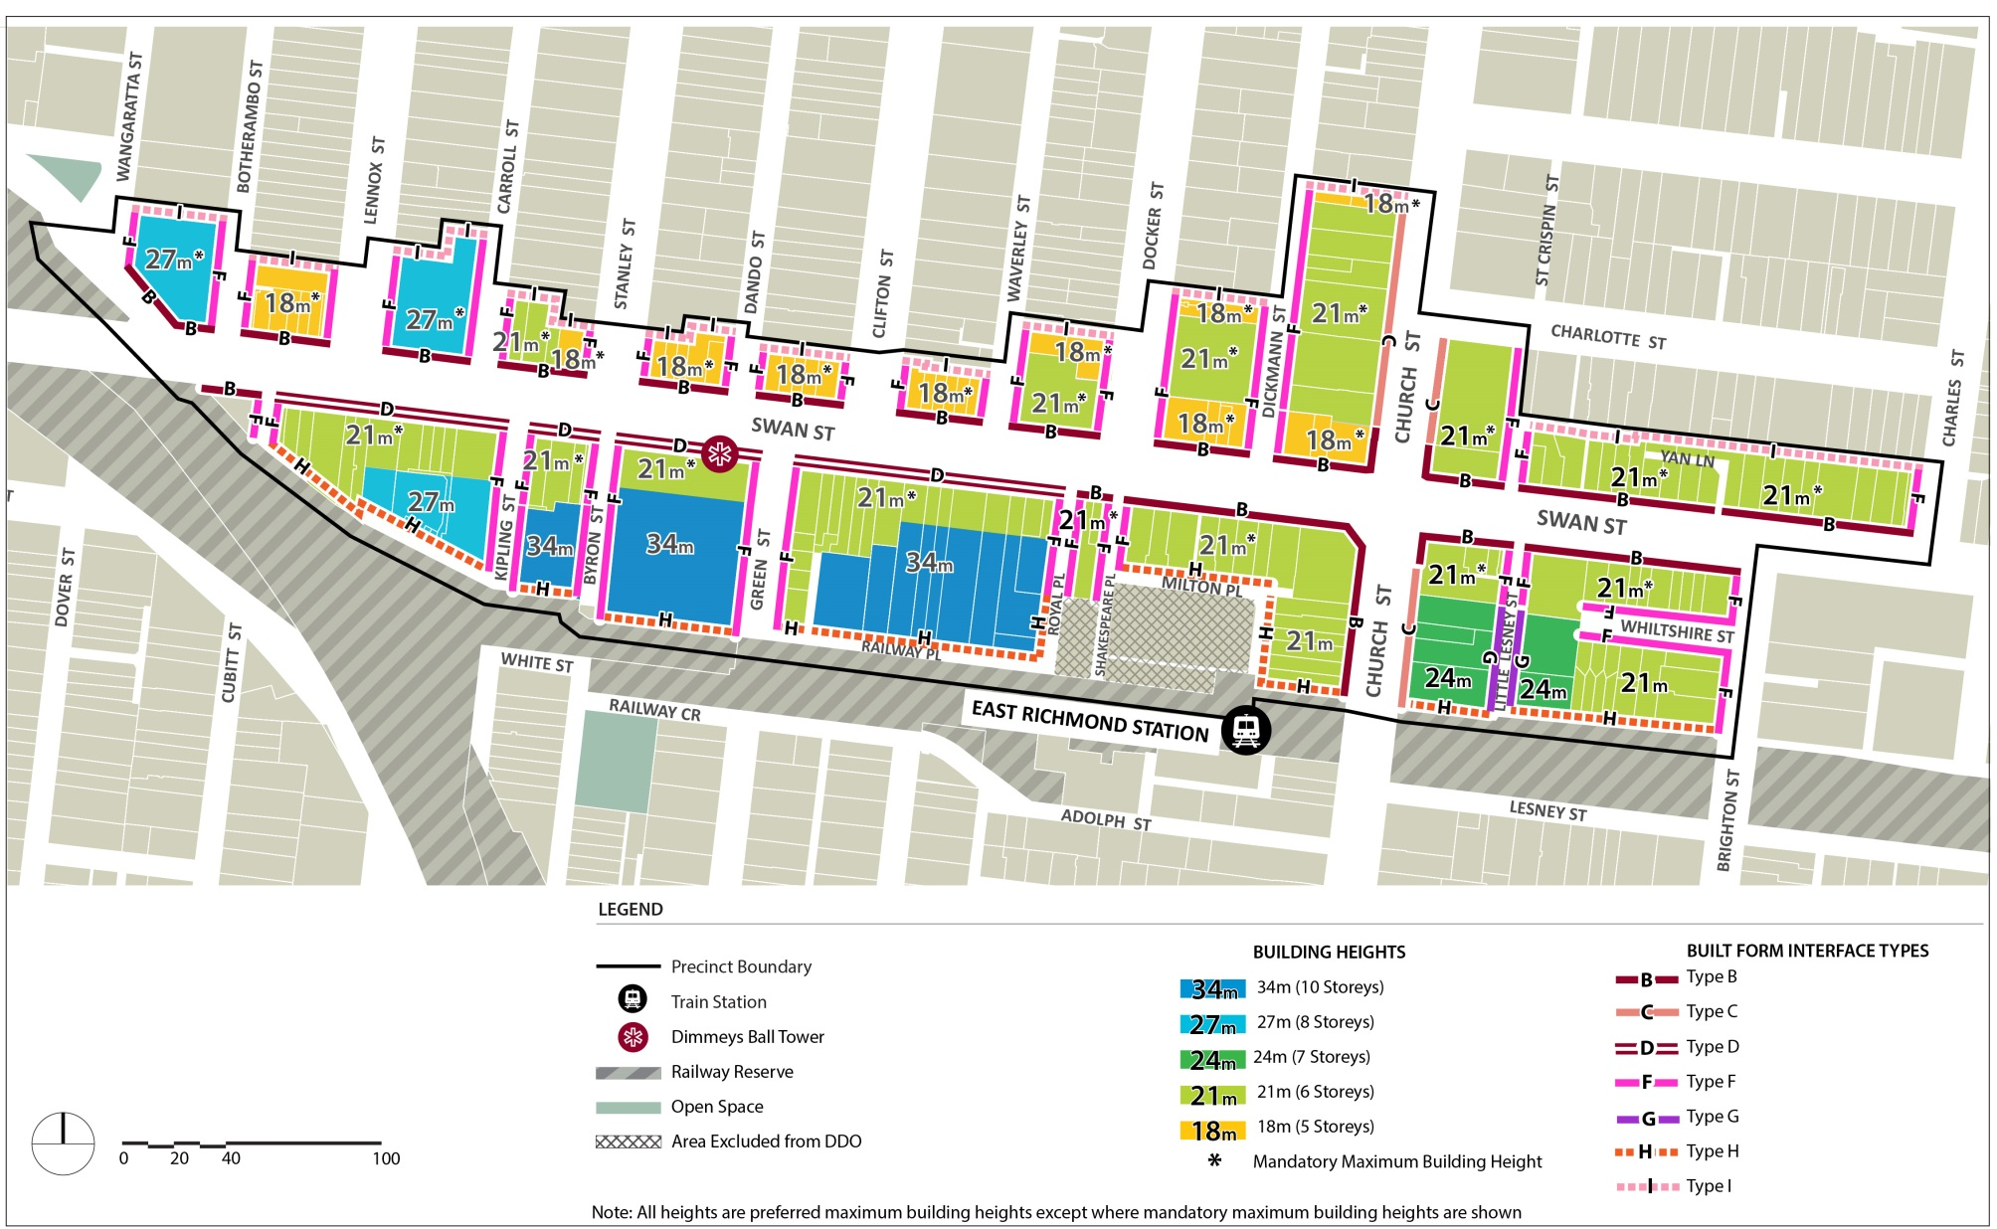
Plan 3: Height and Interface Plan – Precinct 2 – Swan Street Retail Centre

Plan 4: Access and Movement Plan – Precinct 2 – Swan Street Retail Centre
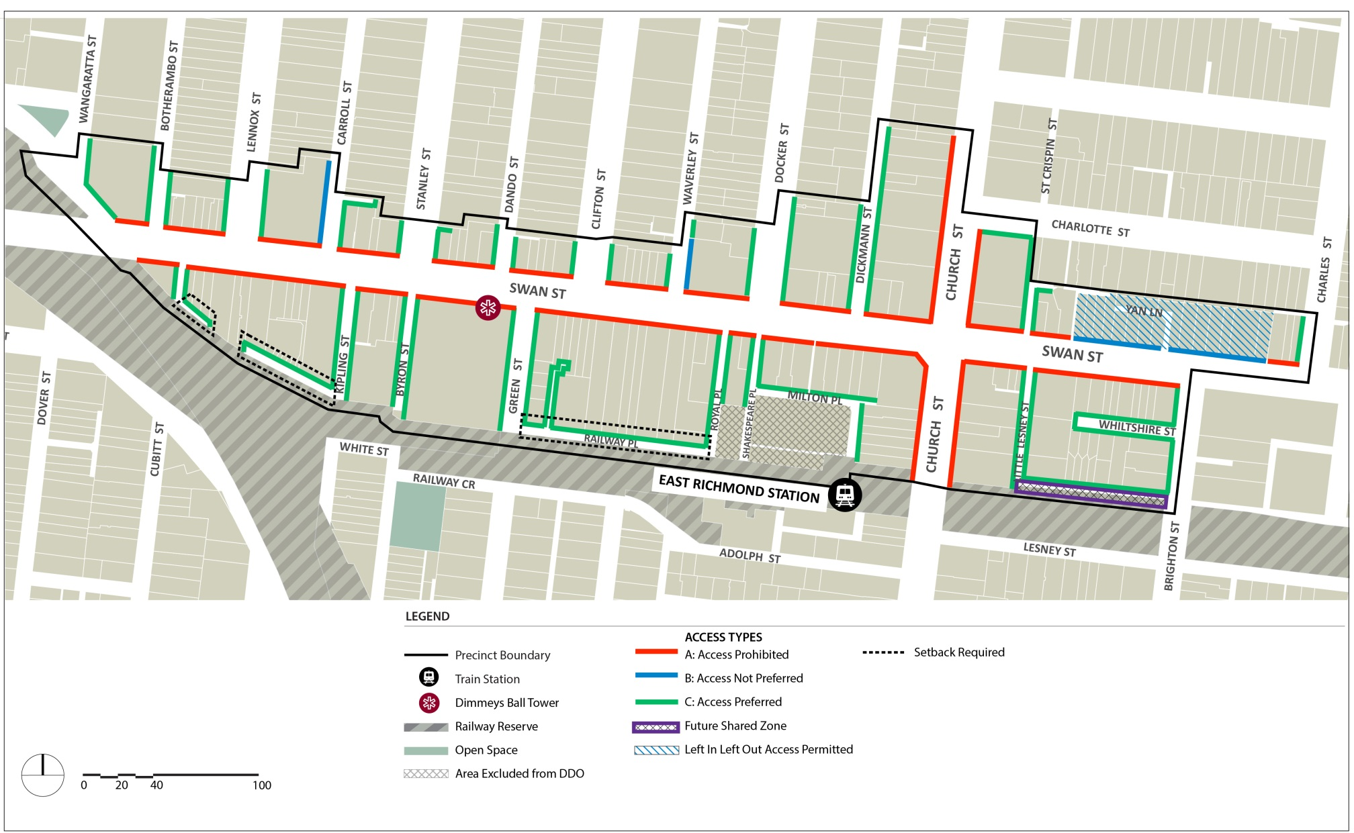

2.3.3 Precinct 3 – Swan Street East
Shown on the planning scheme map as DDO17-3
The design requirements for Precinct 3 are as follows:
- Development along Swan Street should continue the street level experience of the Swan Street and Burnley Street heritage precincts by maintaining the prominence of the street wall.
- Development along Swan Street should enable views to the sky between buildings when viewed from street level on Swan Street and along Lord Street and Edinburgh Street.
- Development should improve the pedestrian environment and amenity of Swan Street, and easements and laneways that provide pedestrian connection to Swan Street and to the entrances to new developments.

Building height | Development must not exceed the mandatory building heights shown on Plan 5.  Development should not exceed the preferred building heights shown on Plan 5.
Street wall heights and setbacks | Development must not exceed the relevant mandatory street wall height requirements or reduce the mandatory setbacks specified in Table 3 and shown on Plan 5.  Development should not exceed the relevant preferred street wall height requirements or reduce the preferred setbacks specified in Table 3 and shown on Plan 5.  Development should be designed to adopt the same setback from all street interfaces for a minimum of 65% of the height of upper levels to avoid repetitive stepped form.  Development at 300 – 312 Swan Street must be setback to accommodate the provision and construction of a 6.0m laneway as shown on Plan 6.  Development on the south side of Swan Street between Coppin Street and Burnley Street identified as “New Laneway Required” in Plan 6 must incorporate a rear setback to accommodate the provision and construction of a continuous minimum 6 metre rear (east-west) laneway with traffic calming measures.
Building Separation | Where development shares a common boundary and no interface treatment is shown in Plan 3, upper level development should:  - be setback a minimum of 4.5m from the common boundary where a habitable window or balcony is proposed  - be setback a minimum of 3.0m from the common boundary where a commercial or non habitable window is proposed.  Where the common boundary is a laneway, the setback is measured from the centre of the laneway.  Development of properties in the locations shown as “Upper Level Building Breaks” on Plan 5 should incorporate side setbacks greater than the standards above and enable clear views to the sky between buildings along Swan Street when viewed from the opposite side of Swan Street, and along Lord Street and Edinburgh Street.
Building Facades and Street Frontages | Frontages at ground floor and within the street wall should be designed with floor to floor ceiling heights suitable to accommodate commercial activity.  Frontages at ground floor should incorporate verandahs, consistent with the form and scale of adjoining verandahs, into the façade design.
Upper Levels | Upper level development should be designed to ensure buildings are expressed in the round and designed to provide detail on facades when viewed from all directions.
Overshadowing | Development must not overshadow any part of the southern footpath of Swan Street (measured as 4.0 metres from the southern road boundary of Swan Street between 10am and 2pm at 22nd September).  Development should not overshadow any part of the opposite footpath of Mary Street and Coppin Street (measured as 2.0m from the road boundary between 10am and 2pm at 22nd September)
Heritage | For development within and immediately adjoining a Heritage Overlay the requirements in Table 5 apply.
Access and movement | Development on the south side of Swan Street between Coppin Street and Burnley Street identified as “New Laneway Required” in Plan 6 must construct the laneway to the site boundary to provide for the completion of the laneway through the adjoining site *See note  Development at 300 – 312 Swan Street must construct a widened laneway of 6.0m as shown on Plan 6.  Development should be designed to enhance, activate and provide passive surveillance to the pedestrian connection between Glass Street and Swan Street as shown on Plan 6.  Development should be designed to enhance, activate and provide passive surveillance to the pedestrian connection between Glass Street and Swan Street as shown on Plan 6.  Vehicle and pedestrian access must be in accordance with the requirements of Clause 2.2.4 and Plan 6.
Note: Prior to the completion of the rear (east-west) laneway, development may access Swan Street via an intermediate north-south laneway in the locations shown on the Access and Movement Plan 6. Any intermediate north-south laneway must be a minimum of 6 metres wide, provide a continuous connection between Swan Street and the future rear (east-west) laneway, enable access from adjoining properties (where relevant) and incorporate ‘Left in’ and ‘Left out’ only vehicle access onto Swan Street.

Table 3 – Street Wall Heights and Setbacks for Precinct 3
Interface Ref | Design Element | Mandatory Requirements | Preferred Requirements
C | Street wall Height |  | 11m maximum (3 storeys) or the parapet height of the adjoining individually significant or contributory building if higher than 11m.  8m minimum.  Match the parapet height of the taller adjoining heritage building
 | Street wall setback | 0m
 | Upper level setback | Minimum 5m for individually significant heritage buildings. | Minimum 5m elsewhere.  Any part of a building above the street wall should be designed to ensure that it occupies no more than one third of the vertical angle defined by the whole building in the view from a sight line of 1.7 metres (on the opposite side of the street).
E | Street wall height |  | 14.5m maximum (4 storeys).
 | Street wall setback |  | 0m.
 | Upper level setback |  | 5m minimum.
F | Street wall height |  | 11m (3 storeys).
 | Street wall setback |  | 0m.
 | Upper level setback |  | 5m minimum for individually significant buildings.  3m minimum elsewhere.
G | Street wall height |  | 14m (4 storeys) maximum.
 | Street wall setback |  | 0m.
 | Upper level setback |  | 3m minimum.
H | Street wall height |  | N/A.
 | Street wall setback |  | 0m minimum unless setback is identified on the Plan 6.
 | Upper level setback |  | 0m.
I | Side and rear wall height |  | 8m maximum on a common boundary with a property in a residential zone.  11.5m maximum if boundary abuts a laneway.
 | Side and rear boundary setback |  | 0m.
 | Upper level setback |  | Development should be setback in accordance with Figure 1 and Figure 2.  Development should minimise stepped form.

Plan 5: Height and Interface Plan – Precinct 3 – Swan Street East
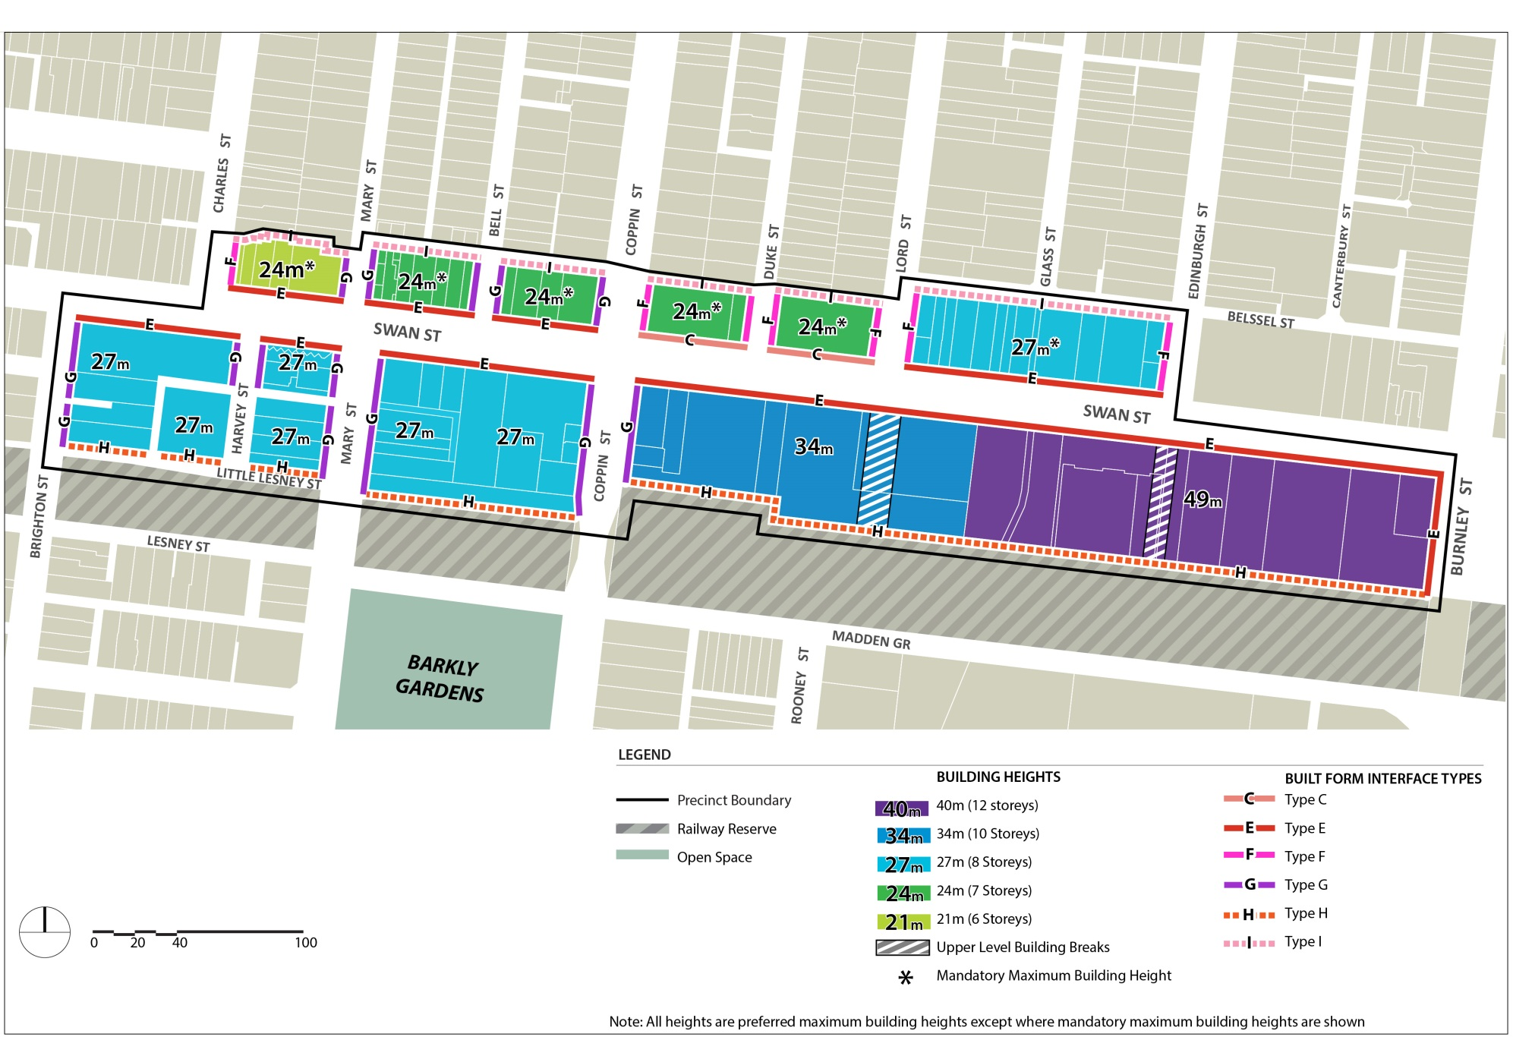

Plan 6: Access and Movement Plan – Precinct 3 – Swan Street East
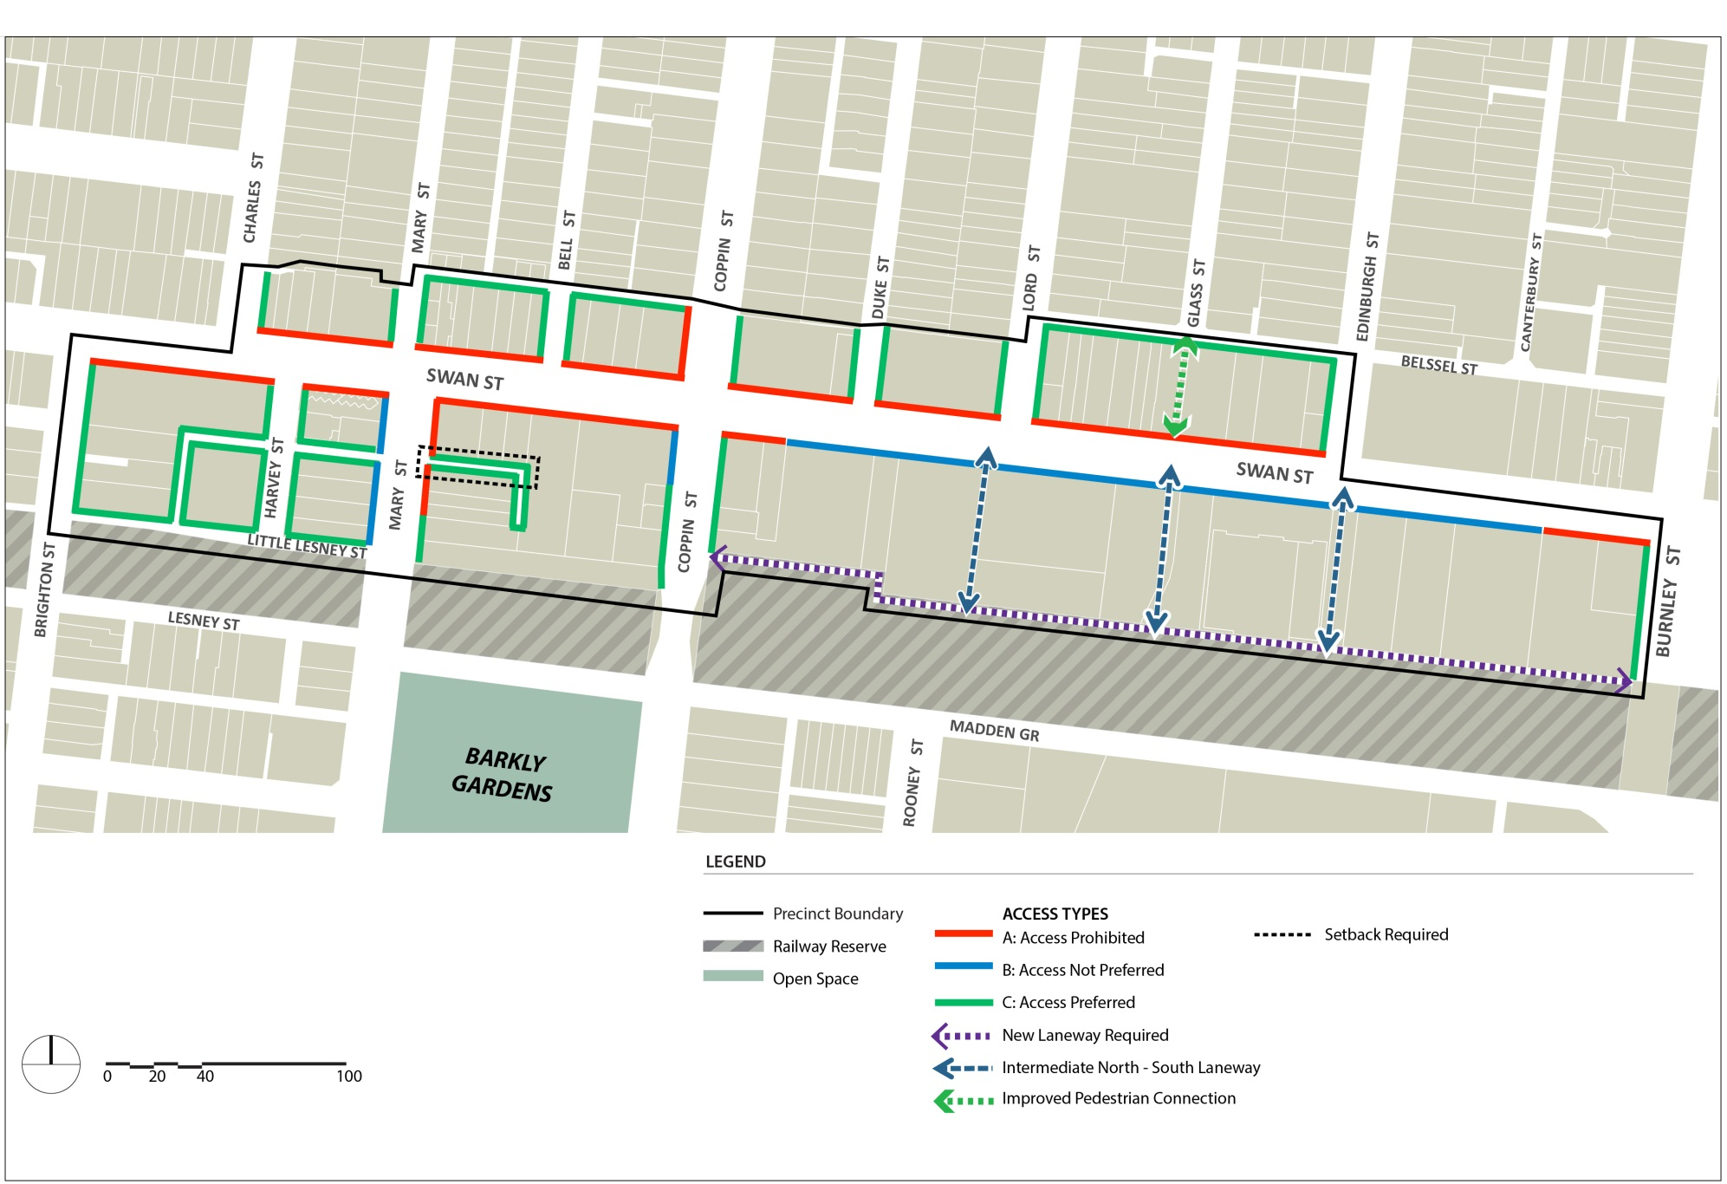

2.3.4 Precinct 4 – Burnley Station
Shown on the planning map as DDO17-4
The Precinct Design Requirements for Precinct 4 are as follows:
- Development should respect the scale, rhythm, and architectural detail of the precinct and the heritage buildings in the Burnley Street Heritage Precinct.
- Development along Swan Street should provide an appropriate transition in the street wall height to the Burnley Street and Bendigo Street heritage precincts.
- Development along Swan Street should enable views to the sky between buildings when viewed from street level on Swan Street and along Cutter Street and Bendigo Street.
- Development should maintain the amenity of Ryan’s Reserve.
Building height | Development must not exceed the mandatory building heights shown on Plan 7.  Development should not exceed the preferred building heights shown on Plan 7.
Street wall heights and setbacks | Development should not exceed the relevant preferred street wall height requirements or reduce the preferred setbacks specified in Table 4 and shown on Plan 7.  Development should be designed to adopt the same setback from all street interfaces for a minimum of 65% of the height of upper levels to avoid repetitive stepped form.  Development at 500 to 506 Swan Street must be setback to accommodate the provision and construction of a 6.0 metre wide laneway as shown on Plan 8.  Development at 130 to 136 Stawell Street must be setback to accommodate the provision and construction of a 3.0 metre wide laneway as shown on Plan 8.  Development at 484 Swan Street should be setback to accommodate the provision and construction of a 3.0 metre wide pedestrian connection between Swan Street and Burnley Railway Station as shown on Plan 8.
Building separation | Where development shares a common boundary and no interface treatment is shown in Plan 7, upper level development should:  - be setback a minimum of 4.5m from the common boundary, where a habitable window or balcony is proposed  - be setback a minimum of 3.0m from the common boundary where a non habitable window is proposed.  Where the common boundary is a laneway, the setback is measured from the centre of the laneway.  Development of properties in the locations shown as “Upper Level Building Breaks” on Plan 7 should incorporate side setbacks greater than the standards above to enable clear views to the sky between buildings along Swan Street when viewed from the opposite side of Swan Street, and along Cutter Street and Bendigo Street.
Building Facades and Street Frontages | Frontages at ground floor and within the street wall should be designed with floor to floor ceiling heights suitable to accommodate commercial activity.  Frontages at ground floor should incorporate verandahs, consistent with the form and scale of adjoining verandahs, into the façade design.
Upper Levels | Upper level development should be expressed as a building in the round and designed to provide detail on facades when viewed from all directions.
Overshadowing | Development must not overshadow any part of the southern footpath of Swan Street (measured as 4.0 metres from the southern road boundary of Swan Street between 10am and 2pm at 22nd September)  Development must not overshadow any part of the opposite footpath along Burnley Street (measured as 4.0 metres from the road boundary of Burnley Street between 10am and 2pm at 22nd September)  Development should not overshadow the opposite footpath of Stawell Street (measured as 2.0m from the road boundary between 10am and 2pm at 22nd September).
Solar access | Development should maintain solar access to Ryan’s Reserve as follows:  - Beyond 16m of the eastern boundary of the reserve from 10am onwards on 22 September  - At the western boundary of the reserve until 2pm on 22 September.
Heritage | For development within and immediately adjoining a Heritage Overlay the requirements in Table 5 apply.
Access and movement | Development at 500 to 506 Swan Street must construct a 6.0 metre wide laneway as shown on Plan 8.  Development at 130 to 136 Stawell Street must construct a 3.0 metre wide laneway as shown on Plan 8.  Development at 484 Swan Street should construct a 3 metres wide pedestrian connection between Swan Street and Burnley Railway Station as shown on Plan 8 and be designed to activate and provide passive surveillance to this connection.  Vehicle and pedestrian access must be in accordance with the requirements of Clause 2.2.4 and Plan 8.

Table 4 – Street Wall Heights and Setbacks for Precinct 4
Interface Ref | Design Element | Mandatory Requirements | Preferred Requirements
C | Street wall Height |  | 11m maximum (3 storeys) or the parapet height of the adjoining individually significant or contributory building if higher than 11m.  8m minimum.  Match the parapet height of the taller adjoining heritage building.
 | Street wall setback | 0m.
 | Upper level setback | 10m minimum from Swan Street setback for land affected by HO 286 (365 Swan Street).  Minimum 5m for other individually significant heritage buildings. | Minimum 5m elsewhere.  Any part of a building above the street wall should be designed to ensure that it occupies no more than one third of the vertical angle defined by the whole building in the view from a sight line of 1.7 metres (on the opposite side of the street).
E | Street wall height |  | 14.5m maximum (4 storeys)
 | Street wall setback |  | 0m.
 | Upper level setback |  | 5m minimum.
F | Street wall height |  | 11m (3 storeys).
 | Street wall setback |  | 0m.
 | Upper level setback |  | 5m minimum for individually significant buildings.  3m minimum elsewhere.
G | Street wall height |  | 14m (4 storeys) maximum.
 | Street wall setback |  | 0m.
 | Upper level setback |  | 3m minimum.
H | Street wall height |  | N/A.
 | Street wall setback |  | 0m minimum unless setback is identified on the Plan 8.
 | Upper level setback |  | 0m.
I | Side and rear wall height |  | 8m maximum on a common boundary with a property in a residential zone.  11.5m maximum if boundary abuts a laneway.
 | Side and rear boundary setback |  | 0m.
 | Upper level setback |  | Development should be setback in accordance with Figure 1 and Figure 2.  Development should minimise stepped form.

Plan 7: Height and Interface Plan – Precinct 4 – Burnley Station
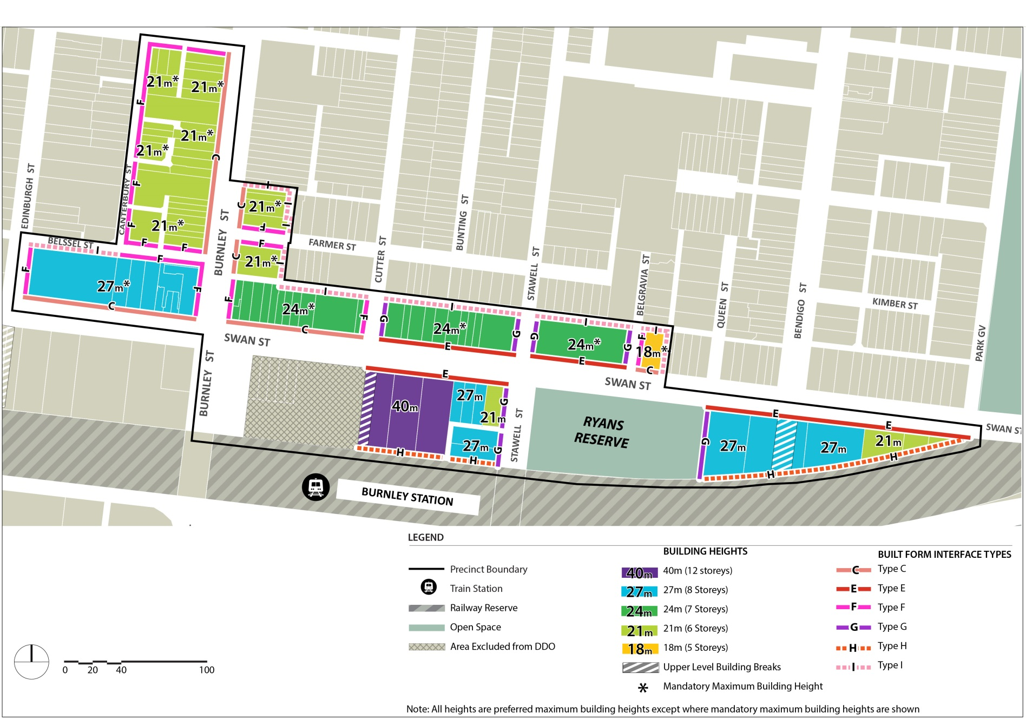

Plan 8: Access and Movement Plan – Precinct 4 – Burnley Station
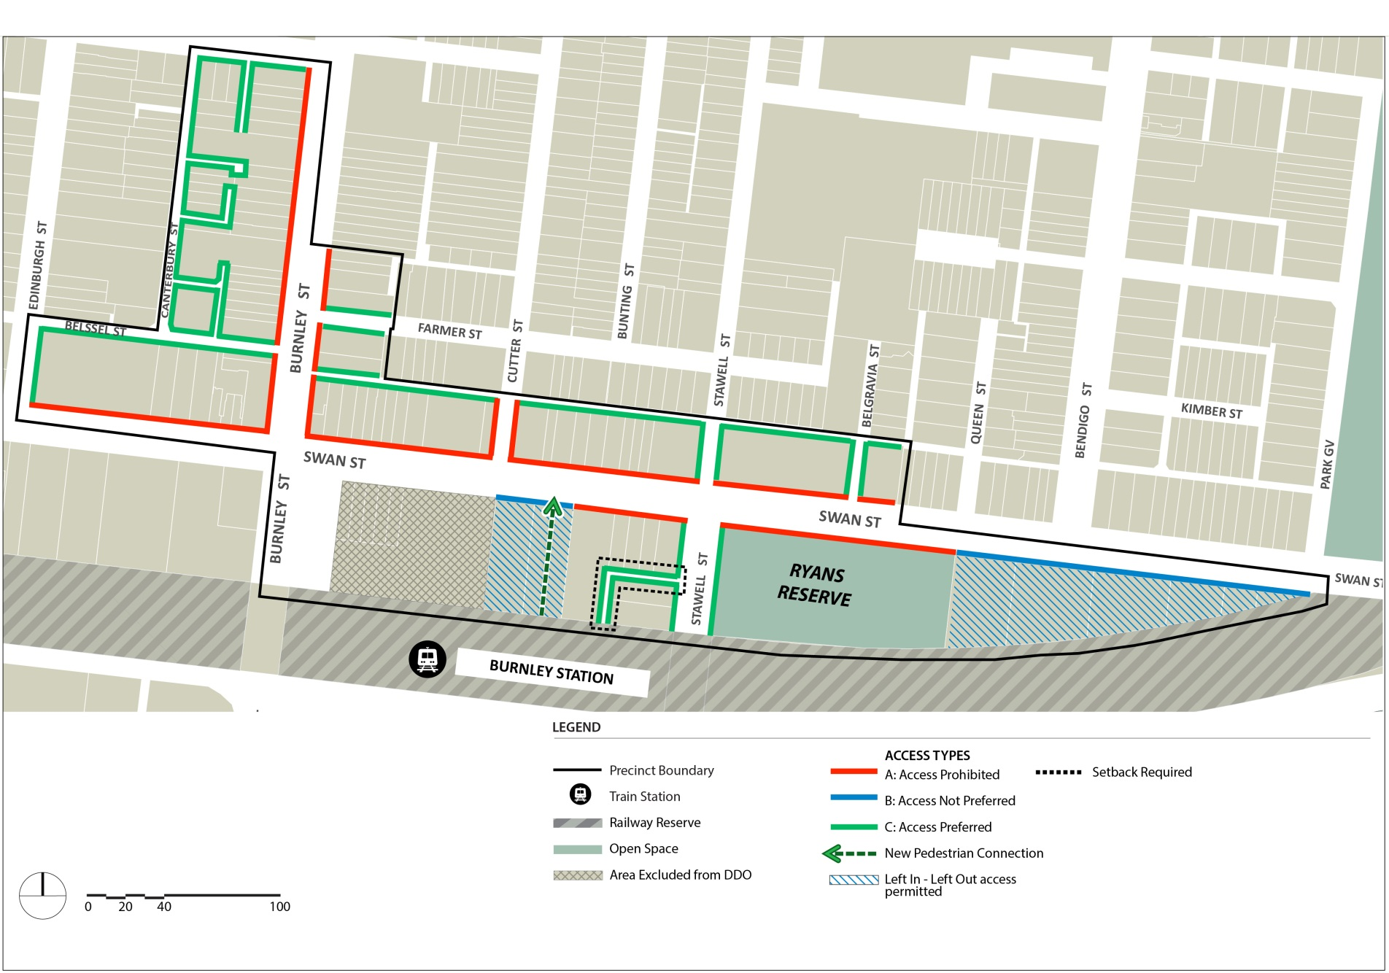

2.4 Application Requirements
Unless with the written consent of the Responsible Authority, an application must provide:
- Perspectives showing the form, massing, profile, material finishes and detailed design of the proposed building(s).
- Sightline analysis for the proposed building(s) taken from nature eye level (1.7m above the level of the footpath, 1 metre from the kerb) from the opposite side of the street.
- For development in Precinct 2 on the south side of Swan Street between Church Street and the rail bridge, perspective and modelling of the proposed building(s) relationship to the Dimmey's Clock Tower when viewed from the north side of Swan Street to Council’s spécifications.
- For development along Swan Street in Precinct 3 and 4, perspective and modelling showing the separation between existing and proposed building(s) when viewed from the opposite of Swan Street and the local streets specified in Clauses 2.3.3 and 2.3.4 as relevant.
- The following information in the Traffic Engineering Report, as appropriate:
- measures to reduce conflict and improve pedestrian and bicycle amenity
- details regarding loading and waste collection
- any impacts on the operational efficiency and road safety of the tram route
- any modifications to existing roads and/or laneways and/or provision of new laneway(s) in accordance with Plan 2, 4, 6 or 8
- a Green Travel Plan prepared by a suitably qualified person outlining site-specific initiatives and actions to encourage the use of more sustainable transport options.
- An environmental wind assessment prepared by a suitably qualified professional to undertake measurements of environmental wind conditions around the proposed development and develop wind amelioration features as necessary.
3.0 Subdivision
DD/MM/YYYY
Proposed C236
None specified.
4.0 Advertising
DD/MM/YYYY
Proposed C236
None specified.
5.0 Decision guidelines
DD/MM/YYYY
Proposed C236
The following decision guidelines apply to an application for a permit under Clause 43.02, in addition to those specified in Clause 43.02 and elsewhere in the scheme which must be considered, as appropriate, by the responsible authority:
- Whether the General Design Requirements and the Precinct Design Requirements in Clause 2.0 are met.
- The design of the streetscape interface and its contribution to an active street environment.
- Whether the proposal contributes to and improves the pedestrian connectivity and amenity of the public realm.
- The shadowing impacts of the development on footpaths and public spaces.
- The wind effects created by the development.
- Whether heritage buildings on street corners retain their prominence when viewed on both streets.
- Whether heritage buildings retain their three-dimensional form as viewed from the public realm.
- Whether upper level development above the heritage street wall is visually recessive and does not overwhelm the heritage buildings.
- The impact of development on view lines to the Dimmey’s Clock Tower.
- The impact of development on the operation of the tram routes along Swan Street and Church Street.
Reference Documents
Swan Street Activity Centre Built Form Framework 2017 (Tract)

Table 5 to Schedule 17 - General design requirements for development on land affected by a Heritage Overlay or immediately adjacent to a heritage overlay

Design Element | Design Requirement
Building facades and street frontages | Development should retain the existing heritage facade of individually significant and contributory buildings.  Infill Buildings and Development Adjoining a Heritage Building  Façade treatments and the articulation of infill buildings on land affected by a heritage overlay or immediately adjoining a heritage building should:  - Adopt a high quality and respectful contextual design response by interpreting the historic façade rhythm of the heritage streetscape and/or adjoining heritage building including fenestration patterns and proportions, the relationship between solid and void, and the module of structural bays  - not compete with the more elaborate detailing of the adjoining nineteenth century heritage buildings, in particular avoid the replication of existing decorative features and architectural detail  - respect the vertical proportions of nineteenth and early twentieth century facades of the heritage streetscape and/or adjoining heritage building  - avoid large expanses of glazing with a horizontal emphasis except to ground floor shopfronts  - maintain the existing canopy/verandah height of the heritage streetscape and/or adjoining heritage building  - avoid the use of unarticulated curtain glazing or highly reflective glass  Contributory or Individually Significant Buildings  Adaptation of contributory or individually significant buildings should:  - avoid highly reflective glazing in historic openings  - maintain the inter-floor height of the existing building and avoid new floor plates and walls cutting through historic openings  - avoid balconies behind existing openings  - retain original or early shop fronts.
Upper Levels (above street wall height) | Upper level development on land within a heritage overlay and immediately adjoining a heritage building should:  - retain the roof form of individually significant buildings between the parapet and new development where this contributes to the significance of the place and/or is visible from the public realm  - incorporate an angled splay comparable with that of the heritage street wall where present on a corner site  - utilise visually lightweight materials and finishes that are recessive in texture and colour, and provide a juxtaposition with the heavier masonry of the heritage facades  - incorporate simple architectural detailing that does not detract from significant elements of the existing building or streetscape  - be articulated to reflect the fine grained character of narrow sites and avoid highly articulated facades with recessed and projecting elements.

Figure 1 to schedule 17 – Residential interface with an existing laneway
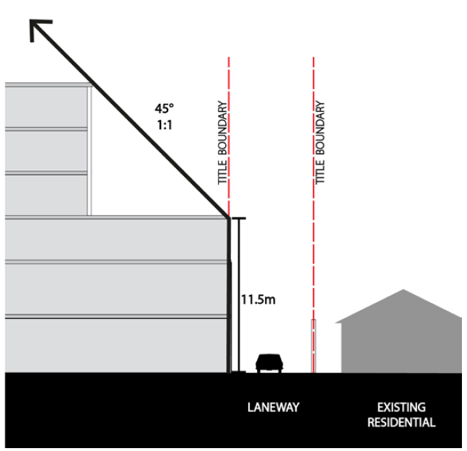

Figure 2 to schedule 17 – Residential interface direct abuttal
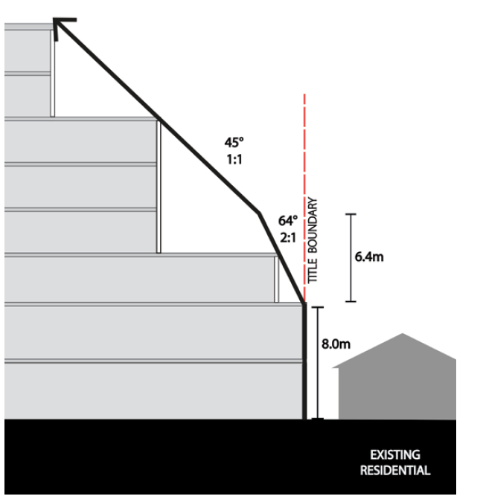

5.0 Expiry
The requirements of this Schedule cease to have effect after 30 December 2019.

