SCHEDULE 17 TO CLAUSE 43.02 DESIGN AND DEVELOPMENT OVERLAY
dd/mm/yyyy
Proposed C191
Shown on the planning scheme map as DDO17.
SWAN STREET ACTIVITY CENTRE
1.0 General design objectives
dd/mm/yyyy
Proposed C191

- To recognise and respond to the distinct character and varying development opportunities defined by the four precincts along Swan Street.
- To support a new mid rise scale built form character with lower built form at the interfaces with streets and the adjoining low rise residential areas that maintains an active, high quality and pedestrian friendly environment.
- To ensure development maintains the prominence of the heritage street wall and respects the architectural form and qualities of heritage buildings and the heritage streetscapes.
- To minimise the amenity impacts on residential properties adjoining the Swan Street Activity Centre including overlooking, overshadowing and visual bulk impacts.
- To ensure that vehicular access to development does not adversely impact the level of service, efficiency, and safety of the arterial and tram network.
2.0 Buildings and works
dd/mm/yyyy
Proposed C191

2.1 Definitions
dd/mm/yyyy
Proposed C191
Street-wall is the facade of a building. Street wall height is measured at the vertical distance between the footpath at the centre of the frontage and the highest point of the building at the street edge, with the exception of architectural features and building services.
Building height does not include non structural elements and service equipment including plant rooms, lift overruns, structures associated with green roof areas and other such equipment provided that all of the following criteria are met:
- The total roof area occupied by the equipment (other than solar panels) is minimised;
- The service equipment is located in a position on the roof so as to minimise its visibility;
- The non structural elements and service equipment minimise additional overshadowing of neighbouring properties and public spaces;
- The equipment does not extend higher than 3.6 metres above the maximum building height; and
- The non structural elements and service equipment are integrated into the design of the building to the satisfaction of the responsible authority.
Setback is the shortest horizontal distance from a building façade, including projections such as balconies, building services and architectural features, to the boundary.
Parapet height does not include features such as brackets, pediments, urns, finials or other decorative elements.
Road boundary is the boundary between the public road and the private property.
Shared zone is a road or network of roads where pedestrians, cyclists, and vehicles share the roadway.
Upper level is development above the height of the street wall.
2.2 General design requirements
dd/mm/yyyy
Proposed C191
The following general design requirements apply to an application to construct a building or construct or carry out works and must be read in conjunction with the relevant precinct design requirements.
Building heights
A permit cannot be granted to construct a building or construct or carry out works which exceeds the mandatory maximum building height shown in the Height and Interface Plans (Plan 1, 3, 5 and 7) of this schedule.
A permit may be granted to construct a building or construct or carry out works which exceeds the preferred building height shown in the Height and Interface Plans (Plan 1, 3, 5 and 7) of this schedule where all the following requirements are met to the satisfaction of the responsible authority:
- the built form outcome as a result of the proposed variation satisfies the general design objectives in Clause 1.0 of this schedule, the relevant precinct design requirements specified in this schedule;
- the proposed building height achieves the preferred future mid-rise character for Swan Street of generally 5 to 12 storeys; and
- the proposal will achieve each of the following:
- greater building separation than the minimum requirement in this schedule
- housing for diverse households types, including people with disability, older persons, and families, through the inclusion of varying dwelling sizes and configurations
- universal access, and communal and/or private open space provision that exceeds the minimum standards in Clauses 55.07 and 58
- excellence for environmentally sustainable design measured as a minimum BESS project score of 70%
- no additional amenity impacts to residentially zoned properties, beyond that which would be generated by a proposal that complies with the preferred building height.
Street wall and setbacks
A permit cannot be granted to construct a building or construct or carry out works which exceed the mandatory maximum street wall height and/or reduces the mandatory minimum setback requirements specified in the Precinct Tables in this schedule.
A permit cannot be granted which exceeds the relevant preferred maximum street wall height and/or reduces the relevant preferred mandatory minimum setback requirements specified in this schedule unless the following are met, to the satisfaction of the responsible authority:
- The built form outcome as a result of the proposed variation satisfies the general design objectives in Clause 1.0 of this schedule,
- The built form outcome as a result of the proposed variation satisfies the relevant requirements specified in this schedule
- The following requirements also apply to the design of the street wall and upper levels:
- Frontages at ground floor and within the street wall must be designed with floor to floor ceiling heights suitable to accommodate commercial activity.
- Frontages at ground floor must incorporate verandahs, consistent with the form and scale of adjoining verandahs, into the façade design.
- Development must be designed to adopt the same street setback from all interfaces for a minimum of 65% of the height of upper levels to avoid repetitive stepped form.
- Upper level development must be designed to ensure buildings are expressed in the round and provide detail on facades when viewed from all directions.
- Where development shares a common boundary and no interface treatment is shown in Plan 1, upper level development must:
- be setback a minimum of 4.5m from the common boundary, where a habitable window or balcony is proposed
- be setback a minimum of 3.0m from the common boundary where a commercial or non-habitable window is proposed.
- Where the common boundary is a laneway, the setback is measured from the centre of the laneway.
Heritage design requirements
The following design requirements apply on land within a heritage overlay or immediately adjoining a heritage overlay.
Design Element | Design Requirement
Building facades and street frontages | Infill Buildings and Development Adjoining a Heritage Building  Façade treatments and the articulation of infill buildings on land affected by a heritage overlay and of new buildings on land immediately adjoining a heritage building must:  - ensure the façade treatments and the articulation of new development are simple and do not compete with the more elaborate detailing of the adjoining heritage building(s)  - respect the vertical proportions of the nineteenth and early twentieth century facades of the heritage streetscape and/or adjoining heritage building(s)  - avoid large expanses of glazing with a horizontal emphasis except to ground floor shopfronts  - maintain the existing canopy/verandah height of the heritage streetscape and/or adjoining heritage building.  Contributory or Individually Significant Buildings  Adaptation of contributory or individually significant buildings must:  - avoid highly reflective glazing in historic openings  - encourage the retention of solid built form behind retained facades and avoid balconies behind existing openings  - maintain the inter-floor height of the existing building and avoid new floor plates and walls cutting through historic openings.
Upper Levels (above street wall height) | Upper level development on land within a heritage overlay and on land immediately adjoining a heritage building must:  - be visually recessive and not visually dominate the heritage building and the heritage streetscape  - retain the primacy of the three-dimensional form of the heritage building as viewed from the public realm to avoid ‘facadism’  - utilise visually lightweight materials and finishes that are recessive in texture and colour and provide a juxtaposition with the heavier masonry of the heritage facades  - incorporate simple architectural detailing that does not detract from significant elements of the heritage building and the heritage streetscape  - be articulated to reflect the fine grained character of the streetscape.
Overshadowing
A permit cannot be granted to construct a building or construct or carry out works that would overshadow any of the following spaces between 10 am and 2 pm at 22nd September:
- any part of the southern footpath of Swan Street, measured as 4.0m from the southern road boundary of Swan Street,
- any part of the opposite footpath of Church Street, measured as 4.0 metres from the road boundary of Church Street
- any part of the opposite footpath of Burnley Street, measured as 4.0 metres from the road boundary of Burnley Street
A permit cannot be granted to construct a building or construct or carry out works which are not in accordance with the overshadowing requirements specified in Clause 2.3 of this schedule unless the resultant overshadowing would not unreasonably prejudice the amenity of the public space, to the satisfaction of the responsible authority.
Vehicle and pedestrian access
Development must provide vehicular access from rear lanes or from side streets in the preferred locations in the Access and Movement Plans (Plan 2, 4, 6 and 8) of this schedule except in locations identified as “Left in - Left Out Access Permitted” in the Access and Movement Plans (Plan 2, 4, 6 and 8) of this schedule.
Development identified as “Left in - Left Out Access Permitted” in the Access and Movement Plan must limit the width of vehicle crossovers and incorporate ‘Left in’ and ‘Left out’ only vehicle access.
Development with redundant vehicle access points to Swan Street, Church Street and Burnley Street must reinstate the kerb, linemark parking bays, and relocate any parking signs.
Vehicle ingress and egress into development, including loading facilities and building servicing, must be designed to ensure a high quality pedestrian amenity and limit potential conflict between vehicle movements and pedestrian activity.
Pedestrian access to buildings, including upper level apartments, must be from a street or a shared zone shown on the Access and Movement Plans (Plan 2, 4, 6 and 8) of this schedule. Where pedestrian access can only be provided from a laneway at the rear of buildings the pedestrian entrance must be setback from the rear laneway and well-lit to enable safe access.
2.3 Precinct design requirements
dd/mm/yyyy
Proposed C191
The following specific Precinct Design Requirements apply in addition to the general design requirements.
Precinct 1 – Richmond Station
Shown on the planning scheme map as DDO17-1
The Precinct Design Requirements for Precinct 1 are as follows:
- Development must provide a consistent built form edge to the street.
- The street wall of development on the corner of Swan Street and Punt Road must mark the entry into the Swan Street Activity Centre.
- The street wall of new development east of Wellington Street must reflect the height and fine grain articulation of the heritage buildings.
- Development must improve the pedestrian environment and amenity of the streetscape along Swan Street and the streets leading to the Cremorne Employment Precinct through high quality architectural design and improvements to the public realm.
- Development must not overshadow any part of the opposite footpath of Cremorne Street (measured as 2.0 metres from the boundary of Cremorne Street between 10 am and 2 pm at 22nd September).
Table 1 – Street Wall Heights and Setbacks for Precinct 1
Interface Ref | Design Element | Mandatory Requirements | Preferred Requirements
A | Street wall height |  | 21m maximum
 | Street wall setback |  | 0m
 | Upper level setback |  | 5m minimum
C | Street wall Height |  | 11m maximum or the parapet height of the adjoining individually significant or contributory building if higher than 11m.  8m minimum.  Match the parapet height of the taller adjoining heritage building.
 | Street wall setback | 0m
 | Upper level setback | Minimum 5m for individually significant heritage buildings. | Minimum 5m elsewhere.  Any part of a building above the street wall must be designed to ensure that it occupies no more than one third of the vertical angle defined by the whole building in the view from a sight line of 1.7 metres (on the opposite side of the street).
F | Street wall height |  | 11m minimum.
 | Street wall setback |  | 0m.
 | Upper level setback |  | 3m minimum.
H | Street wall height |  | N/A.
 | Street wall setback |  | 0m minimum unless setback is identified on Plan 2.
 | Upper level setback |  | 0m.
I | Side and rear wall height |  | 8m maximum on a common boundary with a property in a residential zone.  11.5m maximum if boundary abuts a laneway.
 | Upper level setback |  | Development must be setback in accordance with Figure 1 and Figure 2.  Development must minimise repetitive stepped form.

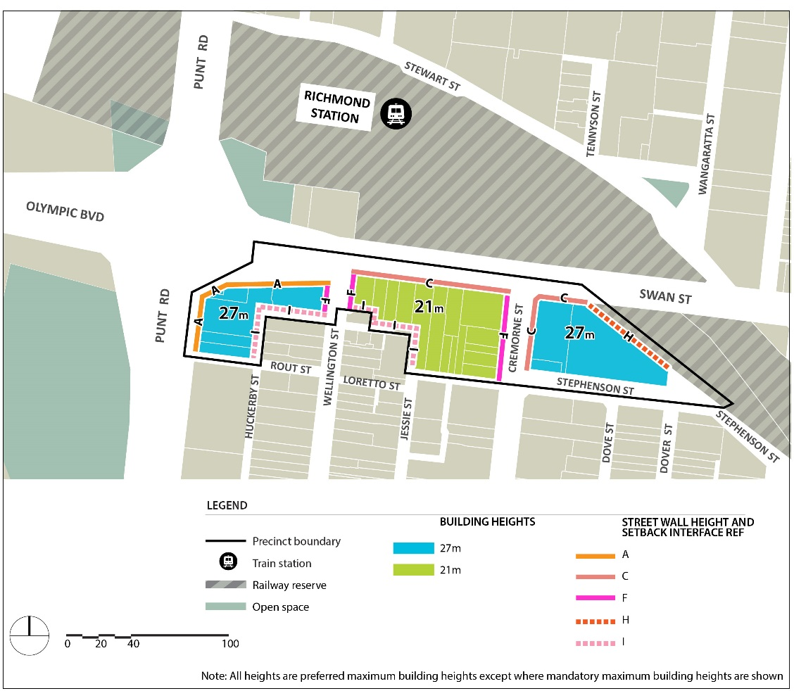
Plan 1: Height and Interface Plan – Precinct 1 – Richmond Station

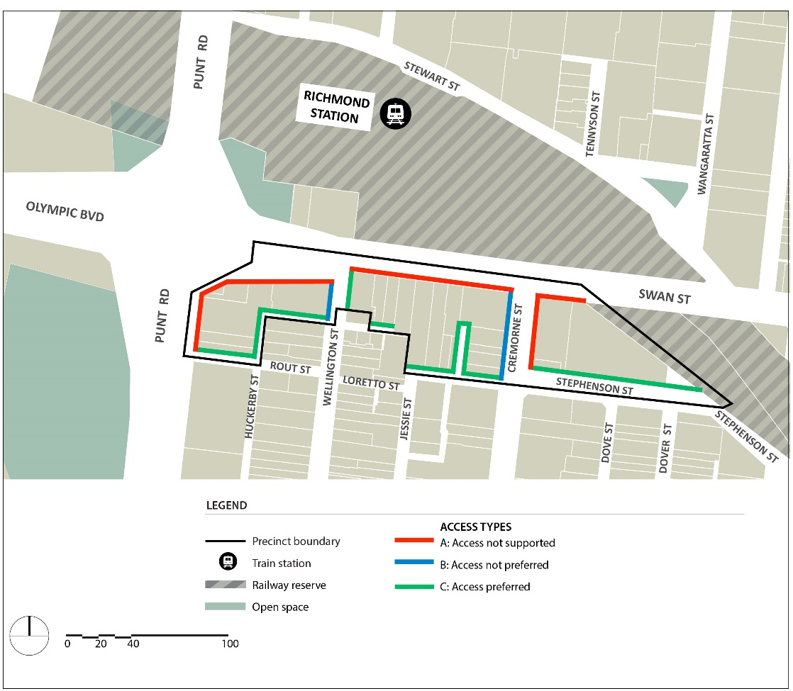
Plan 2: Access and Movement Plan – Precinct 1 – Richmond Station

Precinct 2 – Swan Street Activity Centre
Shown on the planning scheme map as DDO17-2
The Precinct Design Requirements for Precinct 2 are as follows:
- Development must respect the consistent scale, grain and architectural quality of the highly intact heritage streetscapes and the individually significant buildings in the precinct.
- Development along the rail corridor must avoid a continuous wall of taller development when viewed from local streets south of the rail corridor.
- Development on the south side of Swan Street must maintain Dimmey's Tower as the prominent landmark in the streetscape when viewed from the northern footpath of Swan Street east of the rail bridge and west of Church Street.
- Taller built form adjoining the rail corridor must not compete with the architectural form and complexity of the Dimmey's Clock Tower.
- Development must improve the pedestrian environment and amenity of streets and laneways that provide a pedestrian connection to Swan Street, Church Street, East Richmond Train Station, and entrances to buildings.
- Development adjoining Milton Place must be designed to address the potential future public park adjoining East Richmond Railway Station.
- Development must not overshadow any part of the opposite footpath of Lennox Street, Stanley Street, Clifton Street, and Docker Street, (measured as 2.0 metres from the road boundary of the street between 10 am and 2 pm at 22nd September).
- Development must not overshadow any part of the potential future open space adjacent to the East Richmond Station (measured as beyond 7.0m from the eastern road boundary of Milton Place and beyond 10.0m from the southern road boundary of Milton Place between 10 am and 2 pm at 22nd September).
- Development at 108-120 Swan Street and 2 Kipling Street, as shown in Plan 4, should include a rear setback, at ground floor, to facilitate the ongoing function of the laneway and allow for building services and car park access. The setback and laneway should be a minimum width of 6m in total.
- Development of 94-98 Swan Street, as shown in Plan 4, should include a rear setback, at ground floor, to allow for building services and car park access. The setback and laneway should be a minimum width of 3m in total.
- Development should facilitate the creation of a shared zone where properties abut a future shared zone as shown on Plan 4.

Table 2 – Street Wall Heights and Setbacks for Precinct 2
Interface Ref | Design Element | Mandatory Requirements | Preferred Requirements
B | Street wall height | 11m maximum or the parapet height of the adjoining individually significant or contributory building if higher than 11m.  8m minimum. | Match the parapet height of the adjoining heritage building.
 | Street wall setback | 0m
 | Upper level setback | 5m minimum setback | For all development in a heritage overlay, any part of the building above the heritage street wall should be designed to ensure that it occupies no more than one third of the vertical angle defined by the whole building in the view from a sight line of 1.7 metres (on the opposite side of the street).
C | Street wall Height |  | 11m maximum or the parapet height of the adjoining individually significant or contributory building if higher than 11m.  8m minimum.  Match the parapet height of the taller adjoining heritage building.
 | Street wall setback | 0m
 | Upper level setback | 5m minimum for individually significant heritage buildings. | Minimum 5m elsewhere.  Any part of a building above the street wall should be designed to ensure that it occupies no more than one third of the vertical angle defined by the whole building in the view from a sight line of 1.7 metres (on the opposite side of the street).
D | Street wall height | 11m maximum or the parapet height of the adjoining individually significant or contributory building if higher than 11m.  8m minimum. | Match the parapet height of the taller adjoining heritage building.
 | Street wall setback | 0m.
 | Upper level setback | 10m minimum for development up to 21m.  20m minimum for any height above 21m.
F | Street wall height |  | 11m maximum
 | Street wall setback |  | 0m.
 | Upper level setback |  | 5m minimum for land affected by HO335 and individually significant buildings.  3m minimum elsewhere.
G | Street wall height |  | 14.5m maximum.
 | Street wall setback |  | 0m.
 | Upper level setback |  | 3m minimum.
H | Street wall height |  | N/A.
 | Street wall setback |  | 0m minimum unless setback is identified on the Plan 4.
 | Upper level setback |  | 0m.
I | Side and rear wall height |  | 8m maximum on a common boundary with a property in a residential zone.  11.5m maximum if boundary abuts a laneway.
 | Upper level setback |  | Development must be setback in accordance with Figure 1 and Figure 2.  Development should minimise stepped form.

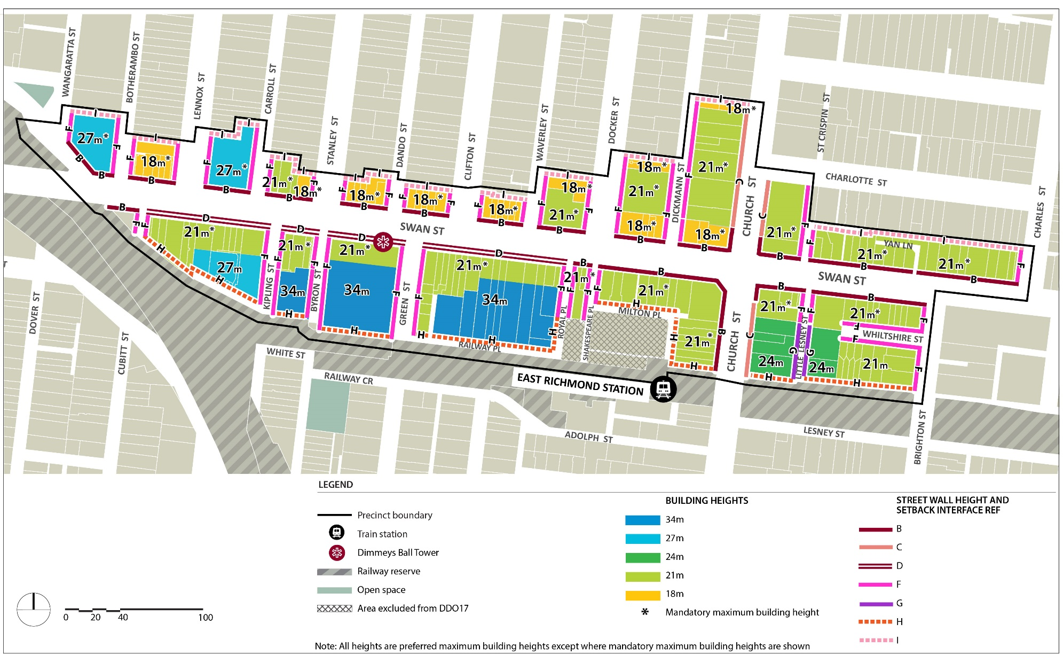
Plan 3: Height and Interface Plan – Precinct 2 – Swan Street Retail Centre

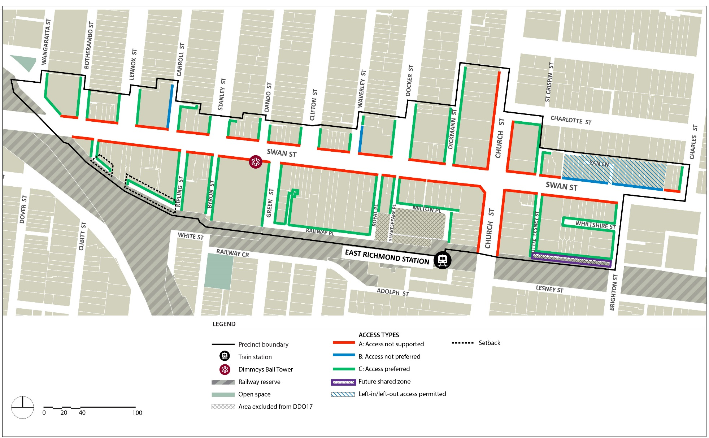
Plan 4: Access and Movement Plan – Precinct 2 – Swan Street Retail Centre

Precinct 3 – Swan Street East
Shown on the planning scheme map as DDO17-3
The design requirements for Precinct 3 are as follows:
- Development along Swan Street must continue the street level experience of the Swan Street and Burnley Street heritage precincts by maintaining a consistent and prominent street wall.
- Development must improve the pedestrian environment and amenity of Swan Street, and easements and laneways that provide a pedestrian connection to Swan Street and to the entrances to new developments.
- Development of properties in the locations shown as “Upper Level Building Breaks” on Plan 5 must incorporate side setbacks greater than the standards in Clause 2 and enable clear views to the sky between buildings along Swan Street when viewed from the opposite side of Swan Street and along Lord Street and Edinburgh Street.
- Development must not overshadow any part of the opposite footpath of Mary Street and Coppin Street (measured as 2.0m from the road boundary between 10 am and 2 pm at 22nd September).
- Development should be designed to enhance, activate, and provide passive surveillance to the pedestrian connection between Glass Street and Swan Street as shown on Plan 6.
- Development should include north-south access in the locations shown on the Access and Movement Plan 6 to allow for building services and car park access.

Table 3 – Street Wall Heights and Setbacks for Precinct 3
Interface Ref | Design Element | Mandatory Requirements | Preferred Requirements
C | Street wall Height |  | 11m maximum or the parapet height of the adjoining individually significant or contributory building if higher than 11m.  8m minimum.  Match the parapet height of the taller adjoining heritage building
 | Street wall setback | 0m
 | Upper level setback | Minimum 5m for individually significant heritage buildings. | Minimum 5m elsewhere.  Any part of a building above the street wall should be designed to ensure that it occupies no more than one third of the vertical angle defined by the whole building in the view from a sight line of 1.7 metres (on the opposite side of the street).
E | Street wall height |  | 14.5m maximum .
 | Street wall setback |  | 0m.
 | Upper level setback |  | 5m minimum.
F | Street wall height |  | 11m minimum.
 | Street wall setback |  | 0m.
 | Upper level setback |  | 5m minimum for individually significant buildings.  3m minimum elsewhere.
G | Street wall height |  | 14.5m maximum.
 | Street wall setback |  | 0m.
 | Upper level setback |  | 3m minimum.
H | Street wall height |  | N/A.
 | Street wall setback |  | 0m minimum unless setback is identified on the Plan 6.
 | Upper level setback |  | 0m.
I | Side and rear wall height |  | 8m maximum on a common boundary with a property in a residential zone.  11.5m maximum if boundary abuts a laneway.
 | Upper level setback |  | Development should be setback in accordance with Figure 1 and Figure 2.  Development should minimise stepped form.

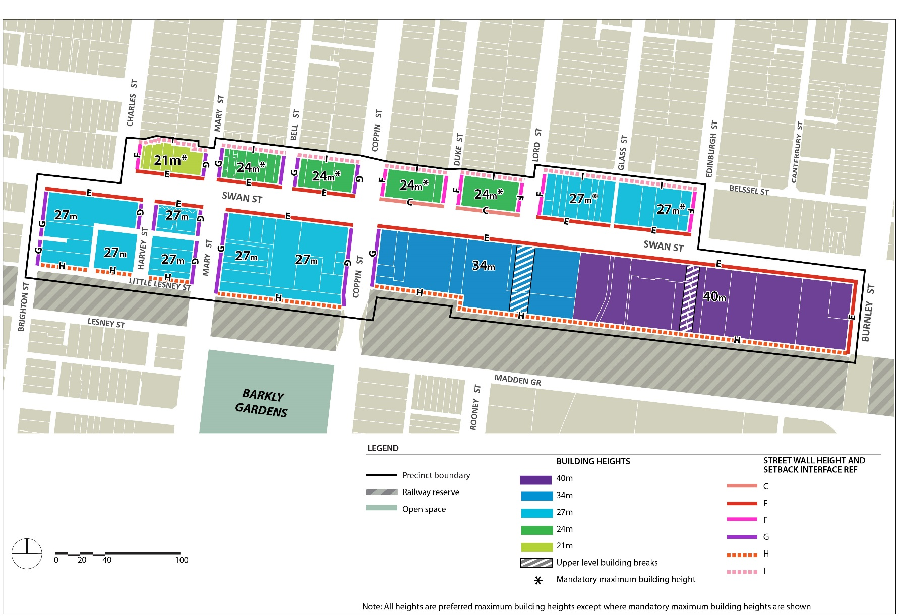
Plan 5: Height and Interface Plan – Precinct 3 – Swan Street East

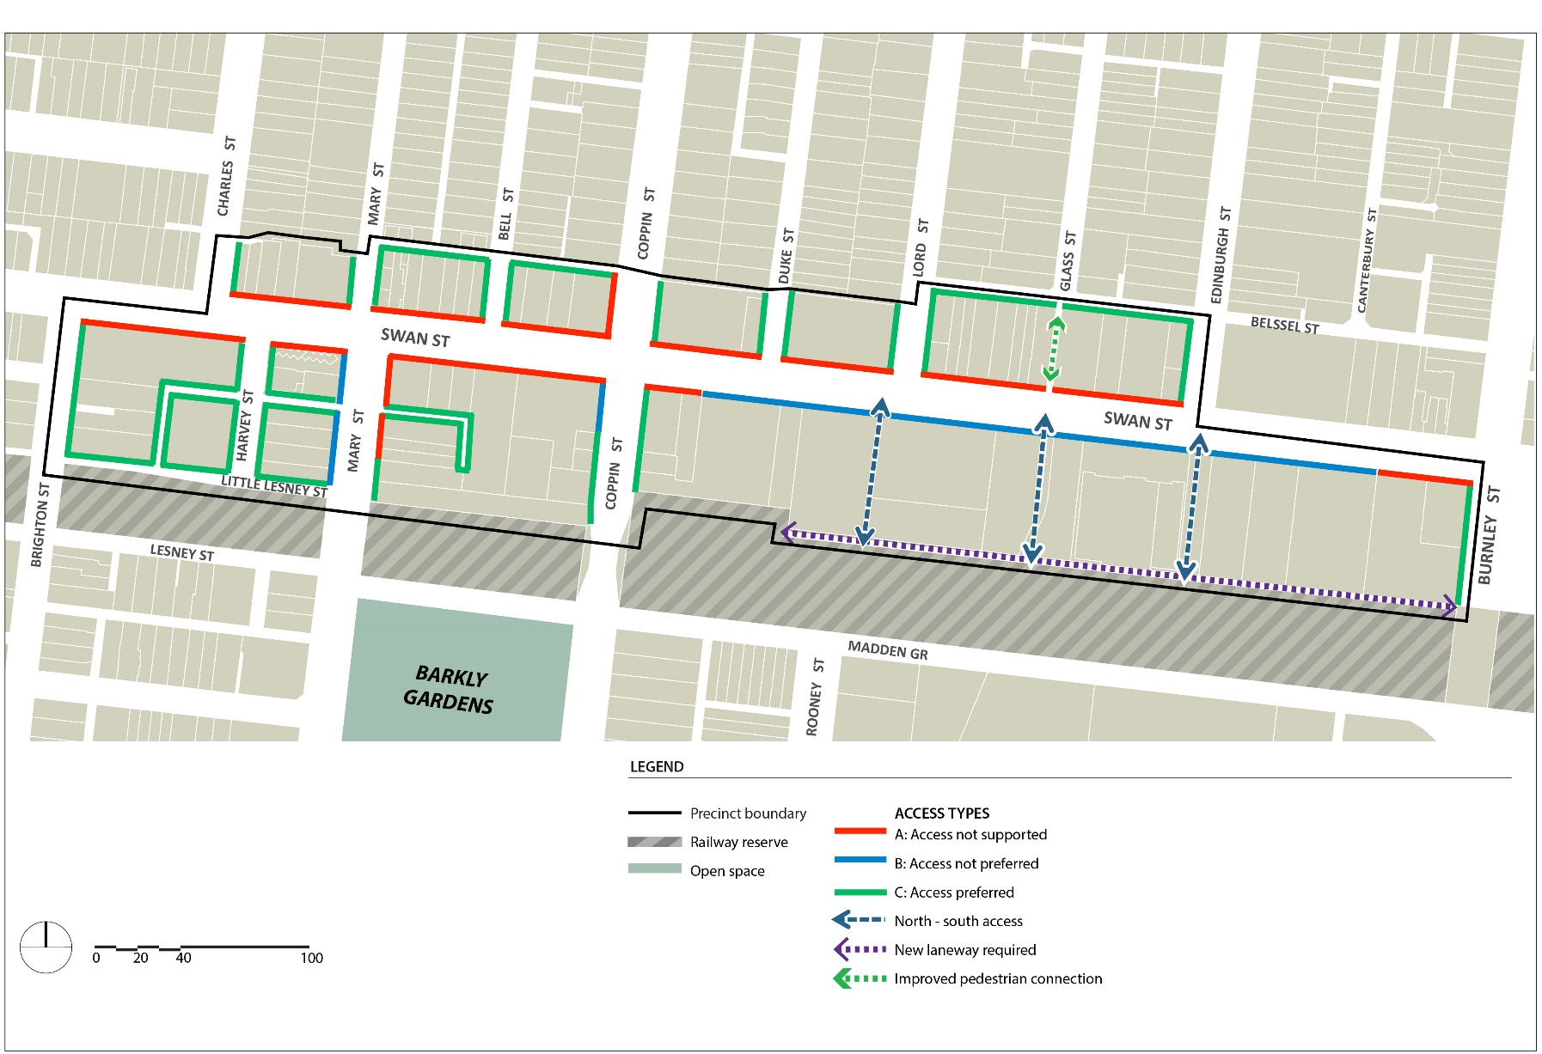
Plan 6: Access and Movement Plan – Precinct 3 – Swan Street East

Precinct 4 – Burnley Station
Shown on the planning map as DDO17-4
The Precinct Design Requirements for Precinct 4 are as follows:
- Development must respect the scale, rhythm, and architectural detail of the streetscape and the heritage buildings in the Burnley Street Heritage Precinct.
- Development along Swan Street must achieve a prominent street wall and provide an appropriate transition in the street wall height to the Burnley Street and Bendigo Street heritage precincts.
- Development must maintain the amenity of Ryan’s Reserve.
- Development of properties in the locations shown as “Upper Level Building Breaks” on Plan 7 must incorporate side setbacks greater than the standards in Clause 2 to enable clear views to the sky between buildings along Swan Street when viewed from the opposite side of Swan Street and along Cutter Street and Bendigo Street.
- Development must not overshadow the opposite footpath of Stawell Street (measured as 2.0m from the road boundary between 10 am and 2 pm at 22nd September).
- Development must maintain solar access to Ryan’s Reserve as follows:
- Beyond 16m of the eastern boundary of the reserve from 10 am onwards on 22 September
- At the western boundary of the reserve until 2 pm on 22 September.
- Development of 500 to 506 Swan Street, as shown in Plan 8, should include a rear setback, at ground floor, to facilitate the ongoing function of the laneway and allow for building services and car park access. The setback and laneway should be a minimum width of 6m in total.
- Development of 130 to 136 Stawell, as shown in Plan 8, should include a rear setback, at ground floor, to facilitate the ongoing function of the laneway and allow for building services and car park access. The setback and laneway should be a minimum width of 3m in total.

Table 4 – Street Wall Heights and Setbacks for Precinct 4
Interface Ref | Design Element | Mandatory Requirements | Preferred Requirements
C | Street wall Height |  | 11m maximum or the parapet height of the adjoining individually significant or contributory building if higher than 11m.  8m minimum.  Match the parapet height of the taller adjoining heritage building.
 | Street wall setback | 0m.
 | Upper level setback | 10m minimum from Swan Street setback for land affected by HO 286 (365 Swan Street).  Minimum 5m for other individually significant heritage buildings. | Minimum 5m elsewhere.  Any part of a building above the street wall should be designed to ensure that it occupies no more than one third of the vertical angle defined by the whole building in the view from a sight line of 1.7 metres (on the opposite side of the street).
E | Street wall height |  | 14.5m maximum
 | Street wall setback |  | 0m.
 | Upper level setback |  | 5m minimum.
F | Street wall height |  | 11m minimum.
 | Street wall setback |  | 0m.
 | Upper level setback |  | 5m minimum for individually significant buildings.  3m minimum elsewhere.
G | Street wall height |  | 14.5m maximum.
 | Street wall setback |  | 0m.
 | Upper level setback |  | 3m minimum.
H | Street wall height |  | N/A.
 | Street wall setback |  | 0m minimum unless setback is identified on the Plan 8.
 | Upper level setback |  | 0m.
I | Side and rear wall height |  | 8m maximum on a common boundary with a property in a residential zone.  11.5m maximum if boundary abuts a laneway.
 | Upper level setback |  | Development must be setback in accordance with Figure 1 and Figure 2.  Development must minimise stepped form.

Plan 7: Height and Interface Plan – Precinct 4 – Burnley Station
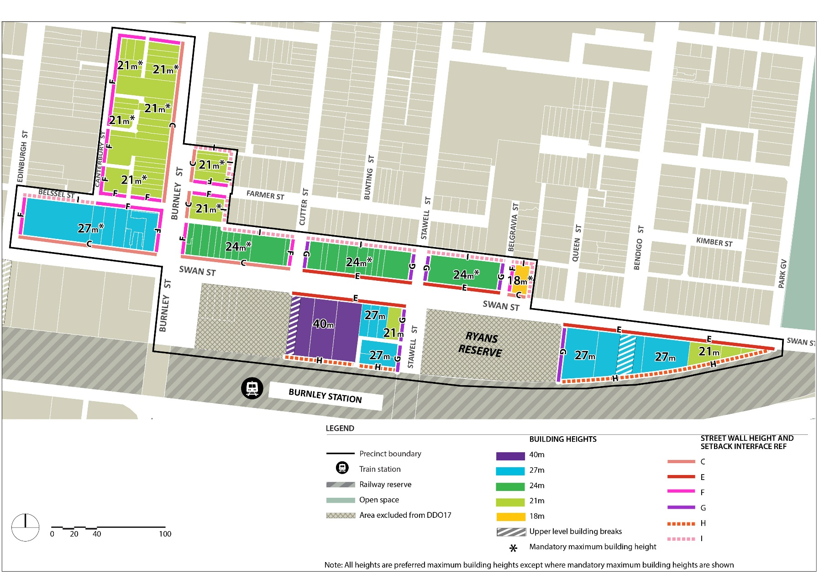

Plan 8: Access and Movement Plan – Precinct 4 – Burnley Station
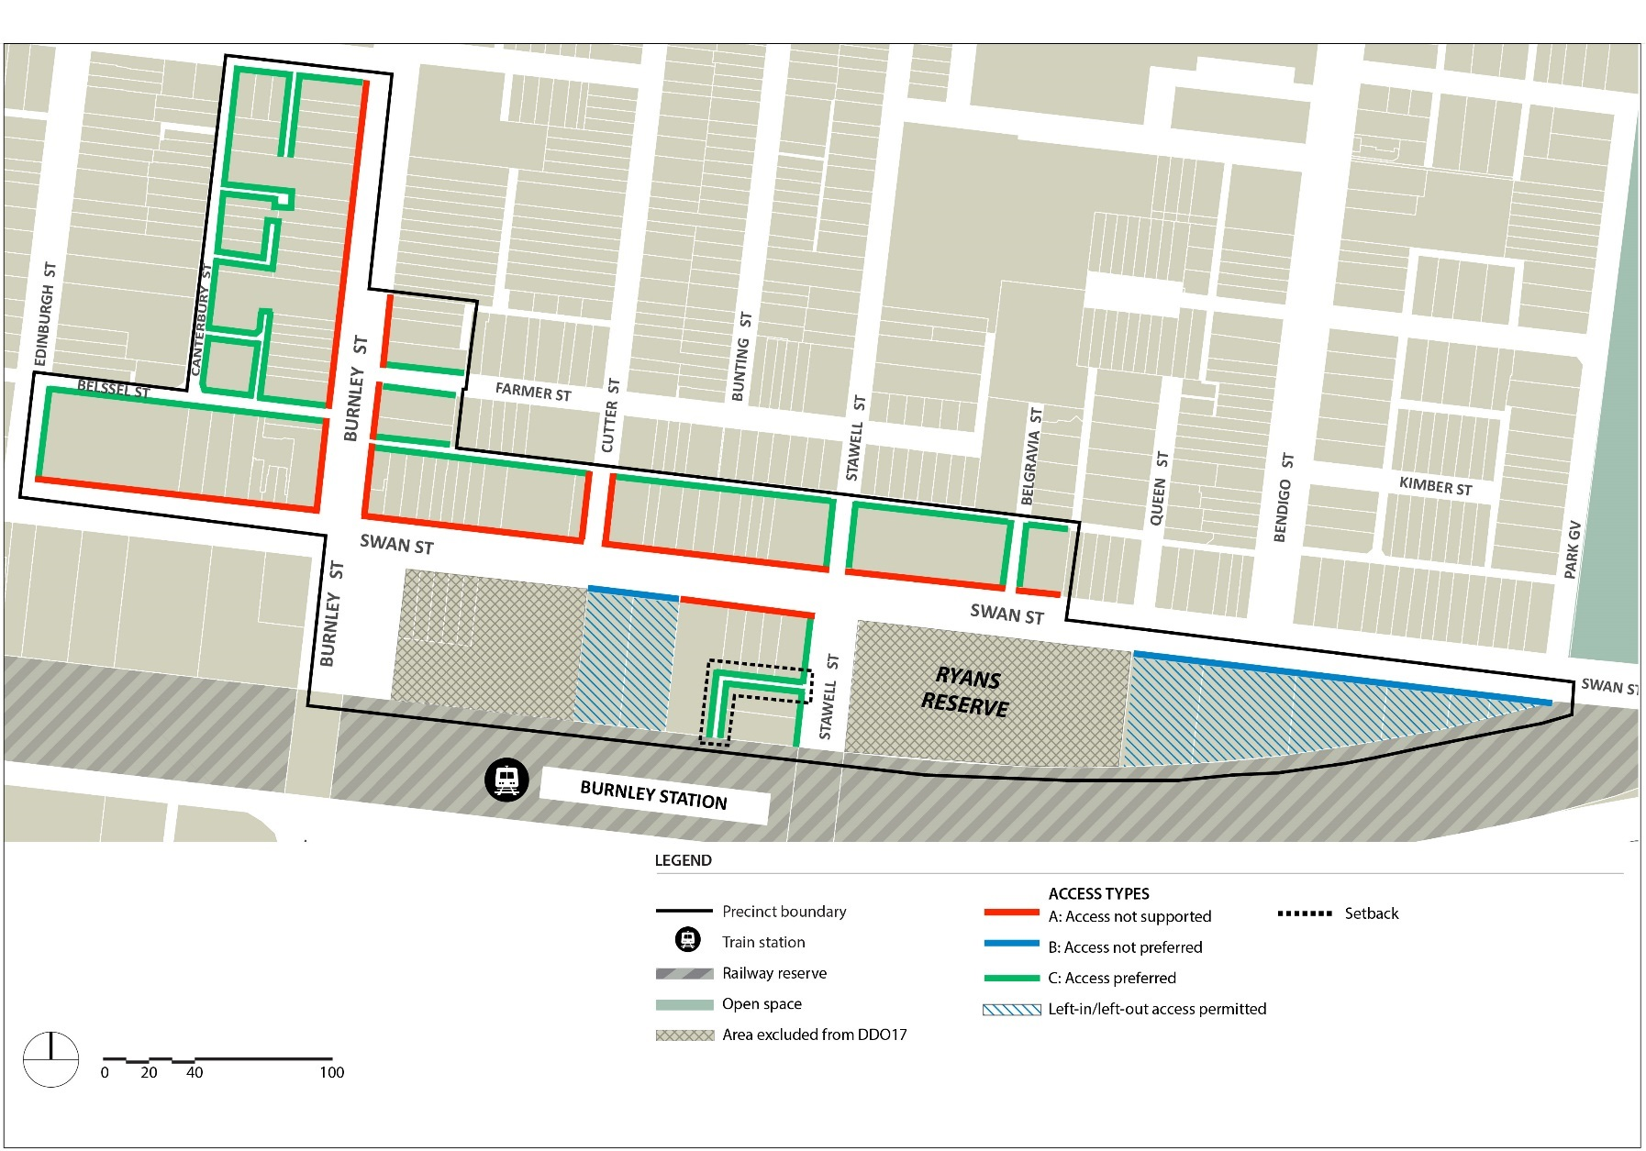

3.0 Subdivision
dd/mm/yyyy
Proposed C191
None specified.
4.0 Advertising
dd/mm/yyyy
Proposed C191
None specified.
5.0 Decision guidelines
dd/mm/yyyy
Proposed C191
The following decision guidelines apply to an application for a permit under Clause 43.02, in addition to those specified in Clause 43.02 and elsewhere in the scheme which must be considered, as appropriate, by the responsible authority:
- Whether the General Design Requirements and the Precinct Design Requirements in Clause 2.0 are met.
- The design of the streetscape interface and its contribution to an active street environment.
- Whether the proposal contributes to and improves the pedestrian connectivity and amenity of the public realm.
- The shadowing impacts of the development on footpaths and public spaces.
- The wind effects created by the development.
- The separation between buildings at upper levels when viewed from the opposite side of Swan Street and from local streets.
- The prominence of the heritage street wall in the vistas along Swan Street, Church Street, Burnley Street, and local streets.
- Whether heritage buildings on street corners retain their prominence when viewed on both streets.
- Whether heritage buildings retain their three-dimensional form as viewed from the public realm.
- Whether upper level development above the heritage street wall is visually recessive and does not overwhelm the heritage buildings.
- The impact of development on view lines to the Dimmey’s Clock Tower.
- The impact of development on the operation of the tram routes along Swan Street and Church Street.
Figure 1 to schedule 17 – Residential interface with an existing laneway
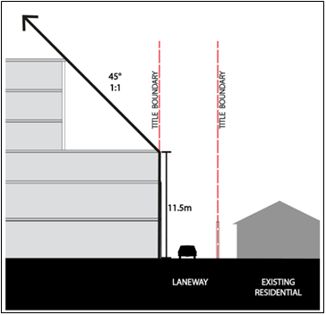
Figure 2 to schedule 17 – Residential interface direct abuttal
