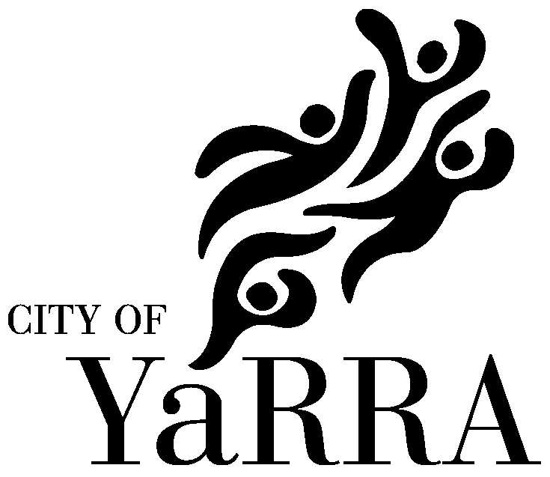
Active Ageing Advisory Group

Terms of Reference.
Purpose

The Active Ageing Advisory Group (AAAG) will provide advice and support to Council regarding the following matters:
- Development of policy and programs impacting on the lives of older people in Yarra, by Council and non-government organisations;
- The needs, interests and well-being of Yarra’s older people;
- The integration of Age Friendly planning into the core planning including social, infrastructure, corporate, recreation, leisure, physical, open space, asset management and statutory planning activities of Council;
- Monitoring and guidance of the implementation of the River of Life Positive Ageing Action Plan;
- Promotion of positive portrayals of older people and Yarra as an inclusive community.

Guiding Principle

To collaborate with Council and the community in raising awareness of ageing issues and promoting a Yarra culture that responds to the needs and aspirations of all older people.

The AAAG will therefore be required to:

Provide information and advice to Council on matters affecting the needs, interests and well-being of Yarra’s older adults.

  - Act as a conduit for the exchange of information and views between community, Council and other representative bodies on issues affecting the lives of older people;

  - Represent the community broadly.

Note: Please refer to Governance – Appointment of Members to Council Advisory, Consultative, etc. Committees POLICY dated 30/110/14 for current processes that supersede some provisions in these ToR.

Membership and Composition

The AAAG will comprise a Councillor and up to 8 *older people.

Members will not be appointed as representatives of particular interest groups, regardless of whether that interest group has nominated them as members, nor are members expected to represent the specific view or be accountable to any organisation.

There will be no age limit to membership. Members are chosen because of their individual knowledge, networks and abilities and their ability to represent a wide and diverse range of experience, expertise, networks and interests relevant to older people.

* Increased from six to eight following Delegates Report to Council in March 2016
Selection Criteria

AAAG members are in general expected to:

- Have the capacity to consult and represent a wide range of views;

- Understand the needs of older people from diverse backgrounds;

- Work with Council to inform stakeholders of activities, outcomes and achievement of AAAG;

- Have the capacity to analyse information and advice on issues affecting older people;

- Have strong knowledge of issues facing older people now and into the future;

- Live, work or study in the City of Yarra.

Residents who represent the following backgrounds are encouraged to apply:

- Different cultural and linguistic background;

- Gay, Lesbian, Bisexual, Trans and Intersex (GLBTI) background.

Term of Appointment and Selection process

The term of appointment will be four years. Each 2 years, half of the group will retire. Retiring members will be eligible for renomination.

Community members will be appointed every 2 years, following a public advertising process. Members will be chosen by a selection subcommittee (“the panel”) consisting of two community members, the Chair and Council’s Coordinator Community Development.

The panel will assess applicants against the selection criteria; consider appointments and make a recommendation to the Chief Executive Officer for approval.

Casual Vacancies

Where vacancies occur, the Group may on the recommendation of the Chair, appoint additional members at any time.

Role of Observers

Community members are invited to attend the AAAG meeting in the capacity of observer. Should observers wish to raise agenda items at meetings, they are invited to do this through a current member.

Role of the Chairperson

The Councillor representative shall be the Chairperson. The Chairperson may act as a spokesperson for AAAG, or delegate the responsibility to another member.

Role of Members

It is expected that where possible, all members attend AAAG meetings for the duration of each, and participate in AAAG Working Groups as agreed. This may include providing input into specified projects. Although not appointed as representatives of specific organisations, AAAG members are expected to provide feedback on the work of the AAAG within their networks.

Decision Making

AAAG is not a decision making body and does not require voting protocols or other decision making mechanisms. As such, a diversity of different views may be expressed by the Group from time to time. These views will be reflected in any reports, and statements issued by the group.

As far as possible, AAAG will provide advice based on the collective wisdom of the Committee and the best available information provided by Council Officers.

Public Representation of Views

The Chair will represent the views of the Group and may, as delegated by the Mayor, make public statements to the media if required. Members are entitled to make comment on matters in their capacity as a member of another organisation or as private citizens; however it should be clear that those views are not expressed on behalf of AAAG or Council.

Secretariat Support

Secretariat and other executive support to the AAAG will be provided by Aged and Disability Services Branch, City of Yarra.

Council Officers will attend the AAAG meeting and provide advice and information in the area of their expertise, including the distribution of minutes to members after meetings

General AAAG Meetings

Meetings are to be held bi-monthly

Working Groups

Based on agreed work priorities, the AAAG may use working groups to progress its work. Working groups will appoint their own convenor. Working group business may be conducted using a variety of methods, including face-to-face meetings, conference, telephone link ups or email.

Working group convenors must be a member of the AAAG, however a community member may be co-opted onto a group and group members may use their discretion to seek input from other people with knowledge or with an interest in the group’s specific interest or subject.

Community Forums

The AAAG may also initiate or be requested to hold community forums:

- to provide opportunities for older people in Yarra to contribute to the AAAG deliberations; and
- to provide information about topics of interest to them.

D14/81567

