Expression of Interest
For
Shared use/Shared occupancy
of
Hosie Street Community Centre – 3 Hosie St, Richmond

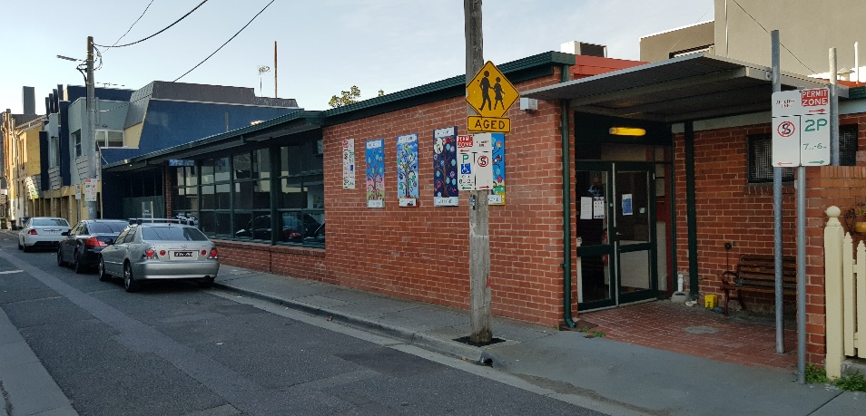

CLOSING TIME: 4pm
CLOSING DATE: 28 June 2019
- Overview

Yarra City Council (Council) is seeking Expressions of Interest (EOI) to access “shared” use / “shared” occupancy of the Commercial Kitchen and Meeting Facilities at Council premises known as the HOSIE STREET COMMUNITY CENTRE, Hosie Street, Richmond (facility).

  - Purpose

The aim of this EOI is to:

- communicate to potential EOI respondents the details of times and the actual spaces and facilities which are potentially available for “shared” use / “shared” occupancy and the expectations and requirements which would apply to any such occupancy arrangement.

- provide sufficient detail to enable an initial assessment by Council of the suitability of responses received; and

- enable Council to select a respondent to the Expression of Interest process.

Key Points:

- The facility is currently used by several community groups on a number of days / evenings each week.
- There are however, a number of days / evenings when the facility is generally, not used as set out in the Table below:

Mondays | ---------------- | ----------------- | Evening hours
Wednesdays | ---------------- | ----------------- | Evening hours
Thursdays | ---------------- | ----------------- | Evening hours
Fridays | Morning hours | Afternoon hours | Evening hours
Saturdays | Morning hours | Afternoon hours | Evening hours
Sundays | Morning hours | Afternoon hours | Evening hours

- Council is seeking to maximise the community use of its investment in such community facilities.

- An opportunity thus exists for the potential “shared” use, of the facility during the periods set out in the Table above.

For more information contact:
Ivan Gilbert
Group Manager, Chief Executive’s Office
9205 5110
ivan. gilbert@yarracity.vic.gov.au

ISSUED ON:
31 May 2019

ALL EXPRESSIONS OF INTEREST TO BE RECEIVED BY:
4.00pm, Friday 28 June 2019

1. INTRODUCTION
Yarra City Council is inviting community groups and organisations to submit an Expression of Interest re the potential for “shared access” to the large function / meeting space and facilities at the Hosie Street Richmond Community Rooms on those days and times when it is currently not used, in order to encourage maximum use of this community owned space and thus, achieve a potential for increased accessibility to a wider range of activities / services for the Yarra community.

Potential Uses could include:

- Health and wellbeing programs
- Cultural activities such as choirs, arts, acoustic music or dance classes
- Local community group meetings on a weekly, fortnightly or monthly basis
- Cooking classes

2. BACKGROUND
The facility is located in Hosie Street, Richmond (just off Bridge Road). It is a multi-use facility comprising of a small function space and a commercial kitchen.

Yarra City Council seeks to enhance the quality of life of community members living in the municipality by forging partnerships with local Clubs or community organisations and offering for hire, the “shared” use of an affordable venue which is responsive to local needs.

Yarra City Council seeks to support a range of community activities through the hiring of the meeting / activity spaces on a casual basis for such uses as - organised activities, ad-hoc meetings or local resident’s small social events.

Yarra City Council Strategic Objectives
Celebrating Yarra’s uniqueness

We believe that Yarra is unique. A community different to all other 78 Victorian municipalities. There is a long history and deep identity that matters to people living in, moving to or just visiting the iconic City of Yarra. Council’s decisions and priorities respect and encourage this uniqueness.

Supporting Yarra’s community

Yarra City Council is driven by strong community values in its provision of services and activities. This includes frequent strong representations to State and Federal Governments on understanding and providing for, community needs and views.

Ensuring a sustainable Yarra

Yarra City Council has made innovative and ground-breaking inroads into reducing the Council’s environmental ‘footprint’. Council continues to enhance its advocacy and partnership arrangements in working to further reduce the community’s environmental ‘footprint’.

Leading local government

Council’s focus on fiscal management and customer responsiveness, is how to structure:

- the use of Council’s properties and facilities in order to maximise the use of and a return on, those community facility investments; and
- access to its property facilities and also to the services provided by both Council and other Groups, being available to the wider community.

Council focusses services to audiences with members including:
Local community Culturally and linguistically diverse community
Older community LGBTQI community

Unemployed and low income community Youth, families and Children
Community with disabilities

3. FACILITY FOR HIRE
Facility comprising:

- Small open function space / activity area;
- Commercial Kitchen
- Small kitchenette;
- Small storage room.

These rooms may be hired individually or in conjunction with each other, on a weekly, fortnightly or monthly basis.

SPECIAL NOTE:

If the Commercial Kitchen is hired, it may on occasions be necessary to SHARE some other facility spaces (i.e. toilets and the access thereto) with other Groups using the Small open function space / activity area. This would require formal arrangement with the other particular user Group.

All use arrangements will require a signed facility user agreement.
For groups/organisations with regular bookings, it is anticipated that facility user agreements would be provided for a 6-month period with an option to extend for a specific period of time subject to availability. The bookings will be created in three monthly terms, with full payment and paperwork required prior to the start of each term.
All hirers will be required to pay a refundable bond and supply a certificate of currency for public liability insurance.

4. PRIORITY OF ACCESS POLICY
All expressions of interests for access to the commercial kitchen and small activity/meeting room will be assessed according to the guidelines listed below:

- Ensure fair, appropriate and equitable access to the Hosie Street Community space facilities;
- Consistency with Council’s policies and any relevant legislation.

The priority of access for the facilities at the Hosie Street Community Centre will be based on the following criteria:

a) First priority will be given to incorporated or registered not for profit organisations which provide low cost activities to local residents from the City of Yarra, particularly if the activity or target audience is not currently being serviced within the community.

b) Second priority will be given to all other incorporated or registered not for profit organisations

c) Request for access by other groups and activities will be assessed according to the following:
- Alignment to Council Vision, Principles and Outcomes;
- Benefit to local families and the community;
- Broadening opportunities for families disadvantaged by economic, social and cultural factors;

5. ELIGIBILITY AND SELECTION CRITERIA
All expressions of interests will be assessed on the following:
- How the proposed program or activity relates to and supports the Vision, Philosophy and Outcomes of the City of Yarra.
- Evidence of need and connection with local community.
6. TERMS OF HIRE
Access to the Hosie Street Community Centre facilities will be subject to the terms and conditions of use consistent with Yarra City Council policies and requirements.

a) Limitations to Use of the Facilities

Council will not accept any events which involve consumption of alcohol or loud music.

b) Fees and Charges

A range of fees and charges are applied to the use of meeting spaces at the Hosie Street Centre. Hirers will be advised of the total fees when the application has been assessed.

The fees and charges vary based on the type of user including:

Concession Rates:
In order to qualify for the Concession Rate, your organisation or group need to be registered as a not-for-profit or incorporated organisation or charity. This is verified via your organisation’s ABN or a certificate of incorporation.
No concessions currently apply for local residents, students or concession-card holders.

Commercial Rates:
Commercial hire rates will apply to all other organisations or activities.

c) User Agreements
The hirer is to sign the facility user agreement and abide by the Conditions of Hire (Appendix One)
7. TIMELINES
Expression of Interest opens on: 31 May 2019
Expression of Interest closes on: Friday 28 June 2019

8. VIEWING THE FACILITY
The Hosie Street Community facility will be available for viewing by interested persons / groups by arrangement to assist you in the preparation of your application.

9. CONDITIONS OF HIRE OF COUNCIL VENUES
Refer attachment 1
If you have any questions or want to visit the venue, please contact Ivan Gilbert by phone on 9205 5110 or email ivan.gilbert@yarracity.vic.gov.au

10. LODGEMENT
Please submit your completed Expression of Interest form by email to:
Ivan.gilbert@yarracity.vic.gov.au

Or by Mail to:
City of Yarra
PO Box 168
Richmond VIC 3121
Please mark attention Ivan Gilbert on your application.

INVITATION TO SUBMIT AN EXPRESSION OF INTEREST

The Yarra City Council welcomes expressions of interests from community groups and organisations to deliver activities at the available activity / meeting spaces within the Hosie Street Community facility.

Your group/organisation will need to consider whether your proposed programs and activities fit with the Council’s Vision, Philosophy and Outcomes as well as the Priority of Access Policy.
To submit an expression of interest, complete the table below and email to ivan.gilbert@yarracity.vic.gov.au

Or by Mail to:
City of Yarra
PO Box 168
Richmond VIC 3121
Please mark attention Ivan Gilbert on your application

If you require assistance with this form or need further information, please contact Ivan Gilbert (Chief Executive’s Office) on 9205 5110.

- Information about you/your organisation
Name of Group/Organisation

Postal Address

Organisation Email

Website address (if applicable)

Contact Name

Contact phone number

Contact email address

Position/role in the group

Do you have public liability insurance?  If yes please attach your certificate of currency for your current policy. |  | YES NO
Is your group registered as a not-for-profit, incorporated organisation, Deductible Gift Recipient or registered charity? |  | YES NO
If yes, please provide the ABN:

- Details of your proposed booking/s

How regularly will you require the room?

Weekly Fortnightly Monthly Bi-monthly
Other (please state) ___________________
Starting and Ending date of Proposed Booking: __/__/__ to __/__/__

Day(s), please tick:
Monday Tuesday Wednesday Thursday Friday

Time(s), must include set up and pack up:
From _____am/pm To _____am/pm

Are these dates and/or times flexible?
YES NO

How many people do you expect to attend each session?

What is the program or activity that your group/organisation proposes to deliver from the Hosie Street Community Centre? What do you hope to achieve for your participants?

Who will attend your proposed activity/program? Can you tell us how your group/organisation may meet any special community needs or interests?

How do you know that your programs or activities are in demand in Richmond or Yarra?

What is your group / organisation’s connection to the Richmond community and to Yarra?

Is there any other information you want like to provide us in support of your expression of interest? Please attach any supporting documentation.

- Declaration

Before signing this Expression of Interest Form, please ensure that you have clearly understood each question and that the information you have provided is accurate and current.
I have understood each question asked above. I acknowledge that all information provided in this Expression of Interest is accurate and up to date.

- Canvassing

Respondents must not approach, or request any other person to approach:

- any member of the Council’s staff; or;
- Councillor of the Council individually;

to solicit support for the EOI’s or otherwise seek to influence the outcome of the EOI process.
The EOI of any respondent which engages in conduct prohibited under this section may not be considered by Council.

- Council’s Rights

I understand and acknowledge that:

- This document is not an undertaking or contractual offer by Council.
- Council reserves the right in its absolute discretion to:

- cease to proceed with, or suspend the EOI process;

- alter the structure and/or the timing of the EOI process;

- vary or extend any time or date specified in this document for all or any respondent or other persons;

- terminate the participation of any respondent or any other persons in the EOI process;

- require additional information or clarification from any respondent or any other person or provide additional information or clarification;
- negotiate with any one or more respondents and allow any respondent to alter its EOI;

- call for new EOI’s;

- reject any EOI that does not comply with the Council’s requirements; and

- select none, some or all EOI components from a particular respondent.
.

Signature of applicant: | Date:
On behalf of (if applicable):

Conditions of Hire for Council Venues
Refer attachment 1.

