Application to  Keep more than two animals on a property  Under General Local Law | 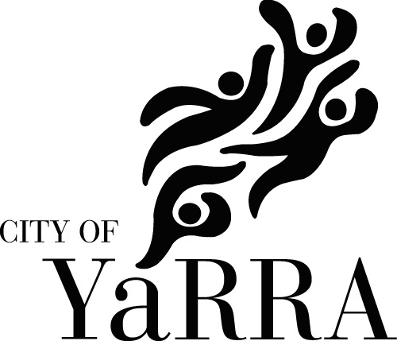
According to Council’s General Local Law, the numbers of animals permitted are as follows:  ANIMAL TYPE House Flat / Unit  Number of Dogs (over 6 months) permitted 2 1  Number of Cats (over 6 months) permitted 2 1  Birds 5 2  Poultry 5 Not permitted  Reptiles 2 Not permitted  Ferrets, guinea pigs, rabbits, mice 2 Not permitted  Cats and dogs exceeding this number must also be registered. The details below are to be completed and returned to Council. In the case of a cat and/or dog, the details must be completed prior to a registration tag being issued.  Please supply the following information:  Applicant contact details:  Name:  Street Address:  Suburb: Postcode:  Contact phone: Mobile:  e-mail:  Type of dwelling (please tick appropriate box):  House Flat / Unit  Animal type and number requested:  Cat/s How many? Dog/s How many?  Birds How many? Poultry How many?  Guinea pig/s How many? Rabbit/s How many?  Reptile/s How many? Mice How many?  Ferret/s How many?  Reason for applying:  You must contact and obtain agreement from any neighbours who may be directly affected  Direct neighbours contacted:  Name: Address: Phone:  Applicant’s signature: Date: / / 20  The personal information requested on this form is being collected by Council so it may consider your application in accordance with Council’s Local Laws. The personal information will be used solely by Council for these purposes or directly related purposes. Council may disclose this information to other Council departments, and any other organisations that may be affected by the application. The applicant understands that the personal information provided is for the above purpose and that he or she may apply to Council for access to or amendment of the information. Requests for access or correction should be made to Council’s Privacy Officer on 9205 5555 or info@yarracity.vic.gov.au | City of Yarra  PO Box 168  Richmond VIC 3121  T +61 3 9205 5555  F +61 3 8417 6666  E info@yarracity.vic.gov.au  W www.yarracity.vic.gov.au

